Gun Control on College Campuses

Parry Brooks

University of Texas El Paso

**Abstract Page**

Gun Control is an issue that has been debated time and time again with not true headway on the side of those who choose to restrict the flow of firearms onto the market. On one side of the debate is the right to self-defense keeping in tune with same right afforded by the 2nd Amendment. The resulting rhetoric from both sides of has resulted in more miss information that actual facts and study on the matter. There is slanted rhetoric on both sides the debate designed to cancel out the supporting evidence of the other side.

The topic of gun control is an ongoing debate in America with no end in sight. The story of a shooting taking place has become common place in the news; the issue is never a surprise. What should come as a shock is that gun violence has spread to America’s schools. From the elementary level to university campuses, all have been affected. There has been much debate, but no true solution on the best ways to protect our students has been implemented. This paper however will focus on the college campus debate. This is due to the fact that both the age groups of the faculty and the some students able to legally possess a firearm. The argument is to determine if it’s wise to arm students and/or faculty members. Gun violence on college campuses is such a random event one has to wonder if he next step to steaming the tide of violence is arm students, and staff alike. To be frank a school is a target rich environment that can be exploited in many ways.

At any time a shooter can find out the location of potential targets by following a class schedule. For information on which classes would offer the most potential targets, a would-be shooter need only consult the college registration website. Every student and faculty member knows is aware that a school’s focus is on learning, but the time to reassess the security of the institution has long since arrived. Will universities be proactive, implementing a well thought out plan to deter or prevent gun violence? One can only hope that is the case. Then again, will they instead succumb to a “knee jerk” reaction based in panic and fueled by fear generated from the latest public shooting? Two sides of the debate with ever changing opinions. But lest be clear, a shooting is not a new event, or even very shocking.

According to the Centers for disease control (CDC), there were a total of 11,208 reported deaths attributed to guns, which totals up to 3.5 deaths for a population number of 100,000 (Newcomb/ABC News, 2015). When compared to the other seven members of the G-8 in 2010 we had almost double their amount combined [Figure 1]. 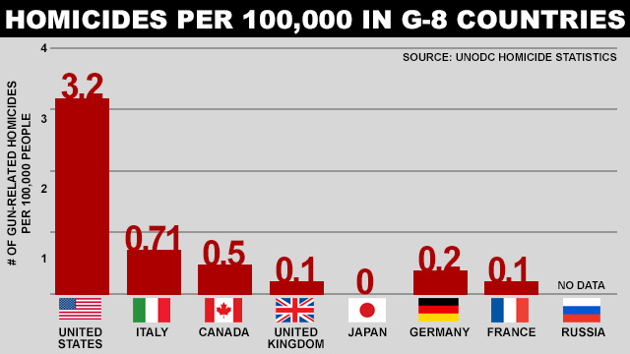

Retrived from (Rosenzweig/ABC News, 2015)

With number like these why has the population shown such outrage of late? The answer is now the violence has hit America where it hurts, the violence has visited the children. To complicate matters even more, what defines a school shooting is up for debate. Is it an active shooter with violence directed toward staff and the student body in general, a student on student altercation, or a crossfire near school property? Also how is each incident is reported

**Armed Students on Campus Property?!?**

Everyone has the right to defend their selves that is not the debate. It seems that evidence would point to the opinion that our schools alone cannot to safeguard our students. So maybe it is time to arm the students instead of relying on campus security. But opinions are varied on the matter of guns on campus shown in this survey [Figure 2] conducted on UTEP students there is no clear cut opinion on the matter.

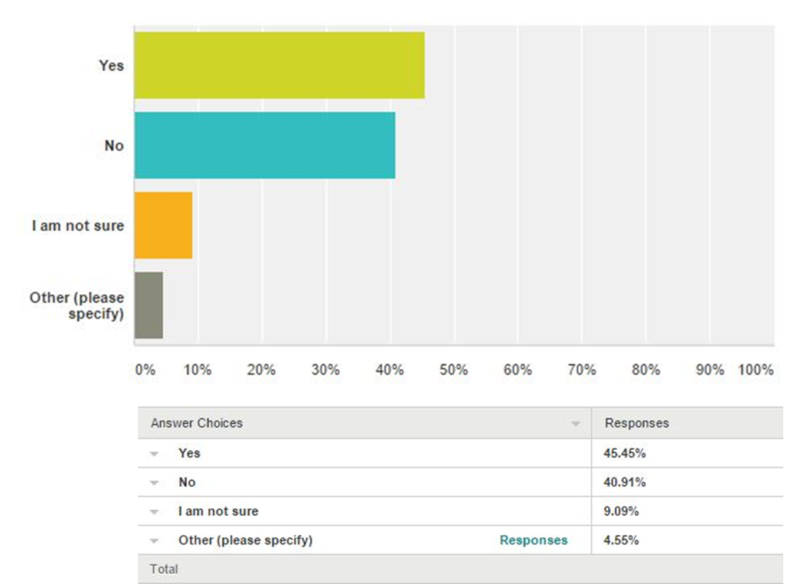

According to University of Calgary, “In 1990, the Gun-Free School Zones Act prohibited any person from knowingly possessing a firearm in a school zone.” (Gereluk, D. T., Donlevy, , J., & Kent Thompson, M. B. 2015). So the logic here is who would think that a crazed gunman would care. So this is one point in favor or arming a student and or the facility. Since the punishment of bringing a gun to school with a one year suspension would not matter to a gunman may kill themselves right after the act is committed.

**Psychological Testing for Armed Facility or Students on Campus**

What additional psychological testing can be done for those wishing to carry weapons on school grounds? On one hand, there is a call to keep weapons out away from the mentally disturbed and that sounds like a logical course of action. The only problem is what exactly defines what is crazy and what will be done in cases where a current gun owner is deemed mentally unstable? The gun-control advocates will argue that it is way too easy for the insane to obtain a gun, the only way to figure out the merits of that argument is to explore the subject further.

Pro-gun control would say there are signs, and there are many examples to pick from. There is the case of Jared Loughner who at age 22 chose to shoot the former U.S. Representative Gabrielle Giffords in the head. Then there was the incident at a movie theater in Aurora, Colorado. Once again, it was an emotionally unstable individual named James Holmes who at 26 opened fire on a full movie theater. According to the Surgical Neurology International, in the case of Loughner “a consensus has been reached that the mentally deranged individual should have received psychiatric evaluation and treatment which were not administered” (Faria Jr., M. A. (2013). In both cases there were signs of mental instability, and in both cases, family members and love ones only suggested that professional was needed. In both cases friends and family could have raised a red flag but were not proactive, so there was no record of past behavior. There is just one problem how does a family member or love one determine what is dangerous behavior in the first place. The love one many times sees an individual as someone they can help or will make excuses for the strange behavior. In most cases nothing can be done unless the individual expresses behavior that would be a danger to their self or someone else. Even the Gun Control Act of 1968, has no real way of defining what is mentally unstable.

The Gun Control act of 1968 states:

It shall be unlawful for any person who has been adjudicated as a

mental defective or who has been committed to a mental institution,

to ship or transport in interstate or foreign commerce, or possess in or

Affecting commerce, any firearm or ammunition; or to receive any firearm or ammunition which has been shipped or transported in interstate or foreign commerce (Bramble 2014, p 308).

The language is so confusing that the ATF had to step in and clarify but even they left room for interpretation. While they did define what constitutes an unstable to include, “A formal commitment of a person to a mental institution by a court, board, commission, or other lawful authority” (Bramble 2014, p 310). The definition did not cover any who voluntarily commits themselves. This may not mean anything at first glance but later on down the road when an individual wants to purchase a fire arm not knowing if the complete mental history comes into play. That being said, when the time to grant a student the privilege to carry a weapon on campus does arrive there may not be any documentation to show their complete mental history. Later on came the arrival of the Brady Bill of 1993.

The Brady Bill did help to establish a waiting period on gun purchases which gave law enforcement time to conduct a background check on an individual if they pleased. The bill however lacked teeth in that it could not mandate states to forward records to the National

Instant Criminal Background Check System (NICS). This meant even more gaps in determining who was not mentally fit to obtain a firearm.

One more reason why using mental illness as a determination of gun ownership will fail, is not all mental illness is the same. Additionally states can create their own measure of what defines mental illness. With the confusing language and failure of enforcement one would think those bills were the result of pro-gun advocates. In fact these gun control laws were in fact formed by individuals attempting to address gun violence from the mentally unstable.

On the counter argument another study shows that most violent acts are not committed by the mentally ill. In fact after all that has been said so far the mentally ill have just as much access to firearm as the rest of the population. This point is stated again in theAmerican Journal of Orthopsychiatry “Contrary to common belief, individuals reporting a mental illness at any point in their lives had just as much access to firearms as those without a history of psychopathology (34.1% vs. 36.3%, respectively)” (Hodges & Scalora 2015, p 213). Knowing this the question of shootings being done by the mentally ill can be debated as false.

According to an article by the American Psychological Association (APA) gives the idea that documented behavior would prevent the individual from legal purchase of a firearm and further explains that at the state and federal level legislation is targeted to restricting the mentally ill from getting their demented hands of a firearm (this still does not answer the question knives) in the first place (Pirelli, Wechsler, & Cramer, R. J. 2015).

According to the APA to further complicate the matter for both the pro-gun and anti-gun control side is the fact that “state laws differ in their disqualifying criteria related to mental illness, which corresponds to variability in reporting practices” (Pirelli et al., 2015). Since there is no uniform measure of insanity a pro-gun advocate would argue, “who’s to say that you would not find me crazy and take my guns.” There is a lot of rhetoric from the side of gun-control on psychological testing, but without a uniform standards or proactive family members, love ones and friends, testing is almost ineffective. According to the American Journal of Orthopsychiatry “a number of states have provisions that require voluntary disposal of firearms by individuals who become ineligible. Only four states have enacted laws to remove firearms from dangerous persons with mental illness” (Hodges & Scalora 2015, p 215).

That being the case, it may be best to prepare for the possibility of an active shooter on college campus.

**Student Faculty Active Shooter Response**

The issue of protecting our students is a point both the pro and anti-gun control advocates can agree on. Like always they both have very different ideas of how this can be done. It should come as no surprise the Obama Administration would like some measure of gun control and June of 2013. According to an article in Education Week (Federal Advice on School Intruders Worries Experts). “The new guidelines were written jointly by the U.S. departments of Education, Homeland Security, Justice, and Health and Human Services, the Federal Bureau of Investigation, and the Federal Emergency Management Agency” (Zubrzycki & Shah. 2013, p 14). On the very end almost as an afterthought is the section dealing with active shooter response on school campuses.

As stated in the article by Education Week “It seems a bit like déjà vu all over again: Another rehashed federal manual, throw in a webinar, and say you're doing something, when in reality you've done nothing but take away actual programs and resources to implement the ideas in the manual” (Zubrzycki & Shah. 2013, p 14). As with many other efforts by gun-control advocates, there is talk, but no action. This is due in part to an ongoing stalemate by both sides.

On the other side of the spectrum, anti-gun control advocates would suggest a more aggressive stance. The National Rifle Association (NRA) has formed a study to explore the option of arming not only teachers but all school personnel. NRA’s National School Shield Task Force is definitely a bias approach from the NRA. They are marketing it as a way to of reducing response time in case of emergency. According to Feldmann “The report also recommends that the National School Shield become an umbrella organization on school safety, providing free access to a web-based assessment of a school's security plan and to a database of best practices (Feldmann, L. 2013).

There is a certain loss of logic in that whole plan. It would be akin to a known burglar going door to door offering to install home security systems. Then to add insult to injury, the crook mandates that he is the one to maintain and monitor the program. It is only natural that the burglar will recommend a system that is to their advantage. The NRA’s program follows the same logic in that potentially they will provide the education and the support for the program.

Both sides of the debate offer suggestions, but in each case both are not viable. On the sides of the pro-gun control a passive approach is taken, almost as a way to shut the public up and show the government is thinking about the issue of gun violence. While the NRA has shown that it is willing to implant their training, and potentially their philosophy among school staff. However even though the Obama study does suggest the students and staff fight back as a last resort both do not focus on the student response and evacuation procures.

**Would Your Feelings of Security Increase or Decrease?**

If on-campus weapons permits becomes a reality would a student’s feeling of security Increase due to a feeling of empowerment. After all after all the press on school shootings highlighting latest madman of the week who would not feel the need to take precautions. On the flip side of the debate is the reasoning that guns on campus do not deescalate the problem but only make it worst. There is however a question that has not been asked, do you think there are guns on campus already?

The debate from both sides fails to explore this possibility stated by Birnbaum “likelihood that regardless of institutional policies, some guns will be present on campus” Birnbaum, R. (2013, p 12). In his article he states that a survey was conducted by the four year colleges during 1997 over 3% of college students admit to carrying a gun on campus. This bit of information pokes holes in the logic of both the pro-gun and the pro-gun control.

Pro-gun (pro-campus carry) will always argue that the only way to stop a “Bad guy” is to have a “Good guy” ever vigilant with their gun at the ready. If this is the case then one must ask, where are these undercover “Good guys” when a shooting did take place? Contrary to the pro-gun stance having a firearm does not necessarily impart bravery. But knowing also destroys the notion that gun free zones in schools work.

If a patron enters a restaurant with a no smoking sign that pack of cigarettes in their pocket does not simply vanish upon walking thru the doors. The lighter the pack of cigarettes are still at the ready concealed from view. Furthermore if at any time the customer chooses not to follow the rules and find a bathroom stall to light up what is to stop them from doing it. By the time they are caught the act lighting up has been performed. The same logic applies to a gun free zone only the consequences are much more serious.

If an armed person walks onto a campus with a gun free zone there is likewise not magical barrier to stop the gun from entering. They simply walk into the area now armed with the knowledge that they are most likely the only one in the immediate area with a gun. Now instead of going to a secluded spot to smoke, they instead start firing a gun. Birnbaum further states “The alternative of establishing “gun-free” zones doesn’t work, they say: stickers on campus saying “no guns allowed” just announce to criminals and psychopaths the absence of defensive weapons.” Birnbaum, R. (2013). The gun free zone may give some a false sense of security but that is all it is. Birnbaum pokes holes in the notion of just what is the feeling of security after all. In short some are naïve enough to believe that that there are not guns on campus, while others stand behind the notion that the sure fire way to stop a gunman (or woman) is to have more guns. In all of this debate one must ask, where are the campus law enforcement?

**College Law Enforcement have a more robust presence on campus property?**

Should college law enforcement have a more robust presence on campus property? That is subjective question. The Law enforcement presence will differ depending on which university a student goes to. Other internal factors such as the location of the school and the how the school grounds are designed also dictate how much security is present. The external factors relate to the crime rate in the surrounding area, and if it has an impact on the campus.

There has been a lot of talk and literature on both sides of the debate but still not real action on the gun control in general. The final decision no matter what law is pass will fall on the school administration at each college.

References

Anestis, M. D., Khazem, L. R., Law, K. C., Houtsma, C., LeTard, R., Moberg, F., & Martin, R. (2015). The association between state laws regulating handgun ownership and statewide suicide rates. *American Journal of Public Health, 105*(10), 2059-2067. doi:10.2105/AJPH.2014.302465

This article looks at three states as they deal with gun permits. They also cross-referenced data on suicides to see if there is a connection between guns and how much they affect suicide related deaths

Birnbaum, R. (2013). Ready, fire, aim: The college campus gun fight. *Change, 45*(5), 6-14. doi:10.1080/00091383.2013.812462

This article focuses in on legislation aimed that will allow guns on college campuses. It takes a balanced view on the subject of arming students and faculty members. The article also takes light jabs at both sides while showing how each side may bend information to suit their argument.

Bramble, L. (2014). Putting a band-aid on a bullet wound: Why gun legislation targeting individuals with mental illness isn't working. *Journal of Health Care Law & Policy, 17*(2), 303-327.

The article gives a pro-gun stance on the topic of how an armed person can stop an armed assailant. In the reading author attempts to put some blame on America’s media for the view of less guns is best as a way to keep firearms out of the hands of deranged. In closing he states the true answer is for more focus to be paid to mental healthcare

Brambles article points out the many reasons why legislation aimed at separating the mentally ill from guns in general is poorly thought out. This reading the author points the many failed attempts by the American government to define what is insane as a determination of keeping firearms out of the hands of the mentally ill. This is a generally neutral article highlighting the less than thought out definitions of insanity formed by the government.

Faria Jr., M. A. (2013). Shooting rampages, mental health, and the sensationalization of violence. *Surgical Neurology International, 4*(1), 85-92. doi:10.4103/2152-7806.106578

This is an article that calls for the halt to demonizing gun owners and focusing more on the mentally ill. It gives four examples of criminally insane shooters and how their deeds have been blown up by the media of their respective areas

Feldmann, L. (2013). Armed teachers? NRA task force suggests voluntary program. *Christian Science Monitor,* , N.PAG-N.PAG.

This article showcases the efforts by the NRA to implement their own brand of self-defense training in our schools. The program offered is 40 to 60 hours long and is meant to qualify school staff in how to react to an active shooting incident. However this article points out the program is little more than a NRA propaganda training machine aimed at school staff.

Gereluk, D. T., Donlevy, , J., & Kent Thompson, M. B. (2015). Normative considerations in the aftermath of gun violence in schools. *Educational Theory, 65*(4), 459-474. doi:10.1111/edth.12127

This article explore looking at the home environment as a cause for home violence. It further goes on to give many statics on the subject.

Hodges, H. J., & Scalora, M. J. (2015). Challenging the political assumption that "guns don't kill people, crazy people kill people!". *American Journal of Orthopsychiatry (American Psychological Association), 85*(3), 211-216. doi:10.1037/ort0000069

This article is a pro-gun look at the view of insane people being tired to gun violence It further goes on to show that the mentally ill are mass grouped in a category of being potential crazed shooters.

Newcomb/ABC News, A. (2015, October 15). Homicides per 100,000 in G-8 Countries[Graph]. Retrieved from http://abcnews.go.com/blogs/headlines/2012/12/us-gun-ownership-homicide-rate-higher-than-other-developed-countries/

Pirelli, G., Wechsler, H., & Cramer, R. J. (2015). Psychological evaluations for firearm ownership: Legal foundations, practice considerations, and a conceptual framework. *Professional Psychology: Research & Practice, 46*(4), 250-257. doi:10.1037/pro0000023

This article give a general guideline to mental health professionals on how to evaluate if a person is mentally stable enough to own a fire arm. There is cross referenced data from the American Psychiatric Association and the American Psychological Association found throughout this article

Zubrzycki, J., & Shah, N. (2013). Federal advice on school intruders worries experts. *Education Week, 32*(36), 14-14.

This article show the lack of study by the federal government on the subject of campus active shooters. The article further goes on to show the passive stance taken by the study by the Obama Administration