Climate Change and Consequences in Water Security

Denise L Garcia

Rhetoric and Composition 1302

**Abstract**

The natural environment is perfectly connected in every way and this is why any missing piece means a significant impact in all components of the natural environment. Climate change and water scarcity are two of the principal factors that are affecting the world around. As temperature exponentially rises, fresh water supplies are being compromised at the same rate, leaving many low income communities with water insecurity and at the same time food insecurity. The purpose of this research is to deeply analyze the causes for the water crisis, climate change and their relationship. The goal is to inform the reader about the consequences and causes of climate change and water scarcity to develop a solution for this issue. Information gathered from several sources have shown some relationship between agriculture, climate change and water scarcity. It is to be discussed at what grade is agriculture affecting the environmental condition of the world.

**What is the Relationship Between Water Scarcity and Agriculture?**

Water is one of the most important resources needed for life to exist. Even though nature has a magnificent way to restore itself and to adapt for survival; nature resources are being overexploited by humans. The weather is changing in drastic ways, the water cycle is being affected by pollution and gases in the atmosphere, the air is contaminated, the depletion of the ozone layer and many other problems are affecting the quality of life for every human and living being on earth.

According to World Wild Life (wwf) agriculture water consumption, water pollution and climate change are the main reasons why rivers, lakes and aquifers are drying up. “Climate change is altering the water cycle around the world, causing water shortages and droughts in some areas and floods in others.” If there is not a solution to this problem, or change in the way water is being consumed the situation will only get worst. It is stated by the website that by 2025 two-thirds of the world’s population may face water shortages.



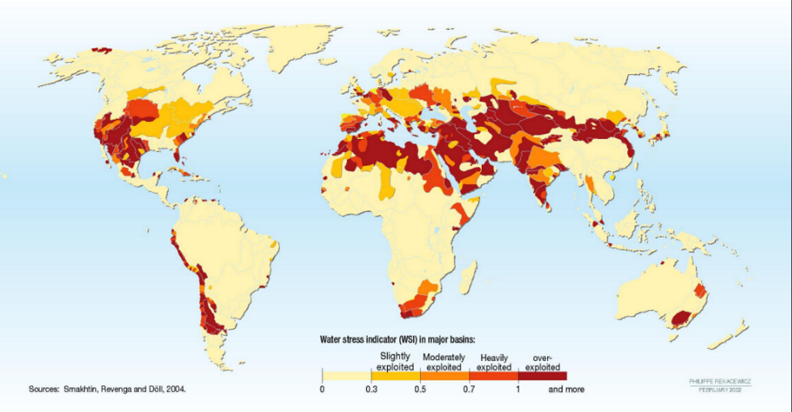According to the United Nations Environment Programme (UNEP), the water global supply is not distributed evenly around the planet, water usage has an enormous difference between developing countries and the develop ones

(Figure 1). Water overuse is affecting in a bigger scale, regions that heavily depend on irrigated agriculture. The difference is that some people in water-stressed areas have the technology and economic resources to oversee the issue. But the majority of the population in lower economic situations, can deal with a lack of water. Farmers and agriculture workers depend on this resource greatly. The entire world depends on reliable water sources, but the real problem with water scarcity is being deal by low income population. Developing countries use 90% of their water for agriculture while developed countries use 45% of their water for agriculture.

Figure 1Demonstrates the areas where water is being exploited in a higher rate

According to the United States Department of Agriculture (USDA) about 80% of the water in the U.S. is used for agriculture and irrigation systems, being this the highest consumer of water, especially in the northern states of the United States. The majority of the irrigation water goes mainly to the growth of grains and grasses that would later feed livestock. Livestock consumes another not so big percentage of water but when it is added together with the irrigation of grains and grasses it make a pretty big impact on how the U.S spends its gallons of water. From Image 1.1, a comparison was made on how much water and food is needed to feed men vs. cows.

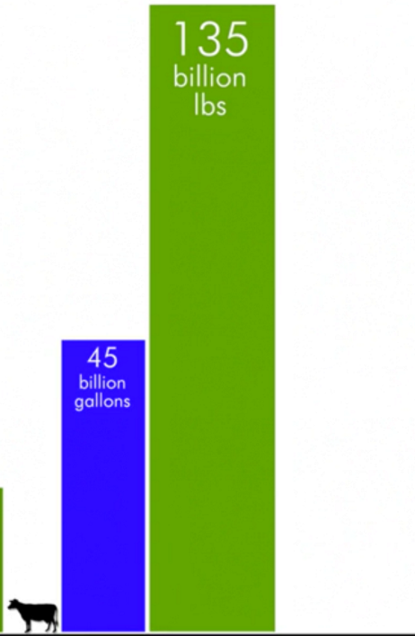

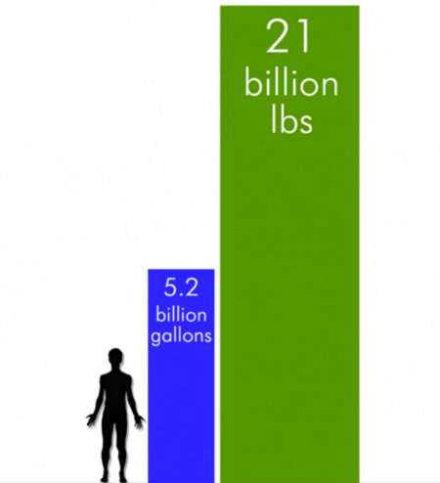

*Image 1.1*

According to the documentary Cowspiracy and the website of this same documentary, the global livestock population in the United States, that is known, which is approximately 1.5 billion cows require 45 million gallons of water per day and 135 billion pounds of food per day, when the whole population of 7 billion people in the world consume 5.2 billion gallons per day. This is not the end of the problem; cows require 135 billion pounds of food per day. This means much more water to irrigate the crops that would later feed the animals.

**How is Livestock Contributing to Climate Change and other Environmental Situations?**

Growing livestock is an underseen problem that needs a lot of attention. It does not just affect water sources, but the depletion of land affecting the rainforest in the amazon for example or forest land in the north; this is because in order to raise livestock large areas for farming are required. The land suffers for destruction of whole environments for more planting lands to produce aliment for livestock. According to [www.keepantibioticsworking.com](http://www.keepantibioticsworking.com) the waste that is produced by the animals is completely toxic since it contains a lot of antibiotics in most of the cases. In a great majority animals are raise in not hygienic places and under stressful circumstances which ends up sickening the animals, the easiest solution that farmers have found is to treat the animal with antibiotics which later on end up in the soil and water sources contaminating the environment.

Methane is a gas, is one of the most plentiful gases on earth. Composed of one molecule of carbon surrounded by four molecules of hydrogen. It is odorless, colorless and tasteless. It is a natural substance produce by living organisms. Methane is produced in environments with minimum oxygen by bacteria that consumes decomposing organic matter. The main human sources of methane are burning fossil fuels and livestock farming. Methane is the main component of natural gas and a lot of the methane emissions are caused by the extraction, processing and transportation of natural gas. Also methane is produced in livestock during the digestion process by cows and other ruminants. Other natural sources are wetlands; this is 78% of the natural emissions. The reason why methane levels are so important, is because methane is one of the most potent greenhouse gases. According to the Environmental Protection Agency (EPA), methane emissions are 16% of the greenhouse gases produced by man activities also methane is 20 times more effective at trapping in heat that carbon dioxide.

According to the co-authors of “Livestock and Climate Change” Robert Goodland and Jeff Anhang, half of the greenhouse gasses emissions caused by humans come from livestock. So it is not only affecting the soils, land and water but it is also contributing to global warming.

**What is greenhouse effect and global warming?**

According to the website, livescience.com (2016); 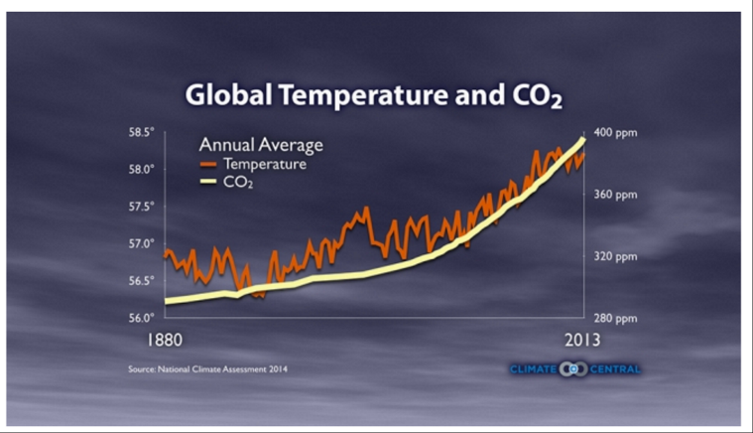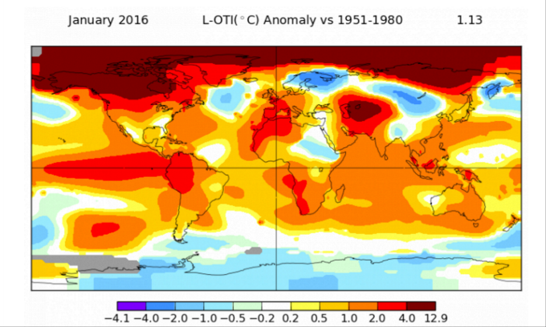Greenhouse effect is a natural cycle where the Earth absorbs energy from the sun and emits some energy back to space. The reason why it is only some is because carbon dioxide (CO2) and other greenhouse gasses absorb IR radiation in the atmosphere and prevent it to escaping into outer space completely. The result is the heating of the Earth’s atmosphere and surface. If this process didn’t exist, the Earth would be totally frozen or at extreme hot temperatures. This processes helps balance the temperature of the planet. The problem is when these gases block too much heat from escaping. There is some heat that is supposed to be sent to space but since these gases are blocking the heat, the temperatures rise in the Earth’s surface.

Credit to: NASA GISS

Figure This is a graphical expression of what this year February’s temperature looked like all around the globe, breaking temperature records.

Figure .1 The relationship between CO2 gases and temperature increase.

This happens primary because of burning fossil fuels, such as coal, oil and methane which release carbon dioxide to the atmosphere. Scientist and researchers have found a direct relationship between the production of greenhouse gas emissions and the rise of temperature. If greenhouse emissions continue to rise, the world’s temperature will follow. This is why it is so important to take action and set goals that would eventually lower the amounts presented in *Figure 3.1*.

**Conclusion**

From the investigation done, a conclution could be done by saying that in fact animal agriculture is affecting the environmental situation greatly. It has been proven that climate change and the water cycle are directly connected, and since the agriculture industry, more specifically livestock industry has a considerate effect on water sources and also in methane gas production, measures of levels of cunsumption must be taken into account. With a growing population, resources have to be well managed and thoughfully administated.There is so much to lose if it is not done.. There are many thing to be done not just by scientist or researchers but for everyone as a community.

**References**

Moss, Angela. R. (2000). *Methane Production by ruminants: Its contribution to global warming*

Eshel, G., Shepon, A., Makov, T., & Milo, R. (2014). *Land, irrigation water, greenhouse gas, and reactive nitrogen burdens of meat, eggs, and dairy production in the United States.*

Water Scarcity. (n.d.). Retrieved May 13, 2016, from http://www.worldwildlife.org/threats/water-scarcity

United States Environmental Protection Agency, Research and Development (2011). *Draft Plan to Study the Potential Impacts of Hydraulic Fracturing on Drinking Water Resources.* Retrieved from www.epa.gov

United States Environmental Protection Agency (2016). *Overview of Greenhouse Gases Retrieved from www.epa.gov*

Worldwatch Institute (2016).  *Livestock and Climate Change.* Retrieved from www.worldwatch.org

United States Department of Agriculture (2015). *Irrigation and Water Use.*

United Nations (2012) *Millennium Development Goals Report* Retrieve from www.un.org

Glaser, C., Romaniello C., Moskowitz Karyn (2015) *Cost and Consequences: The Real Price of Livestock Grazing on America's Public Lands pg. 8-11*

Jacobson, Michael F. (2006). *More and Cleaner Water. In Six Arguments for A Greener Diet: How a More Plant- based Diet Could save Your Health and the Environment. pg. 87 to 95*