

Latinitas and BorderSenses  
ENG 5318: Community Literacy Internship   
Submitted to Dr. Isabel Baca

Jasmine Villa

May 13, 2013

Table of Contents

Overview of internship and portfolio ………………..……….... 3

Critical reflection essay ………………………………..………. 4

Copy of contract for Latinitas ………………….……….……... 10

Copy of contract for BorderSenses ………………….….……... 14

Non-profit workshop document for Latinitas ……………….… 17

Non-profit workshop document for BorderSenses ……………. 18

Latinitas anthology …………………………………………….. 20

BorderSenses workspace ………………………………………. 21

Self-Evaluation ……………………………………………….... 22

Overview of Internship and Portfolio

For the Spring 2013 ENG 5318 course I opted to intern with two non-profit organizations: Latinitas and BorderSenses. As the Communications and Fundraising Assistant for Latinitas, my internship tasks were completed during my off-hours. To ensure my employment requirements and internship tasks did not clash, my agency mentor at Latinitas, Alicia Rascon, provided stellar mentorship and ensured my service-learning tasks were on track. To supplement my internship with Latinitas I opted to take on a second internship with BorderSenses – where I have been a volunteer with BorderSenses since February 2012. My agency mentor, Minerva Lavega, has provided me with the hands on experience I need toward becoming a successful grant researcher and writer. Both internships have assisted in my academic and personal growth. This portfolio includes copies of my original contracts, modified contracts, self-evaluation essay, critical reflection essay, drafts of documents used for an in-class peer-review workshop, and the final products for both internships.

Critical Reflection Essay

For the Spring 2013 ENG 5318 course I opted to intern with two non-profit organizations: Latinitas and BorderSenses. Both internships have assisted in my academic and personal growth and I have found a profound connection between my internship tasks and the readings for this course – I must note that I found a deeper connection with Latinitas than BorderSenses. The collaborative experience with both organizations has inspired me to continue working within the non-profit sector; however, it has also taught me that I need to be sterner or at least more proactive in voicing my concerns (I am too quiet). There were times when the Latinitas’ staff/internship boundaries overlapped, even though I made it explicitly clear in person and in the contract that they couldn’t overlap. I came across setbacks such as Latinitas being evicted while multiple events were occurring within 1-2 weeks from one another or receiving minimal feedback from Minerva for the BorderSenses workspace. Overall, this service-learning experience makes it explicitly clear that working within the non-profit sector is a risk, but a rewarding risk. I would like to dedicate my career toward working in the non-profit sector by focusing on community writing and civic engagement.

**Work produced for non-profits**

The tasks for both organizations varied. For BorderSenses I predominantly focused on researching grants and drafting a grant proposal. For Latinitas I oversaw the logistics of the Latinitas anthology. The following is a brief overview of my internship tasks for each organization:

Latinitas

I created a general outline of the book, started an on-going database of key prominent Latina writers (academia, prolific writers, etc.) whom could serve as potential networking contacts throughout the book process, and created a list of tentative local publishers in El Paso and Austin Texas, Latino publishers, and e-publishers. I also created templates for an outreach letter to send to potential contributors to the anthology and Latina authors; however, I did not include them in the portfolio because I have not received feedback. Due to the setbacks in April, I did not complete the template letters for donors and publishers. Additional completed tasks for the Latinitas internship included identifying and creating an on-going database of similar non-profit organizations with a youth writing focus that may serve as a potential contacts for obtaining content for the book, creating a tentative timeline/deadlines for this project, selecting potential articles that may serve as content for the book, submitting two drafts of the anthology to Alicia, and assisting with two writing workshops by securing guest spears, venue, and creating a total of 20 writing prompts and assisting. The Chicas Write Now conducted a mini-workshop during the Chica Art Fest on March 23rd and a lengthier workshop was successfully launched on April 20th at the Jose Cisneros Public Library.

BorderSenses

For BorderSenses, I oversaw the creation of a grant database by identifying and listing 35 new potential grant opportunities as well as identifying and listing previously received grants. The original contract stated I would identify and list 60 new grant opportunities, write at least one grant proposal and that a tentative timeline/calendar would be established; however, due to time constraints and technology problems these tasks will be completed during the summer.

**Connection between both internships and course readings**

The service-learning and community-based writing I conducted for both organizations emphasized the collaborative and team work components of service learning. The collaborative efforts in constructing the Latinitas anthology and the BorderSenses workspace have provided “important pedagogical approaches in the field of technical communication” (Alexander & Powell, 2012, p. 48). I would like to pursue a career within the non-profit sector and both organizations provided hands-on experience with collaborating with others to complete/advance a project. I normally dislike working with groups, but this experience was more fruitful because, unlike school projects, it was more professional.

Throughout my BorderSenses internship I had difficulty seeing the connection between my completed tasks and the field of rhetoric and writing studies. Unless I was working on a grant proposal, my tasks felt largely administrative since the workspace grew from a grant database to a fundraising database. Once I began to work more diligently on the grant proposal I was able to see a stronger connection with rhetoric and writing studies; however, as I reread the “Team Writing” I found the connection (team writing) I naively missed between BorderSenses, the course readings, and my graduate studies. In “Team Writing for the Community” Kara Poe Alexander and Beth Powell (2012) state the collaborative aspect is importance because it involves “writing for a real, concrete, audience, and, as such, give student-writers the opportunity to develop skills in rhetorical analysis, such as adapting a message to a given exigency or purpose” (p. 48). For BorderSenses I collaborated with Minerva, my agency mentor, and the administrative assistant toward creating an effective workspace and when I worked with them the workspace had a purpose. It seems that working individually was the detrimental part of the internship with BorderSenses. I was engaged/motivated more when I worked with others, as a team. Working in the non-profit sector is pure collaboration. I may have worked on individual tasks for both organizations, but I did collaborate with others. For Latinitas I collaborated with Editorial Interns and my agency mentor, Alicia Rascon, to breathe life into the Latinitas anthology.

Similar to the students from Alexander’s and Powell’s study (2012), I “learned many skills form the servicing-learning component, including greater audience awareness and writing, research, and teamwork skills” (p. 63). Audience awareness differed for both organizations; however, both internships provided opportunities to remove myself from the academic setting and apply what I have learned about intercultural rhetoric and audience awareness to community projects. For BorderSenses I had to model the workspace to fit the technology needs of Minerva and others. I had to keep the workspace simple and highly accessible. Adding a substantial amount of content to the workspace would have proved to be largely ineffective if the person whom would assist in managing the workspace would not be able to effectively use it. The Latinitas setting is challenging because audience awareness surpassed the writing component and relied on intercultural communication. Latinitas is the ideal place for acquiring hands on experience with writing for difference audiences in a single setting.

Tiffany Rousculp’s article “When the Community Writes: Re-envisioning the SLCC DiverseCity Writing Series” appealed to me because it embodied what I’m trying to do with Latinitas. From the workshops to the book, I’m working with multiple writing groups/individuals with diverse backgrounds. The book has numerous collaborations from different writers and it is “self-representation” of what it means to be a Latina. Most importantly, the Latinitas book is a representation of the “the words of the community … presented as is, not interpreted by another party” (390). I cannot review content based from a collegiate mindset or like an academic setting. The anthology is not a textbook and it is not my place to voice someone else’s opinion. The book is creating a third-space for Latina teens to not only publish their story, but to have their voice heard in an underrepresented field. These resilient Latinas will aid in transforming how Latinas are viewed due to content being obtained from a national level. I may not be contributing content to the book (writing a narrative) and my story will not be told, but I am part of a small group of people working together to empower Latina youth.

The adaptive methods used to fulfill the internship tasks for both organizations correlates with what Thomas Deans (2007) claims as both entities adopting “other’s social motives” (p. 458). I found this to be true in both of my internships. For BorderSenses I adopted the need to help provide an effective and organized tool (the workspace). For Latinitas I adopted the need to help enhance the Latina voice in literature. For BorderSenses I found this applicable as well, specifically in enforcing the activity theory and how I was placing the “location less in terms of *place* and more in terms of *activity*” (Deans, 2007, p.451). I did not include the draft of the grant proposal in my portfolio since it requires revision and feedback from Minerva, but, more importantly, I saw the grant proposal as an activity that I knew had to be done the right way and not as a task that needed to be completed in order to class requirement (place). I saw both of my internships as goal-driven activities and not so much as tasks that needed to be completed in order to achieve the A. My heart was in the activities and the tasks and I know I will continue working on my “internship tasks” during the summer.

**Connection with graduate studies**

In “Assessing Adaptive Transfer in Community-Based Writing,” Michael-John DePalma addresses six characteristics (dynamic, idiosyncratic, cross-contextual, rhetorical, multilingual, and transformative). I recognize the six characteristics taking place in both of my internships. My internship with BorderSenses focused on the dynamic, rhetorical and transformative characteristics. Researching and drafting a grant employed the aforementioned tools. On the other hand, the characteristics that are stronger are the rhetorical, idiosyncratic, and multilingual characteristics. The audience for the different project tasks for Latinitas changes with every document. If I am addressing teens, I have to fuse the rhetorical and multilingual characteristics. As a graduate student it can be challenging to write, let alone think, like a bubbly, enthusiastic, Latina teen; however, it is a mindset that has to be implemented when reviewing content and the writing prompts. The anthology itself is a mixture of multiple genres and, in the end, must be cohesive to represent the passage of discovery and self-identity. The themes, albeit different, within each chapter must coincide with the overall concept of identity. While it’s fairly easy to explain the task, the methods taking place behind each task requires an in-depth knowledge of rhetorical inventions that I’ve learned throughout my studies as a Masters student.

Learning Experience  
 I have used portions from my progress report within this assignment to emphasize the academic growth I have experienced with both organizations. Honestly, the personal growth I have experienced outweighs the academic experience. I have been provide with outstanding opportunities to make a difference in the community and I am eternally grateful to have Latinitas and BorderSenses by my side.

Copy of Contract: Latinitas

**Community Writing Contract**

**The University of Texas at El Paso**

This contract must be signed by the student and the agency mentor, then reviewed and approved by the instructor. All three parties must have a copy.

**Organization:**  Latinitas

**Mailing Address:** 1359 Lomaland Suite #502  
 El Paso, TX 79935  
**Agency Mentor:** Alicia Rascon  
 (915) 219- 8554 E-mail: [latinitasaly@yahoo.com](mailto:latinitasaly@yahoo.com)   
**Student:** Jasmine Villa   
 (915)820-6545 E-mail: [jasmine.villa@gmail.com](mailto:jasmine.villa@gmail.com)   
**Instructor:** Dr. Isabel Baca

(915) 747-6245 E-mail: [ibaca@utep.edu](mailto:ibaca@utep.edu)   
**Course:** English 5318, Community Literacy Internship

**Term:** Spring 2013

**Internship dates:** February 11th – April 19th, 2013

**Student intern will do the following:**

* Student intern will oversee the logistics of the book by:
  + Creating a general outline of the book; including, but not limited to, gathering suggestions from additional collaborators for the title of the book, chapters for the book, content, themes, artwork, etc.
  + Creating an on-going database of key prominent Latina writers (academia, prolific writers, etc.) whom could serve as potential networking contacts throughout the book process (submitting content, promoting the book, etc.). An example of a key Latina writer is someone in academia or whose literary works have made a difference in the community, like Norma Cantu. Student intern will not contact the writers or establish a networking connection with said writers.
  + Creating a list of tentative local publishers, Latino publishers, and e-publishers. Student intern will not contact said publishers.
  + Creating templates for an outreach letter to send to potential Latina authors, contributors, publishers, and donors – a total of four templates. The student intern will not send these templates to the authors, contributors, publishers or donors.
  + Creating a tentative fundraising plan to publish the book. This includes, but is not limited to, creating a tentative kickstarter campaign, generating a grant, sponsor or donor list. Student intern understands this sponsorships database will be updated throughout the internship. Student intern will not apply to any fundraising opportunities.
  + Identifying and creating an on-gong database of similar non-profit organizations with a youth writing focus that may serve as potential contacts for obtaining content for the book.
  + Creating tentative timeline/deadlines for the book. This includes and is not limited to the content submission period, contacting authors, fundraising endeavors, and for publication purposes. Student intern understands the deadlines are tentative and may change throughout the internship as the book progresses.
  + Create tentative timeline/deadlines for the book. This includes and is not limited to: submission period, contacting authors, securing authors, fundraising, and for publication purposes.
  + Selecting potential articles that may serve as content for the book from Latinitasmagazine.com, MyLatinitas.com, and user submitted articles received by Latinitas. Student intern understands content submitted will need final approval form the Agency Mentor, Alicia Rascon.
  + Submitting 2-3 drafts of the book to the Agency Mentor, Alicia Rasocn.
* Assist with two writing workshops (March and April) by helping the writing workshop leader. Student intern agrees to:
  + Secure a venue for writing workshops.
  + Secure 1-2 guest speakers and partners per writing workshop.
  + Create a minimum of 20 writing prompts, for youth between the ages 10-15, to be used during the workshops and/or future workshops.

**Student intern agrees to:**

* Separate tasks from the duties required from the internship and the Communications and Fundraising Assistant staff position.
* Collaborate with additional interns and Latinitas staff to further advance the book’s progress. Credit will be given to those involved when submitting and presenting materials regarding the internship to classmates and instructor of the ENG 5318 course and/or student intern’s peers.
* Assist with additional tasks as long as they do not conflict with the deadlines for the current projects or are relevant to service-learning, literacy, rhetoric, and writing studies with the student intern’s qualifications and time schedule.
* Provide up-to date progress reports and time sheets every meeting period. Student and Agency Mentor, Alicia Rascon, will meet twice a week for thirty minutes on Tuesday and Thursday, between 10am-6pm, to discuss the progress of the projects. Student intern will stay an extra hour once a week in order to avoid a time conflict with the internship and staff position.
* Continue her involvement with the book, pro-bono, at the end of the internship and will dissolve the “student intern will not do” section.

**Tentative Calendar (Submitted in February)** [1]

February:

* Outline book by chapters/themes
* Secure venue for April workshop
* Secure speaker for workshop (March & April)
* Create list of local publishers, Latino publishers, and e-publishers
* Create template for an outreach letter to send to potential Latina authors, contributors, publishers, and donors
* Theme/very rough draft of the book (outline)
* Create 10 writing prompts/lessons
* Establish a submission period (March 1st – 31st).

March

* Identify similar organizations that may serve as potential contacts for content, contributions, or publicity
* Select potential book content from the magazine, MyLatinitas, and send to potential YEAB contacts
* Second draft of the book/modify original outline; start adding content to the book
* Establish a layout
* Create 10 writing prompts/lessons
* Identify similar organizations that may serve as potential contacts for content, contributions, or publicity

April:

* Create and establish a fundraising plan with deadlines
* Research potential donors
* Third draft of the book; book should already have content and submissions should begin to be submitted.

Copy of Contract: BorderSenses

**Community Writing Contract**

**The University of Texas at El Paso**

This contract must be signed by the student and the agency mentor, then reviewed and approved by the instructor. All three parties must have a copy.

**Organization:** BorderSenses

**Mailing Address:** 1500 Texas Ave.  
 El Paso, TX 7981  
**Agency Mentor:** Minerva Lavega  
 (915) 861-4767 E-mail: [minerva@bordersenses.com](mailto:latinitasaly@yahoo.com)   
**Student:** Jasmine Villa   
 (915) 820-6545 E-mail: [jasmine.villa@gmail.com](mailto:jasmine.villa@gmail.com)   
**Instructor:** Dr. Isabel Baca

(915) 747-6245 E-mail: [ibaca@utep.edu](mailto:ibaca@utep.edu)   
**Course:** English 5318, Community Literacy Internship

**Term:** Spring 2013

**Internship dates:** February 11th – April 19th, 2013

**Student intern will do the following:**

* Create a grant database for BorderSenses and will write 1-3 grant proposals that will be evaluated by a professional grant writer from BorderSenses. The grant database will consist of, but is not limited to:
  + Identifying and listing previously received grants, year received, and categorizing which grants are eligible to reapply.
  + Identifying and listing a minimum of 60 new potential grant opportunities.
  + Creating a tentative timeline and calendar towards applying to grants. Student intern understands the calendar and deadlines are tentative and may change throughout the internship.
  + Collaborating with BorderSenses staff and volunteers to ensure the grant database is up to date.

**Student intern agrees to:**

* Collaborate with BorderSenses volunteers and staff to further advance the grant database’s progress. Credit will be given to those involved when submitting and

**Tentative Calendar**[2]

February:

* Submit draft of the grant for the Regional Touring Program (RTP) on February 25th.
* Submit 5-6 grants per week to the grant database.
* First draft of the grant database is due on February 25th.

March:

* Submit 5-6 grants per week to the grant database.
* Submit 1 grant proposal.

April:

* Submit 5-6 grants per week to the grant database.
* Submit 1 grant proposal.

Non-Profit Workshop Document: Latinitas

This section includes the workshop document I brought to the peer-review session. Consuelo Salas and Claudia Santiago offered feedback on the outline of the book. Consuelo offered substantial feedback on the writing prompts. They provided positive feedback on the draft of the book. Unfortunately, I had brought 2 articles for this peer-review session.

Non-Profit Workshop Document: BorderSenses

This section includes the workshop document I brought to the peer-review session. Consuelo Salas and Claudia Santiago offered feedback on the workspace. They both recommended I be more specific with how the front-page is worded. They provided positive feedback on the template I used for the grants; however, it was the organization of the front-page that I needed assistance and they helped me modify it. Fig. 1 and Fig. 2 are the screen shots I took after the peer-review session. During the peer-review session I had the workspace open for them.

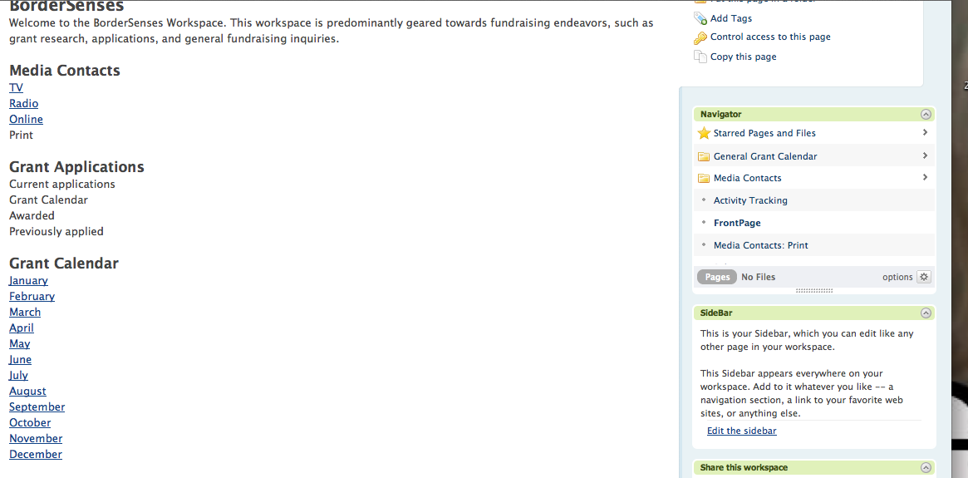

Fig. 1

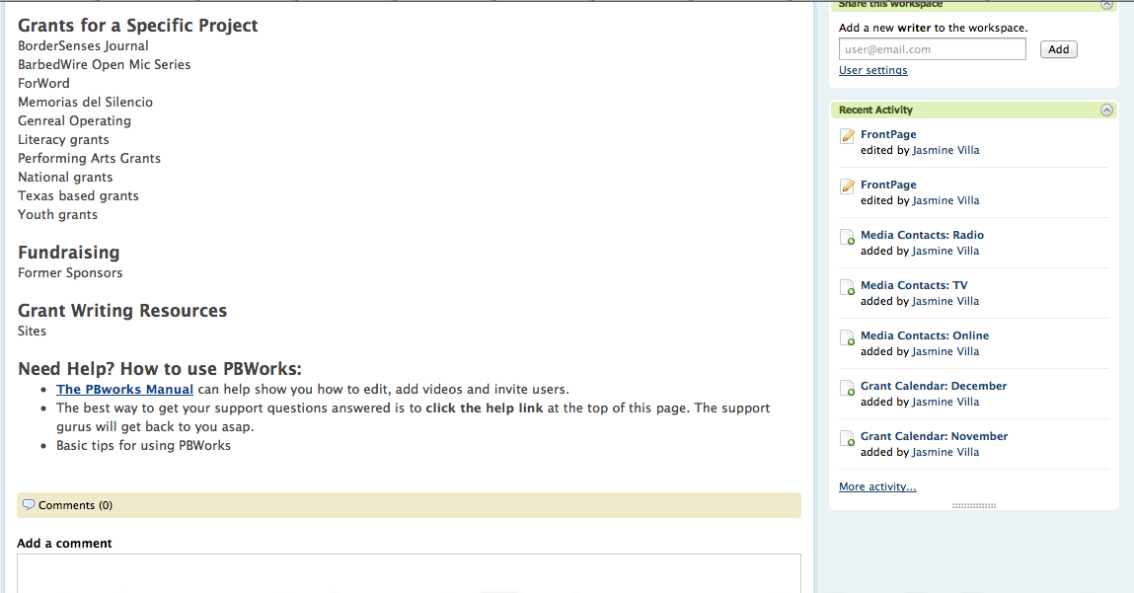

Fig. 2

End-Product: Latinitas Anthology

This section includes the final product of the Latinitas anthology. The documents in this section have received feedback and have been approved by Alicia Rascon, my agency mentor. This section also includes an updated calendar.

End-Product: BorderSenses Workspace

This section includes the final product of the BorderSenses workspace. The documents in this section have received feedback and have been approved by Minerva Lavega, my agency mentor. This section also includes an updated calendar.

When I gave my final presentation for my internships, Dr. Baca mentioned quality vs quantity and how as long as your heart is in it we should not feel bad if we had to modify our contracts. This stuck with me and my feelings of feeling like a failure were replaced with pride. Unlike my fellow students I juggled two internships. I have not expressed this in class or to my fellow classmates, but I honestly did not feel pride for doing two internships. I knew that’s what I wanted to do and I viewed it as it not being a big deal. I was doing something that I love doing and did not see it as an opportunity to excel/outshine my fellow classmates.

Self-Evaluation

**Thoughts on service-learning**

I may have been overzealous with asking to complete two internships and I occasionally felt that I had dug myself in a hole. In the beginning of the semester I wanted to obtain additional opportunities to transfer what I am learning in school to the organizations I work with. I wound up learning more than I expected and have thoroughly enjoyed this class and the readings. I may not have actively participated online, but it did not mean that I neglected the readings. I found it interesting how a portion of the readings correlated with a good chunk of the readings I had to do for my intercultural rhetoric course. Now that the semester has come to an end, I can confidently say that I have a newfound appreciation for service learning. I am definitely on board with this, since I am using my education to learn skills that I can apply in both my career and in the community because I believe “what’s the point of learning if I can’t transfer my skills towards constructing something positive in my community”. I don’t expect all composition scholars to think this way and don’t expect for them to follow in the same suit. For me, this class strengthened the need to establish a bridge between academia and the community. It was surprising to see a new level of passion for civic engagement. Aside from my enthusiasm for the class content, I do believe that I excelled with my internship duties and did not disappoint my agency mentors with the final product.

**Internships**  
 The majority of my internship tasks for Latinitas were completed, with the exception of the outreach templates. I did not feel right submitting something that has not received feedback as a final product for the internship. The tasks for BorderSenses were partially completed. I did not complete the 60 new grants and instead found 35 grants. I did work on a grant proposal, but did not feel comfortable submitting it as a “final” product for this internship. Despite these setbacks, I excelled in my other internship tasks and have provided a final product that satisfied both agency mentors. I plan on completing the tasks I did not complete during this internship and will continue to collaborate with both organizations. The workspace is in its infancy stage and I am looking forward to   
 The Latinitas anthology is the project I am most proud of. The purpose of the book is to enable Latina youth to have a voice and I am honored to assist in creating this third-space in literature where Hispanics are underrepresented. For the writing prompts, I had to address serious issues, yet the language and how it’s worded had to be concise, engaging, and relatable to teens. This was really difficult and I accepted the challenge Since the age group for the anthology expanded, I had to find a middle ground between teens and the older crowd. I am confident that the anthology and the work I have conducted will bring some type of transformation or social change to the organization and I honored to be a part of this project.   
 Overall, I enjoyed taking this course and believe that I did really well with everything that I had to complete. Was it perfect? No, but it’s a learning experience and I will be transferring what I have learned about service learning to future volunteers whom are completing service learning requirements with Latinitas. I mention Latinitas the most in my portfolio and in this evaluation because, even though I did learn a lot from BorderSenses, I found Latinitas to be the foundation of my personal and academic growth both in and outside of this internship.

**\* I kindly ask that my self-evaluation to not be posted online or in publications.**

1. Highlighted items in the contract are incomplete and have been removed with the approval of Alicia. The task will be completed during the summer. I had a tentative contributors and authors template, but it has not received feedback; therefore, I am not including it in the portfolio.
2. Highlighted items in the contract have been modified with the approval of Minerva and Dr. Isabel Baca. The task will be completed during the summer. I was only able to complete 35 grants instead of 60.