Jennifer Falcon

CEPCO, Ceci P. Herrera

1 May 2016



For the Spring 2013 ENG 5318 course I opted to intern with two non-profit organizations: Latinitas and BorderSenses. As the Communications and Fundraising Assistant for Latinitas, my internship tasks were completed during my off-hours. To ensure my employment requirements and internship tasks did not clash, my agency mentor at Latinitas, Alicia Rascon, provided stellar mentorship and ensured my service-learning tasks were on track. To supplement my internship with Latinitas I opted to take on a second internship with BorderSenses. I have been a volunteer with BorderSenses since February 2012 where I assisted with the event logistics for the Librotraficante event taking place in March. My agency mentor, Minerva Lavega, has provided me with the hands on experience I need toward becoming a successful grant researcher and writer.

Both internships have assisted in my academic and personal growth. I have documented the progress of both internships in a singular chronological order. Copies of e-mails will be labeled as a,b, or c corresponding the page number for the journal entry. For example, Journal #2 is on page 4 then e-mail will be labeled as 4a, 4b, etc. Since I worked off-site for both internships, the methods of communication differed. For Latinitas I predominantly met with Alicia in person to discuss the progress of the book and tasks; however, I relayed the progress of the workspace to Minerva via e-mail. Even though I am fulfilling two separate internship contracts, the Latinitas internship will be the main internship I would need to fulfill and BorderSenses will be extra content

**Journal #1: February 11, 2013  
Time: 15 minutes**

Today officially marks the first day of both internships. I will be meeting with Minerva Lavega, my BorderSenses agency mentor, on February 22nd to finalize my internship contract. My contract has been approved and signed by Alicia Rascon for my Latinitas internship.

**Reflection:**

I’m excited to start this internship! I look forward to seeing what I can learn as a grant writer and researcher. I’ve had previous experience creating a workspace for writers for Latinitas and it has proven to be a valuable tool. I hope Minerva is pleased with the results. I’m more comfortable working with Latinitas and I sincerely hope my internship does not pose a problem with my regular tasks. I have faith that the boundaries will be respected, but in case they

**Question:** Am I doing myself a disservice by not branching out to a different non-profit organization? Does this reflect negatively on my comfort zone?

**Journal #2: February 14, 2013**

**Time: 2 hours  
Latinitas:** Today I met with my agency mentor for Latinitas, Alicia, to discuss the writing workshop. Laura Werthmann joined and we discussed potential names for the workshops, and for additional direction on the type of writing prompts that are needed. Our top names for the workshops are Chicas Write, Literary Chicas, Literary Divas, Literary Queens and Wordweavers. I researched potential writing assignments and discussed the parameters of the book with Alicia. A tentative blog-a-thon for Women’s History Month was discussed. She asked that I work on writing prompts to see what we can use for the blog-a-thon and the anthology. The following are the parameters of the book:

**Themes:** Identity and self-discovery

**Chapter Ideas:**

- Sense of duty, responsibility, help the next generation; first person in family to go to college, part of their motivation is seeing others go to college (family members) - Being ashamed of their culture; self-discovery as they grow older. Being a teenager and coming into the “real world”.  - Role models: wanting to volunteer and make a difference; who their role models are.

- Cultural celebrations; language (Spanish; Spanglish).

- Immigration/Transition

- Poetry

- Cultural/Borderland Identities

**Page length:** 100-150

** Book is multimodal **

* First page: Dedicated to all young women who know what it is to feel lost, and then find themselves through writing.
* Second page:Insert a quote: “If there’s a book that you want to read, but it hasn’t been written yet, then you must write it.” -- Toni Morrison (note: do we need permission to post this?)
* **Introduction:**
  + Written by Laura D. and Alicia
  + 3 to 5 pages about the book, Latinitas (our mission), and why we’re publishing.
  + How is identity defined/shaped.
* Chapter 1: Introduced with a quote and followed by a short contribution from a Latina writer.
* Chapter 1 Content: War within (conflict: who am I?) (use creative title)
* Chapter 2: Introduced with a quote and followed by a short contribution from a Latina writer.
* Chapter 2 Content: Role of family and education in shaping identity (use creative title)
* Chapter 3: Introduced with a quote and followed by a short contribution from a Latina writer.
* Chapter 3 Content: Cultural heritage; what does it mean to be a Latina ( use creative title)
* Chapter 4: Introduced with a quote and followed by a short contribution from a Latina writer.
* Chapter 4 Content: Self-discovery and acceptance (use creative title)

**NOTE:** This is a tentative outline; chapters will be expanded once content is submitted.

**Chapter Content/Format:**

1. Only select a certain number of content from the age group over 21. Focus more on teen submissions.

2. Design contest for the book (pending).

3. 5 articles minimum per topic.

4. Start the description of writing prompt like this (tentative): Think of a specific time in your life when  _______; turn THAT into a story. Describe how you want others to see your story; make your voice come to life.

5. Personal narrative; We’re not accepting short stories, but the prompt can be answered in a hybrid format (poem/narrative/use code-switching).  6. Use poetry and artwork to separate lengthy pieces or writing level discrepancies.

7. Content must be a maximum of 4 pages.

Since I arrived an hour early last week and an hour early today, the time does not conflict with my employment tasks.

**Reflection:**

I was somewhat worried that my internship boundaries are not being respected. I calmly reminded Alicia about the parameters of my internship. I hope the writing workshop is a success. Alicia wound up selecting the name “Chicas Write Now” workshop with a potential subheading of “Literary Fiesta”. It’s somewhat difficult to make writing fun for teens, but I accept this challenge! Hopefully this will be another venue to obtain content for the book. We discussed the lack of a Latina voice within non-fiction literature for at least 30 minutes, which was refreshing and reignites my passion toward publishing this book. Since February of last year, I’m starting to enjoy coordinating writing programs more so than writing itself.

**Journal #3: February 20, 2013**

**Time: 5 hours**

**Latinitas:** Today I researched and contacted several of the El Paso Public Library branches for the writing workshop in March and April. Unfortunately, many of the preferred locations in the Eastide/Central were booked for March, or had only one-hour slots open. I also worked on a tentative calendar for the Latinitas internship.

**BorderSenses:** Minerva asked if I would work on a Regional Touring Grant on February 20th and I agreed on February 21st to work on the grant. We are meeting on February 22nd to finalize my contract and to further discuss this grant. The e-mail concerning the grant has been attached at the end of Journal #3. I also worked on a tentative calendar for the BorderSenses internship. I researched grant opportunities, but I came up short and was able to find at least 10 potential grants. I bookmarked the grants and will transfer the information to the form at a later date. Many of the grants that I am finding are regionally specific. I need to brush up on my grant research skills.

**Reflection:**

The calendars were attached separately to each contract; however, in order to save trees, a single tentative calendar has been attached (see below). The depth of both contracts is somewhat overwhelming. I’ve been working on drafting the grant for BorderSenses, but I keep rewriting what I have written. I am not satisfied with it, but I will continue to work on it. I know that Minerva will be there to assist me in case a problem with the grant arises. The grant seems somewhat daunting, but I’ll accept the challenge.

**The following is a tentative calendar for both internships:**

**February**

**Latinitas:**

* Outline book by chapters/themes
* Secure venue for April workshop
* Secure speaker for workshop (March & April)
* Create list of local publishers, Latino publishers, and e-publishers
* Create template for an outreach letter to send to potential Latina authors, contributors, publishers, and donors
* Theme/very rough draft of the book (outline)
* Create 10 writing prompts/lessons
* Establish a submission period (March 1st – 31st).

**BorderSenses:**

* Submit draft of the grant for the Regional Touring Program (RTP) on February 25th.
* Submit 5-6 grants per week to the grant database.
* First draft of the grant database is due on February 25th.

**March**

**Latinitas:**

* Identify similar organizations that may serve as potential contacts for content, contributions, or publicity
* Select potential book content from the magazine, MyLatinitas, and send to potential YEAB contacts
* Second draft of the book/modify original outline; start adding content to the book
* Establish a layout
* Create 10 writing prompts/lessons
* Identify similar organizations that may serve as potential contacts for content, contributions, or publicity

**BorderSenses:**

* Submit 5-6 grants per week to the grant database.
* Submit 1 grant proposal.

**April**  
**Latinitas:**

* Create and establish a fundraising plan with deadlines
* Research potential donors
* Third draft of the book; book should already have content and submissions should begin to be submitted.

**BorderSenses:**

* Submit 5-6 grants per week to the grant database.
* Submit 1 grant proposal.

**Journal #4: February 22, 2013**

**Time: 1 and half hour**

**BorderSenses:** Today I met with Minerva to discuss my contract at a BorderSenses staff meeting. Minerva approved the contract and we both agreed to change the deadline of the grant to April instead of February, since the deadline for the RTP grant is in September.

**Reflection:**

Minerva has been very helpful and supportive of the projects for this internship. I look forward to establishing a grant tool that will benefit this organization. From my previous involvement with BorderSenses, it is very disorganized. I hope that this will “add” some order, at least in the fundraising area. The workspace is meant to predominantly deal with grants; however, I have a feeling that it will turn into a useful administrative tool.

**Journal #5: February 24, 2013**

**Time: 2 hours**

**Latinitas:** I focused on identifying and listing local publishers, Latino publishers, and e-publishers for the book. I also began researching writing prompts and submitted 5 to Alicia that would be useful for the blog-a-thon in March (March 11th- 15th) and for the Latnitas anthology. I found at least 15 potential publishers, but the following Latino publishing companies seem like a perfect fit for the Latinitas anthology:

a. Piñata Books: <http://www.latinoteca.com/arte-publico-press/pinata-books>  
 b. Cinco Puntos Press: <http://www.cincopuntos.com/submissions.sstg>

**Reflection:**

The publishing route the book is taking is unclear at this point. I found an interesting article (http://latino.foxnews.com/latino/opinion/2012/12/14/not-enough-hispanic-authors-books-due-to-publishing-industry/) about Latinos and the publishing industry. It gives me hope that our book WILL get published.

**Question:** Is it lucrative to research publishing companies this early in the process, even though a draft of the book has not been completed? I should consider revisiting the publishers during the summer in order to update the list.

**Journal #6: February 28th - March 3, 2013**

**Time: 1 hour**

**Latinitas**: Aside from communicating with Monica Gomez and Kristal Oblinger and securing them as guest speakers for the Chicas Write Now workshop, I did not work on additional internship tasks. Monica was a tentative guest speaker for the March 23rd workshop; however, it was deemed more beneficial to have her as a guest speaker for the April 20th workshop. Instead, Krystal from Free Hole slam will offer a mini-slam poetry lesson during our Chica Art Fest on March 23rd, from 11pm -12 pm. I don’t have an in-depth reflection of the process of securing her as a speaker; however, I find one of my Black Board discussions for this week to embody my internship experience thus far. Therefore, I found it pertinent to include it in the journal as my reflection portion for today.

**Reflection:**

The Higgins/Long/Flower put forth a four-part model, which appeared mostly in the drafting of the contract, from my end, and not the negotiation itself or within the contract timeframe. Both agency mentors have known me for over a year and I was already familiar with what they specifically needed and drafted what I wanted to do, based on my previous and recent interactions with them, rather than speak with them. For example, the new BorderSenses journal and Memorias del Silencio will be published soon and would require funding. Their ForWord Workshop and Barbed Wired Open Mic Series requires funding as well. Funding is their top concern at the moment and I saw/ this as an opportunity to alleviate the time constraints (the staff is very small) they face.  I’ve been helping them with grant research (sporadically), but I figured it would be more beneficial to have their own grant database. The negotiation itself was more of an explanation of what I wanted to do and she approved it right away, didn’t need to negotiate it, really.  The only part I had to negotiate was how my volunteer duties would be different from the internship duties.

For Latinitas, the project itself arose by accident (in December) after I suggested an idea. I honestly thought it wouldn’t be given much thought since we were having a very basic conversation about literature. The idea turned into the core of the internship project, drafted the responsibilities, and my agency mentor agreed on the contract-- again, not much negotiating from my end. I know the four-part model is somewhat present, but it’s not in a linear or formal fashion and it definitely did not take place within the time frame of the contract negotiation.

This experience so far has inspired me to continue working within the non-profit sector; however, it’s also taught me that I need to be more stern or at least more proactive on ensuring the contract/the boundaries are respected. There are times when the Latinitas’ staff/internship boundaries overlap, even though I made it explicitly clear in person and in the contract that they couldn’t overlap. The deadlines are not as concrete as I would like them to be, but that’s manageable. It’s a learning experience and the issues are being worked out

**Journal #7: March 10, 2013**

**Time: 8 hours**

**Latinitas:** I drafted templates of the outreach letters for contributors, donors, and authors. I have also started working on writing prompts and have completed 15 potential writing prompts for the book that can be implemented in the Chicas Write Now workshop or in an after-school club. I will review them with Laura Werthmann this upcoming week. This is a sample of the writing prompts that I’ve completed:

1. The smell of mamá’s cooking and abuelita’s abrazos can cause a heart to swell with joy. How has another Latina influences your life (personal, education, etc.)?

2. How has your family influenced your decision-making, goals, and personality? Would you be where you are today? Focus on one experience that involved your family and caused an impact (ether negatively or positively).

3. Are you proud of your Hispanic heritage?

4. What makes a Latina a “Latina”?

5. How has your heritage affected/influenced your decision-making (negatively or positively)?

6. How has the media impacted your view of your own culture?

7. How have you been discriminated against as a Latina, minority or person of color, and how did you overcome it?

8. Do you feel like you are accepted?

9. What experiences have you shaped you who you are today?

10. Did your barrio influence your outlook on life and goals?

I have also began browsing MyLatinitas.com and Latinitasmagazine.com for content that can be potentially used for the anthology. Additionally, I’ve drafted a tentative outline of the book.

**BorderSenses:** I identified and listed 5 grants for the workspace. I transferred the information from the previously bookmarked grants to the grant form. I have also contacted Minerva and provided an update on the progress of the internship. The e-mail correspondence is attached at the end of Journal #7. I created an account with PBWorks, formatted the front page, and began adding content to the workspace. Fig. 1 and Fig. 2 are screen shots of the first draft. Fig. 1 is the top section and Fig. 2 is what is seen when the user scrolls down the page.

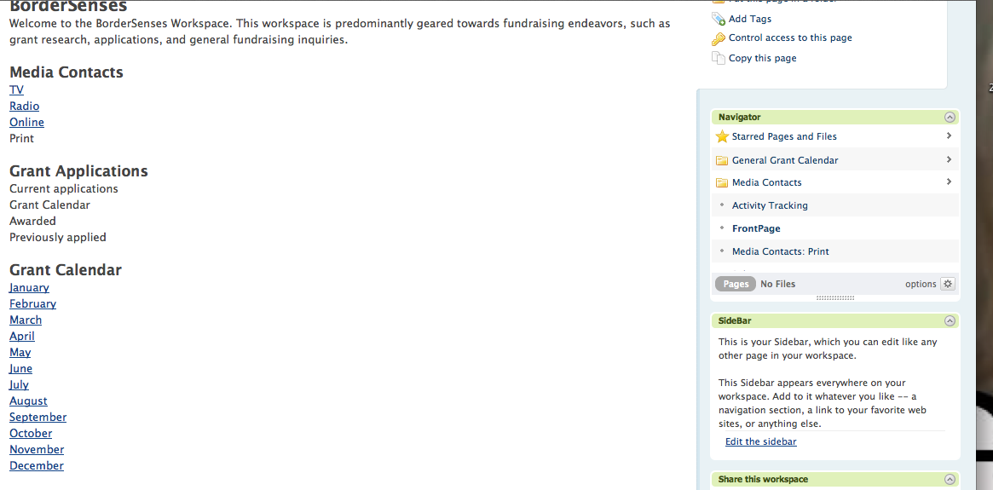

**Fig. 1**

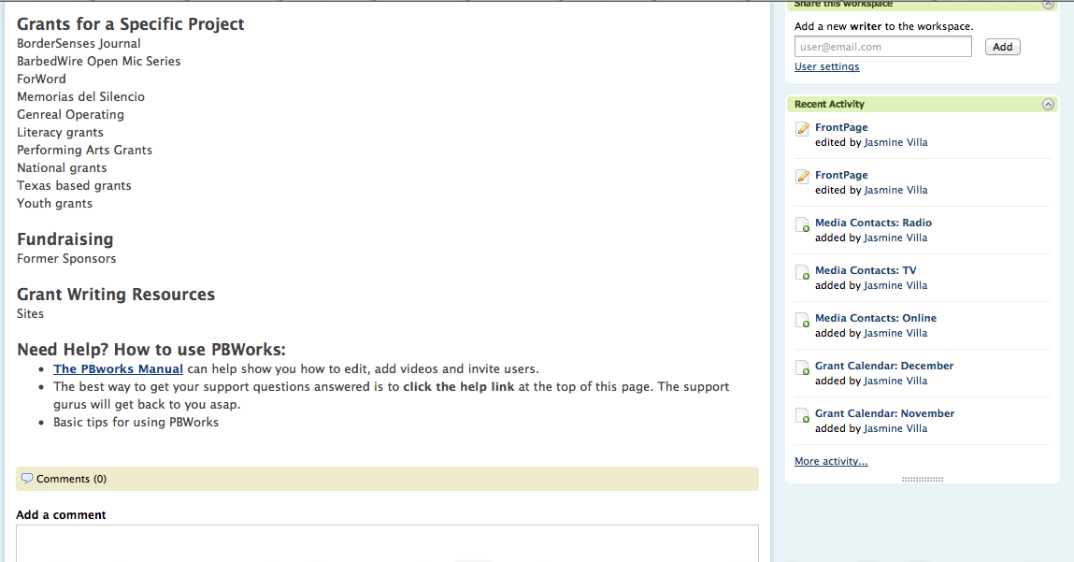

**Fig. 2**

**Reflection:**   
I used portions of available templates that pertain to the organization’s mission and need. I will not work on a draft for publishing companies, since each proposal is different. I’m hesitant on continuing to work on the outreach letters, since the anthology is still in its infancy stage. From the outreach letters, it’s imperative to be aware of the audience. The outreach letter toward potential authors is very upbeat and light-hearted, while the donor letter has a slight academic tone.

**Journal #8: March 12, 2013**

**Time: 2 hours**

**Latinitas:** Latinitas won the SXSW Revolucionario award; therefore, Alicia will not be available this week. I met with Laura and we discussed writing topics. Since we both pulled information from each other, it’s difficult to list, which prompts are mine and which are hers. The prompts and outline created on March 10th have been modified and are a hybrid from her ideas and mine; thus, it is a collaborative endeavor and I am unable to take full-credit for the creation of this portion of the internship project.  
 As previously mentioned, a social media campaign is being utilized to increase venues for potential anthology content or to create networking opportunities. Alicia finalized the content for the social media campaign over the weekend. The following social-media campaign is a hybrid and potential source toward obtaining content for the magazine:

**SOCIAL MEDIA CAMPAIGN:**

**-Monday (FACEBOOK) March 11:** Change your status to what being female means to you or fill in the blank with (I’m proud to be a woman because_________.” Share your status on our latinitas yeab Facebook group.

**-Tuesday (TWITTER) March 12:** Tweet about who is your favorite female role model (use a hashtag #latinitas)-tweet why you are proud to be a woman #latinitas-tweet what advice you would give to younger females (or a younger version of yourself?) #latinitas

**-Wednesday (PINTEREST)** March 13: Post a picture of yourself holding an empowering message for others on pinterest (use latinitas in the description) & upload to mylatinitas [http://mylatinitas.com/photo](http://www.facebook.com/l.php?u=http%3A%2F%2Fmylatinitas.com%2Fphoto&h=uAQFXHyH_&s=1)

**-Thursday (VIDEOS ON MYLATINITAS) March 14:** Post a vlog or video on your thoughts about girl power, female role models, women's issues or why you are proud to be a woman on mylatinitas. OR share an inspirational video you've come across and post it on mylatinitas. [http://mylatinitas.com/video](http://www.facebook.com/l.php?u=http%3A%2F%2Fmylatinitas.com%2Fvideo&h=qAQE_GN8K&s=1)

**-Friday (TWITTER) March 15:** Tell us who is your favorite female blogger. Use hashtag #FF and #latinitas AND Tweet links to your social media from earlier in the week

**Content pulled from Twitter or photos posted to MyLatinitas can potentially be added as epigraphs for the anthology or to enhance the multimodal nature of the book.**

Reflection:

**Journal #10: March 14, 2013**

**Time: 3 hours**

**Bordersenses:** I received feedback for the draft of the BorderSenses website. Minerva seems pleased. I have also updated the workspace based on the feedback by adding the MCAD and Ford Foundation grants. I researched grants and have identified and listed 5 potential grants.

**Reflection:**

The workspace is off to a great start! I’m still motivated to keep searching for additional grants; however, the workspace is starting to feel tedious and the search is becoming frustrating. I may have had an idealistic view of grant writing.

**Journal #11: March 19, 2013**

**Time: 1 hour**

**Latinitas** I received feedback on the writing prompts, outline, and tentative draft of the book. Feedback I received from Alicia is to expand the age group from 15 to under the age of 22 for the writing prompts, and to revise the calendar. One of the calendar changes is the content submission date. The original content submission period was March 1st – March 31st; however, a Women’s Month social media campaign, blog-a-thon, and a current writing contest from Austin and Texas State University have pushed the date to submit content to mid to late April.The main area of concern for the writing prompts is the age of our writers. For example, a lesson being taught at Club Latinitas (an after-school enrichment program at local public libraries and Housing Authorities) differs from one being taught at a writing workshop.

**Reflection:**

Latinitas is the ideal place for acquiring hands on experience with writing for difference audiences in a single setting. As a graduate student it can be challenging to write, let alone think, like a bubbly, enthusiastic, Latina teen; however, it is a mindset that has to be implemented when reviewing content and the writing prompts. I thought I had a clear understanding of their audience, but I still have a lot to learn.

**Journal #12: March 23rd**

**Time: 2 hours**

**Latinitas:** On March 23th, Latinitas hosted a poetry-writing workshop with guest speaker Krystal Oblinger from Free Hole Slam from 12pm-1pm at the Union Plaza. The workshop took place during the Chica Art Fest. In collaboration with the Mujeres de la Tierra, Girl Scouts and the Downtown Artist Market, Latinitas hosted a Women’s History Month Art Fest celebration. This art festival was promoted as the Chica Art Fest. As part of my internship requirement, I assisted Krystal with the lesson by grouping the girls and handing out supplies. She gave a soulful poetry performance, taught the girls how to breathe while performing, described a poetry slam and the lack of women in the filed, and provided an extended metaphor workshop. The workshop was fairly small due to the low turnout because of the ridiculous and tumultuous windy weather; however, the four teens at the workshop wrote a poem and read their poem aloud. This “mini-poetry slam” was enthusiastic and the girls were enthralled with the lesson – Krystal is a natural teacher! I networked with Krystal and she is a tentative speaker for the Chicas Write Now workshop taking place on April 20th (10 am – 1pm) at the Jose Cisneros Public Library.

**Reflection:**The poetry session was invigorating, but it was disheartening to see a low-turn out. Alicia offered feedback on marketing tips for the next workshop. Even though my internship clearly stated that I would not participate in the PR and Marketing of the workshop, the marketing tasks were added to my employment tasks.

**Journal #13: March 26th – 27th, 2013**

**Time: 10 minutes**

**Latinitas:** Alicia asked to contact Ysella Ayn Fulton and forwarded her contact information to me (see attached e-mail at the end of Journal #11 on March 26th. I followed up on May 27th (see attached e-mail at the end of Journal #13).

**Reflection:**

I hope she responds soon!

**Question**: If Ysella and Papagayo do not answer, should they be contacted for future presentations?

**Journal #14: April 2nd – April 3rd 2013**

**Time: 10 minutes**

**BorderSenses:** Provided Minerva an update on the worskspace and asked who should be added to the workspace once it’s complete (see attached e-mail at the end of Journal #14).

**Reflection:**

The feedback I have been receiving from Minerva is very minimal. I seem to be the one who follows up rather than the other-way around.

**Question**:

**Journal #15: April 4th, 2013**

**Time: 5 hours and 10 minutes**

**Latinitas (10 minutes):** Alicia asked to contact local high school counselors and English teachers to promote the Chicas Write Now workshop. Even though this is not part of my internship, I’ve helped expand the list of local contacts that can potentially be contacted during the submission period (see attached e-mail at the end of Journal #15). Alicia also sent the Chicas Write Now flier to use during the promotional process. I also met with Alicia to finalize the agenda for the Chicas Write Now workshop, including what materials are needed and assigning leading/assisting tasks.

**BorderSenses (5 hours):** Identified and listed 20 grants. I was lucky enough to find a single site that listed numerous Arts, culture, and youth development grants.

**Reflection:**

Promotion and marketing is out of my comfort zone for the Chicas Write Now workshop. I am a more comfortable contacting an individual via e-mail instead of calling them. The promotional aspect is gearing toward calling, which is something I am not pleased with at the moment.

**Journal #16: April 8th  - April 10th, 2013**

**Time: 10 minutes**

I scheduled a meeting with Dr. Isabel Baca regarding my internship with BorderSenses on April 8th (see attached e-mail at the end of Journal Entry #16). I met with Dr. Baca on April 10th.

**Reflection:**

I was relieved to hear that my BorderSenses internship will be seen as extra and the focus will predominantly lie on Latinitas.

**Journal #17: April 16h  2013**

**Time: 7 hours**

I identified and bookmarked 25 grants to meet the 60 grant criteria. I contacted Minerva to update her on the workspace, as well as to notify her of the April 22nd deadline. I will finish the grant workspace on April 22nd.

**Reflection:**

Grant research is a tedious and frustrating process.   
Question: Ask Minerva about future programs to expand the grant search.

**Journal #18: April 16h  2013**

**Time: 7 hours**

**BorderSenses:** I identified and bookmarked 25 grants to meet the 60 grant criteria. I contacted Minerva to update her on the workspace, as well as to notify her of the April 22nd deadline. I will finish the grant workspace on April 22nd.

**Latinitas:** I have added 3 additional articles to the book. The book has 15 potential articles at the moment. I have created a tentative fundraising calendar for the book, but it is waiting revision/feedback from Alicia. Also, the anthology was introduced to the Latinitas Youth Editorial Advisory Board.

**Reflection:**

Grant research is a tedious and frustrating process.   
**Question:** Ask Minerva about future programs to expand the grant search.

**Journal #19: April 20h  2013**

**Time: 3 hours**

**Latinitas:** In this wordweavers’ writing workshop, local teen girls ages 13 -19 were invited to speak out and unleash their creativity through the pen. This monthly workshop series is aimed at literary divas who would like to gain writing skills, connect with literary leaders and have the opportunity for their work to get published in LatinitasMagazine.org as well a printed anthology. On April 20th, the Chicas Write Now launched its first workshop. Attendees had a behind-the-scenes of the editing process of a magazine article, received writing tips toward unleashing their inner literary strengths, and wrote an op-ed piece on what being a Latina means to them. Monica Gomez, member of the El Paso Writer’s League, published author, and award-winning performing singer/song writer, taught a creative writing lesson to take the attendee’s writing to another level. Chicas Write Now will host the next monthly workshop on May 18th from 11 am – 1pm at Jose Cisneros Public Library. I led the behind-the-scenes look of the magazine by offering editing tips.

**Reflection:**

Unfortunately, only one teen attended. Despite my hard driven efforts to promote the workshop, only one teen attended. We had more volunteers at the writing workshop than participants.

**Question:** What were our weak promotional strategies?

**Journal #20: April 22nd – April 30th, 2013**

**Time: 3 hours**

**Bordersenses:** Finalizing workspace and encountered errors, see attached e-mail at the end of Journal #20 for explanation. I have attached my final correspondence concerning (see attached e-mail at the end of Journal #20), the workspace and how I will proceed once the internship ends.

**Reflection:**

It’s really frustrating and infuriating; this is taking me back to step one!

**As of April 30th, due to the allotted time, the following items will be completed after the internship deadline:**

**Items that will be completed after internship is over with Latinitas:**

* Third draft of the book; book should already have content and submission periods will be solidified in the summer.
* Finalize fundraising calendar/kickstarter project.

**Items that will be completed after internship is over with BorderSenses:**

* Submit draft of the grant for the Regional Touring Program (RTP) in April
* Identify and upload 20 grants.
* Create the grant calendar

**Final Reflection:**

Service learning is a fickle process, specifically if one is working within a non-profit sector. Throughout my internships, I’ve experienced setbacks and, at times, felt “unprofessional” or as if I did not “live up” to both of my agency mentors’ expectations. I did not express these concerns with my agency mentors, since I am my worst critic and these were temporary melodramatic moments.

The scope of both projects required additional in-depth collaboration with both agencies, but I made the naïve mistake of taking on too much and did not fully recover when setbacks occurred. This was evident in the BorderSenses workspace when I had the saved tab mishap. Research I conducted in March was lost due to a glitch stemming from technology. While this process was frustrating, after speaking with Baca I felt relived that the content for BorderSenses would be seen as extra.

Aside from the BorderSenses setback, one major problem that arose in April was Latinitas being evicted from the office building. Given less than a month’s notice, it was difficult to take the book to the next level since the focus of the organization dealt with 1. Making the annual Girl Power Fest a success, 2. Finding an office and packing before the 30th and 3. Making the Butterfly Effect Fundraiser a success. When inquiring about feedback I had to choose between the book and the editorial tasks. I often chose the editorial route because when you’re prioritizing tasks that need immediate attention, the book could wait but the editorial tasks could not. To me this sounds like an excuse I am making for myself, perhaps I should have been more cognizant with time management; however, one of the things I’ve learned from volunteering and working within the non-profit sector is the importance of prioritizing and how, at times, this may lead to tasks or people falling between the cracks. In the end, I know that I did my best and will continue to work on my internships projects after the end of the semester.