**Table of Contents**

Overview of internship and portfolio ………………..……….... 3

Copy of contract for CEPCO …….…………….……….……... .4

Copy of CEPCO Brochure…………………..……………….… .7

Copy of Border Immersion Program Brochure …………..……. .8

Reflection Journal …………………………………………..... 9

Evaluation ……………………………………………………..... 28

**Overview of Internship and Portfolio**

In English 5318 I chose to do intern at the Central El Paso Community Organization (CEPCO). My agency mentor was Ceci P. Herrera, and the internship projects included redesigning, revising, and editing two brochures. One brochure was for CEPCO, and the other for the Border Immersion Program, which is a program that is part of the Cristo Rey Lutheran Church. This church also provides financial assistance to CEPCO. Overall I feel proud of the brochure I composed for CEPCO, because I know that my agency mentor was pleased with it, and it meets the needs of both the organization and my mentor. I am unsure of how the Border Immersion Program was received due to the illness of Pastor Rose Mary. I feel it is my fault that this project was not completed because I chose to work on the CEPCO brochure first. It required more editing, and when I was just about finished with it I redesigned it because it was not quite what my agency mentor wanted. I informed Ceci that I will be available in the future to continue working with them in order to complete the Border Immersion Program Brochure, and to make any changes to the CEPCO brochure should they be needed. At this point I am most excited to volunteer at CEPCO in the future, and continue helping them in any way I can. This was exactly the type of experience I was hoping to have so that I can be more involved in the El Paso community.

**Journal #1: January 27, 2016**

Today the class will meet representatives from several nonprofit agencies. I’m looking forward to listening to the different agency mentors, and learning about their organizations. This is important to me not just because I need to find an agency for my internship, but because I’m not originally from El Paso. I moved here in August of 2011, and while so much of my life exists here I don’t feel connected to the city in any way. My entire experience here revolves around UTEP, which is understandable because I work at UTEP, and take classes at UTEP, but I want to be more connected to the community of El Paso, and not just the university.

I’m nervous about not finding an organization that is a good fit for me. What types of things should I be thinking about when I select an internship?

**Journal #2: January 27, 2016**

The agency presentations went well. There were a lot of interesting organizations and its obvious that they do great work, but I found myself gravitating towards the Central El Paso Community Organization (CEPCO). I spoke with Pastor Rose Mary and Ceci. Ceci runs the After School Program at Cristo Rey church, which is run by Pastor Rose Mary. Pastor Rose Mary also runs a Border Immersion Program. These are two separate programs that seek an intern to work on several projects. These projects include brochures, website, and produce a video. This seems like a lot of work, but there is another student that is interested in this organization and I think between the two of us we would be able to complete all of the projects they mentioned during our first meeting. We spent about ten minutes talking to Ceci and Pastor Rose Mary, but I think that this is the nonprofit I’m going to choose. I want something that will help me build stronger ties to the community.

**Journal Entry #3 February 1, 2016**

Based on the first meeting with CEPCO I decided that I will work with CEPCO, and after talking to Michael he will also be working there. We are both interested in working on the video. I think he has more experience with composing a video than I do, but I’m hopeful that we can work on it together and give Pastor Rose Mary the type of informational video she wants and needs. We were told we could contact them by sending an email to the email address on the back of the Border Immersion Program brochure. I sent an email to Lianette to set up a meeting to discuss the projects and internship in more detail. She was listed on the brochure as a contact person, but both Michael and I were very confused about who is receiving this email. We spoke to Pastor Rose Mary and Ceci, and were told to contact Pastor Rose Mary by emailing the address on the back of the brochure, but that doesn’t appear to be Pastor Rose Mary’s email address. For now we have decided to wait for a reply and go from there, because this isn’t quite how we expected this to go.

**Journal #4 February 3, 2016**

As expected I did not contact the correct person about the internship. Luckily Lianette forwarded the email to Ceci and we have set up a meeting for February 9th. Ceci appears to be very excited that both Michael and I will work with CEPCO and Pastor Rose Mary.

**Journal #5** Meeting with Michael 2/5

Today I met with Michael to discuss the contract. We haven’t met with our agency mentor yet, but we do have a general ideal of the types of projects we might be working on for CEPCO. We put together a very rough draft of our contract. It is more of an outline at this point, but we don’t meet with Dr. Baca until 2/10. It’s a quick turn around for us. We meet with Ceci and Pastor Rose Mary on 2/9, and then with Dr. Baca on 2/10, but I think that we can put this together in that amount of time. It won’t be easy, but coordinating schedules and setting up meetings may cause some problems for us in the future.

**Journal #6 February 9, 2016** First meeting at Cristo Rey

I just now finished the first meeting with Ceci and now it’s clear how each program functions. Cristo Rey is a Lutheran Church. Through the church CEPCO and the Border Immersion Program exist as programs that are financially supported by the church. I took notes while we spoke to them. I’ve attached some of the bullet points here. These bullet points include information about the Border Immersion program, and some of the projects we discussed that will be part of our contract.

**Border Immersion Program**

* groups from universities and partner churches (youth groups, etc.), 4 days to 1 week,
* Goal - have groups learn about immigration, legal process, immigration stories about process (testimonials), answer questions about current political statements, current laws, immigrate stereotypes, address the issues and comments so groups can understand the truth and form a more informed opinion
* Presentation from border patrol
* Visiting detention center, enunciation house (shelter for immigrants), asylum seekers, who qualifies for a visa, unincorporated areas of Texas (can’t go to Juarez anymore), Colonias visit

**Video**

Promotional video 🡪 5-7 min, 10? 15?

* Use for presentations, put on the website,
* Intended audience 🡪 formal/informal introduction, send to partner churches and groups,
* Interviews and testimonials included
* Opportunity to join some of the events

**Website**

* Update contact information, need access to website, photos (by group), set up Word doc with website update information, remove ads if possible (cost, etc.), basic tutorial information,

**Brochure (2 or 3?)**

* More professional, not as simple, update CEPCO and After School Program brochure, update Border Immersion brochure (images, color, etc.),

**Contact Information**

Ceci P. Herrera as agency mentor (915) 779-6023 (contact information in email) [cecipherrera@aol.com](mailto:cecipherrera@aol.com)

Border immersion

Rose Mary Sanchez-Guzman (915) 422-6545 (mobile) [borderimmersion@gmail.com](mailto:borderimmersion@gmail.com) Lianette Pappaterra (862) 432-3092 (mobile)

**Journal #7 February 15, 2016** Revisions

Michael and I sent our contract to Dr. Baca via email. We have a few revisions to make. Most of the revisions are reminiscent of one of our readings. In “Establishing Community Partnerships and Purposeful Project Goals” by Crystal S. Aschenbrener (2015) writes that it is beneficial “when a service-learning project is focused on a set of specific goals rather than a set number of hours, it can create many more beneficial opportunities for both the nonprofit organization and the student” (p. 165). The feedback we received about our contract pushed us to be more specific about our goals, which reminded me of this article because I will not be working at CEPCO. I am working remotely, which means I will mostly be on my own, so the contract needs to be as specific and clear as possible not just so that I know my goals, but so that my agency mentor is aware of the parameters that we are both working within. Now that we revised our contract we will wait for Dr. Baca to approve it, or suggest more revisions before we can sign it and have our agency mentor sign it.

**Journal #8 February 24, 2016**

Our contract was approved, has been signed and submitted to Dr. Baca. Now it’s time to begin working on the projects. After discussing the best way to complete the projects and do so at the level and quality desired by Pastor Rose Mary and Ceci.

Michael will take the lead on the video, which means he will attend the meetings, and visit the Colonias with the student groups. Based on the schedule of events it doesn’t appear as if I will be able to tag along. Since I won’t be able to help him film we’ve agreed that I’ll help him in other ways. This week I sent Michael consent a consent form so that he will have documentation that the participants in the video agreed to be shown in the video, and in photos for the brochure. I think it’s important to have this type of documentation so I was glad to be able to help Michael put a consent form together.

For my projects, which are the brochures, I have started to do some research on brochures and different programs I can use to create one. I don’t want to use Photoshop because I’m not familiar with using that program to create a brochure using different templates. I can’t say that I am thrilled with the design and overall look of these templates, but I decided that it is best I use something in Word or PowerPoint. I feel it is important that they brochures be in a format that can be easily updated or revised in the future. The only way this can be done is if they are made in a program that Ceci or Pastor Rose Mary are familiar with, and that has created some design limitations for me.

**Journal #9** Spring Break

This week I’m on spring break, which allows me more time to research programs available for me to use, or templates that are specific to Word and PowerPoint. I found two templates that I think will work. The CEPCO brochure in white is plain, and I can’t say that I’m thrilled with the design right now. I know that I can edit it later by adding a background color, so it’s not a main concern right now. I do like the template I found to use for the Border Immersion Program brochure. I have added one picture to see how it will fit, and it looks good enough to print.

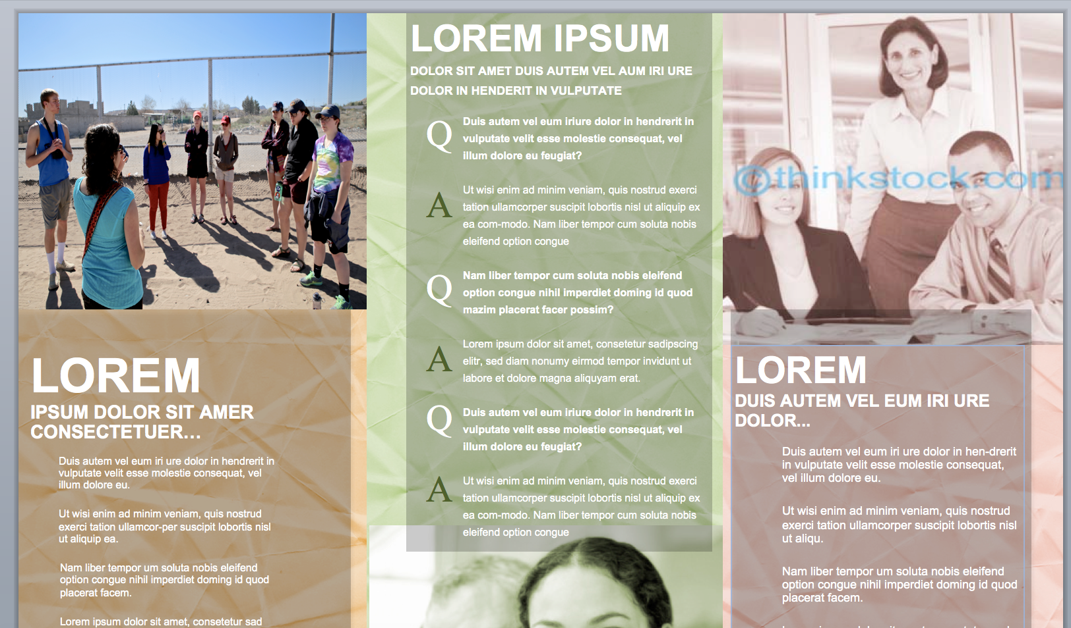

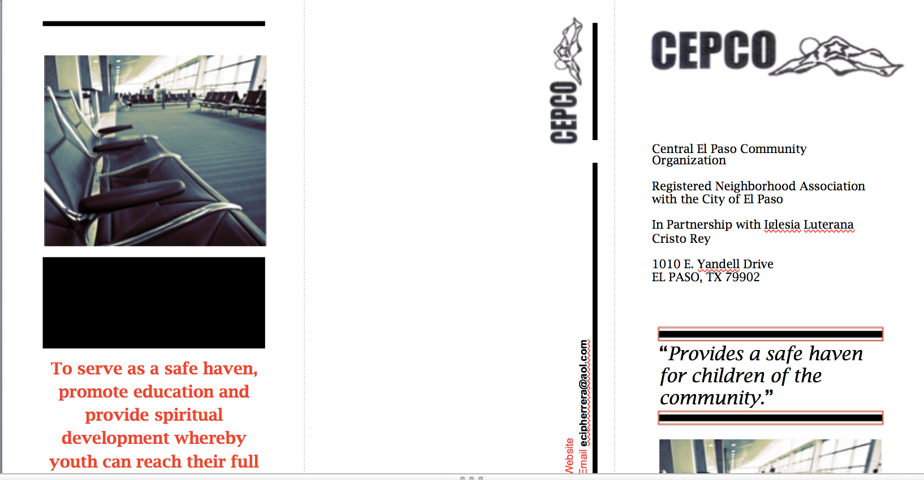

**Journal #10** 3/24 Meeting with Ceci

Since the spring break I have continued to work on the brochures. I was having a hard time working on both at the same time, so I decided to focus on the CEPCO brochure because it required more revisions than the BIP brochure. I emailed Ceci to set up a meeting to discuss the current draft, and the text. The CEPCO brochure that she distributes is very heavy on text, and does not contain pictures. I’m unsure of what text to remove, and what is most important. Now that I’m making more progress with the brochure I need to talk to Ceci to collaborate on the brochure and what information can be removed. I made notes of the areas I think are repetitive, and which parts contain information about the organization that seem to be highlighting the mission and goals of CEPCO. The issue for me is how to capture the essence of CEPCO, and why it exists without ever working there. I’m wondering if spending time working there would have made this part easier. She has emailed me the CEPCO logo, and will send me pictures to add to the brochure.

**Journal #11 March 29, 2016**

Ceci emailed me the pictures. They appear to be of good quality, and will work for the brochure. I’m feeling very lucky that she quickly responds to my emails and that communication with her is easy. I enjoy talking to her about the brochure, and CECPO in general. She’s very passionate about the organization, and that makes me happy to be able to help her in some small way.

**Journal #12 March 30, 2016** Oral Presentation

Today in class we gave oral presentations about the current status of our internship projects. It felt more like a progress report than a presentation, which was helpful because I was a bit nervous. I have not completed as much as I hoped I would have by this point in the semester. I’m not concerned about finishing on time, because I’ve met with Ceci and we continue to exchange emails about the brochure. The BIP brochure requires less work so I know I can finish that one quickly. I have a general sense of where Michael is with the video. I know that he has put together a rough cut. I watched it and gave him some suggestions as an audience member. He seems to be moving along with his projects. We will complete everything on time. My biggest concern is giving agency mentor what they want/need

**Journal #13 April 13, 2016** Class Discussion

Today in class we gave a brief update on where we are with our projects. I discussed with Dr. Baca, and the class that I think some of what I talk about with Ceci gets lost in translation. I’m not sure that when I mention design and layout that she understands what I am talking about. She seems to be happy with the layout of the brochure, and how I have broken up the text to make it easier to read, but I’m not sure that what I say is fully understood. We’ve talked recently about the general layout and why I chose the one I did so that it can be updated more easily in the future. That conversation has led me to the conclusion that when we discuss design, and the layout of the brochure we may not be talking about the same thing. I think Ceci views the brochure as just a text document, when there is so much more going into my thought process.

I recall an assigned reading about meeting community needs and the importance of successful communication. Perhaps because I am approaching this from a different angle than my agency mentor we are not as successful in communicating about the project in regards to writing and arranging it. I’m going to have make a note of this for the critical reflection.

**Journal #14 April 15, 2016**

The internship ends today and I have completed two brochures, but have yet to set up a meeting with both Ceci and Pastor Rose Mary to review the documents. I found a program that I could use for free as a student that allowed me to create a more professional and visually appealing brochure. I emailed Ceci and will meet with her on 4/19. I think she will be pleased with the new design. It looks more professional than the Word Doc version, and I know the main goal was to have something that looked nice and contained the information that was most important.

I included some screen shots of the new brochures.

Pastor Rose Mary has been ill and so I have not been able to meet with her. I have designed the brochure, and transferred the text from the previous brochure without her input. The goal of this project was to update and revise the brochure. I am hopeful that she likes the design, and my arrangement of information. Michael was helpful in providing me with pictures he took while he was filming the student groups, and emailing me the Border Immersion Program logos. Since it is difficult to communicate with Pastor Rose Mary his help has made it easier for me to continue with this project.

**Border Immersion Brochure** – Still need to add text to a few sections. The new pictures were taken provided by Michael, and I used a few from the website.

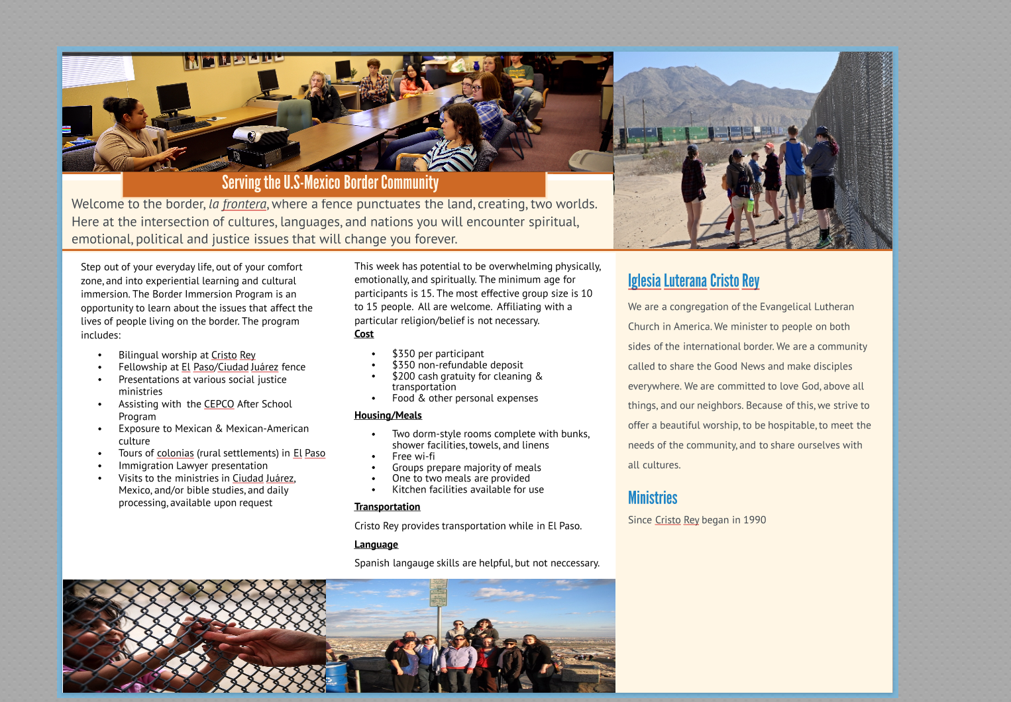

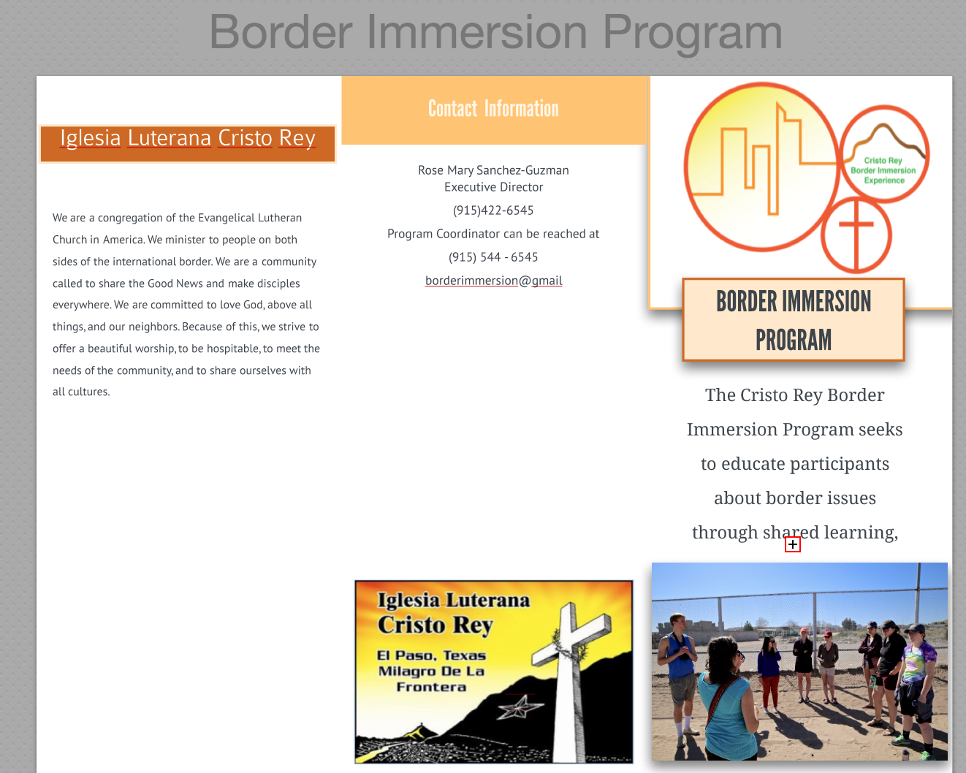

**Journal #15** **April 19, 2016 Meeting with Ceci**

Ceci likes the brochure. I am so relieved. She is very happy with the new design, and has given me a few suggestions for revisions. The revisions are minor and are mostly related to word choice. The choice of words is important because the About Us section needs to be clear and concise. As she hands the brochure out to potential volunteers and/or donors her intended audience must be able to read the brochure be fully informed about what it is CEPCO does, and why. I suggested to Ceci that we use pictures that don’t look as similar to each other as the ones currently in the brochure. She agreed to email me pictures not taken on the same day to add a little variety to the brochure. Originally there was talk of completing three brochures, one for CEPCO, the CEPCO After School Program, and the Border Immersion Program, but Ceci has informed me that two will be fine for now.

Pastor Rose Mary has not returned to Cristo Rey. She is recovering at home, and Ceci suggested I email her the draft of the BIP brochure. I will do this later today, and hope for feedback, but I am prepared to not hear from her as she recovers from surgery.

**Journal #16 April 20, 2016** New Pictures

Ceci emailed pictures. She also directed me to a section I did not revise yet. I’m glad she is looking over these as carefully as she is, because I’ve been looking at the document for so long that I am concerned I’ll miss the small details. The pictures she sent me helped to make the brochure look more professional. I’m very pleased with the finished product, and am relieved to know that she feels the same.

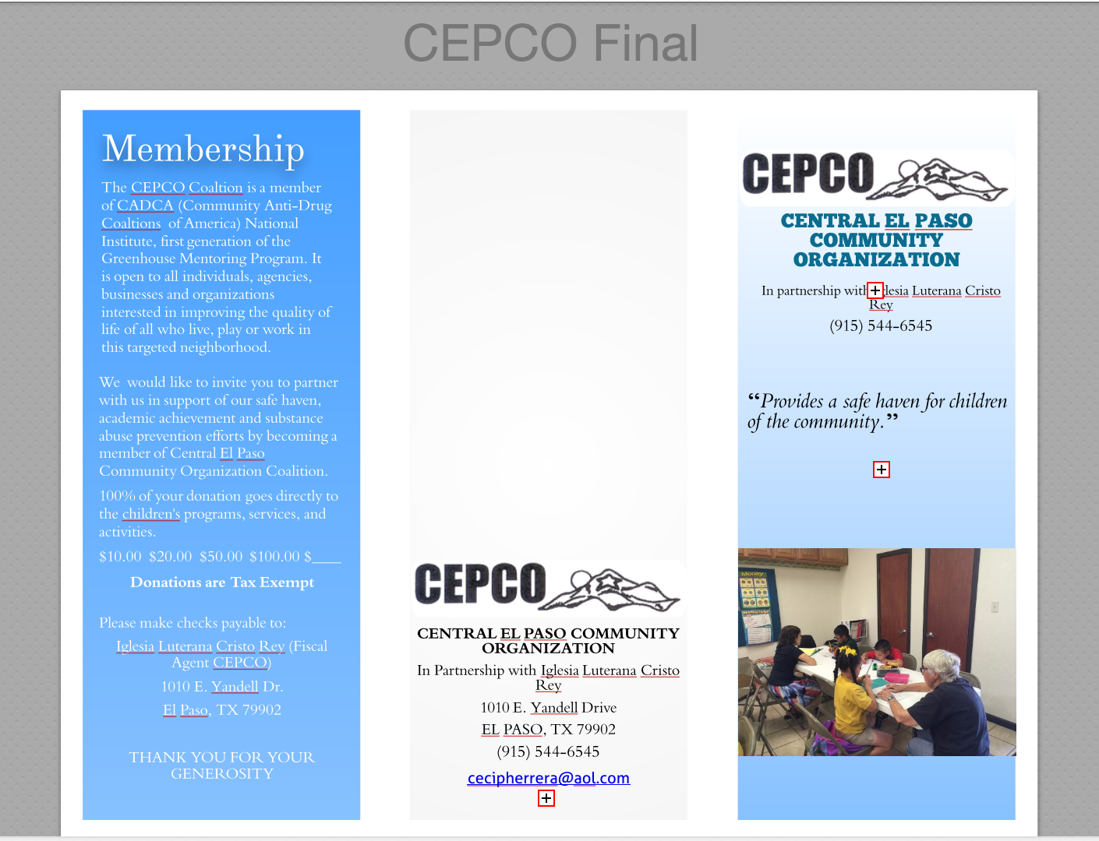

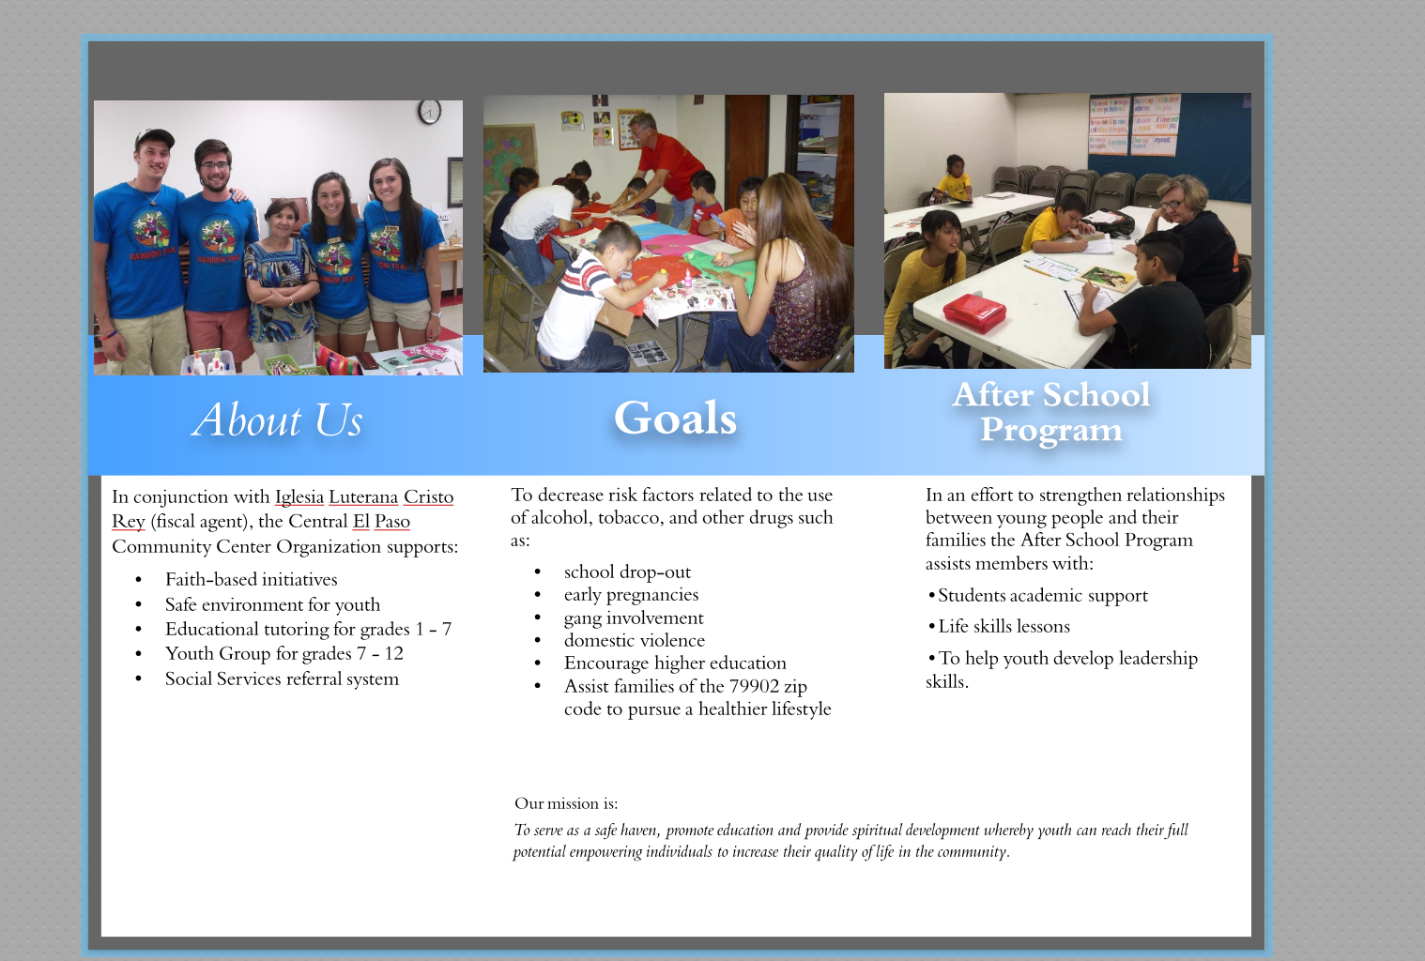

**Journal #17 April 26, 2016** Email about Student Evaluation

Today I emailed the student evaluation form to Ceci. She expressed interest in attending our presentation on 5/2. I hope she can attend so that the class can learn more about CEPCO. She has also emailed me a few small text revisions. I like that she continues to go over the brochure. This puts me at ease because I know she will receive the brochure that she wants, and throughout my internship I was concerned about providing her with the document that best suited her needs.

**Journal #18 April 27, 20016** Final Brochure Draft

I emailed Ceci to let her know that I made all of the revisions she suggested. She will try and attend our presentation. I will bring a few color copies to class to show what I did, and to include in my portfolio. The internship is now over, and between Michael and I we completed all but one of the projects in our contract. The only project not completed is the Border Immersion Program brochure. It is about 85% complete. At this point it needs suggestions for revisions from Pastor Rose Mary. I included the majority of the text from the previous brochure. I condensed a few sections, and removed text that was redundant. I think to complete it I may need to use a few different pictures, and edit text based on the preferences of Pastor Rose Mary. I’m looking forward to meeting with her when she is fully recovered to finish the brochure.