Health Sciences
YOUR FINAL PROJECT TEAM INFO HERE
Final Project team member names, Module, name, credits, etc. here.
Please keep our logo and website in place.
YOUR FINAL PROJECT TEAM INFO HERE
Final Project team member names, Module, name, credits, etc. here.
Please keep our logo and website in place.

Micrsoft Word® template tips were used as a guide line for this document.
The health sciences concentration is intended for students seeking admission into professional programs in medicine, dentistry, physical therapy, or occupational therapy. It provides students the opportunity to learn health education content and methods while completing specified science prerequisites.
Physical Activity/Exercise
The physical activity/exercise concentration is designed for students with interest in physiological and programmatic aspects of exercise, nutrition, fitness, and physical activity.
The school health concentration is intended for students interested in teaching health education within a public or private school setting. Upon completion of their bachelor’s degree, they are eligible to apply to the fifth year Graduate Teacher Education Program (GTEP) in the Graduate School of Education at PSU. After completion of GTEP, they will be certified to teach in the state of Oregon.
In addition to meeting the general University degree requirements, students earning a B.A./B.S. degree in health studies must successfully complete:
- The common degree requirements
- One of the four concentration areas, from which a plan of study is developed with an academic adviser

Division of Public
Administration
Master of Public Administration

Mark O. Hatfield School of Government

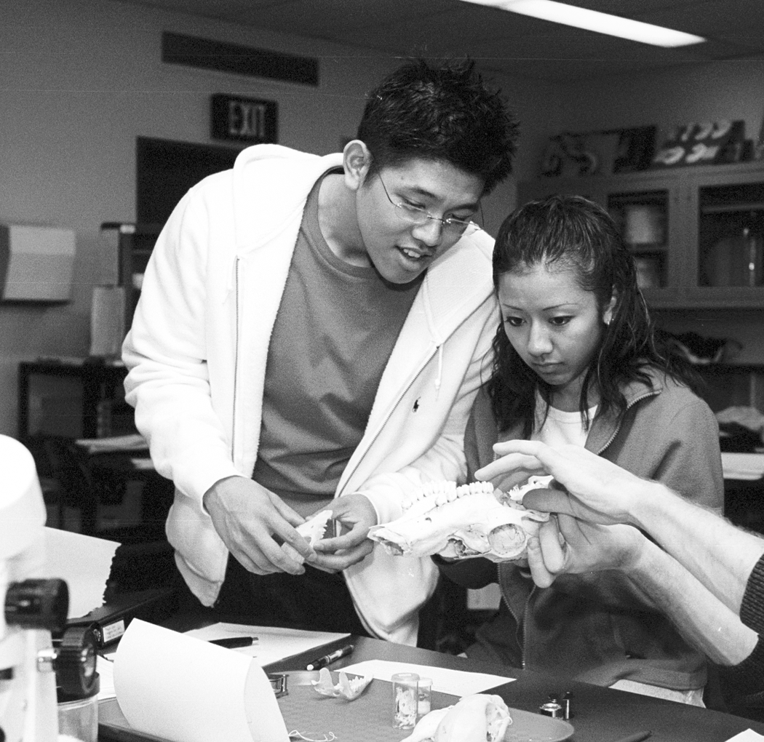


Your Department
Portland State University
Post Office Box 751
Portland, Oregon 97207-0751

503-725-3511 tel
503-725-5525 fax
email@pdx.edu
www.pdx.edu
Portland State University is an affirmative action/equal opportunity institution. Printed on recycled paper. 7/06

B.A./B.S. in health studies
at Portland State University
The undergraduate program in health studies at Portland State University contains more common core courses with four separate concentrations: community health education, health sciences, physical activity/exercise, and school health.
Community Health
The community health education concentration prepares students for entry-level careers in health education.
Health Sciences
The health sciences concentration is intended for students seeking admission into professional programs in medicine, dentistry, physical therapy, or occupational therapy. It provides students the opportunity to learn health education content and methods while completing specified science prerequisites.
Physical Activity/Exercise
The physical activity/exercise concentration is designed for students with interest in physiological and programmatic aspects of exercise, nutrition, fitness, and physical activity.
The school health concentration is intended for students interested in teaching health education within a public or private school setting. Upon completion of their bachelor’s degree, they are eligible to apply to the fifth year Graduate Teacher Education Program (GTEP) in the Graduate School of Education at PSU. After completion of GTEP, they will be certified to teach in the state of Oregon.
In addition to meeting the general University degree requirements, students earning a B.A./B.S. degree in health studies must successfully complete:
- The common degree requirements
- One of the four concentration areas, from which a plan of study is developed with an academic adviser
Common Degree Requirements
Credits
Stat 244 Intro to Probability and Statistics 4
PHE 250 Our Community, Our Health 4
PHE 295 Health Promotion and Disease Prevention 4
PHE 350 Health and Health Systems 4
PHE 443U Environmental Health 4
PHE 450 Epidemiology 4
PHE 404 Internship 8
Total 32

Concentrations
Community Health Education 44
Health Sciences 16
Physical Activity/Exercise 56
School Health 48

The undergraduate program in health studies at Portland State University contains more common core courses with four separate concentrations: community health education, health sciences, physical activity/exercise, and school health.
Community Health
The community health education concentration prepares students for entry-level careers in health education. The health sciences concentration is intended for students seeking admission into professional programs in medicine, dentistry, physical therapy, or occupational therapy. It provides students the opportunity to learn health education content and methods while completing specified science prerequisites.

