The intersection of literacy and technology represents a vast area of study where many scholars address, and critique areas of concern in digital rhetoric and how these issues may or many not all impact our writing. The all of this is purposely vague. To put it simply, in some way, it all impacts our writing. This is reflected in the various fields of study that exist under the umbrella of digital rhetoric. Much like rhetoric, digital rhetoric has no clear and generally agreed upon definition. There is not an all encompassing and neatly wrapped definition of digital rhetoric. With many different definitions there are various similar and conflicting approaches to digital rhetoric studies. The lack of a universal definition, however, is not necessarily negative. Scholars in the field have the freedom to explore many different areas of interest to digital rhetoric. However, the result of this can be a large amount of attention is given to defining digital rhetoric, understanding what it means, and developing theories based on these definitions and understandings. The drawback of this is the attention given to definition and theory in digital rhetoric, and a lack of scholarly work in application. Currently, there exist numerous appeals to scholars to critically address and think through many issues pertaining to technology and its use in the classroom. These areas of study include work in understanding the role of technology in the classroom, its social use and the implications of both in our daily lives and writing. There is a great deal of work in drawing attention to the technology we don’t see, and therefore may not process as technology.

All of the theory being discussed within digital rhetoric, and digital humanities creates a lot of good conversation, but what does it do aside from draw our attention to it? However, when researching how this all impacts our daily writing lives the conversation should continue into the territory of application. Equal attention also needs to be given to how we incorporate these theories in the composition classroom. Digital rhetoric can no longer to afford to primarily focus on theory, and/or build upon preexisting theories. It’s time for the call to shift from pushing scholars to be aware of the technology and how it impacts our writing, and start incorporating more of the theory into our pedagogy. Using assignments that allow for theories to be applied in the classroom also exposes students to the theoretical work done in digital rhetoric in a practical, and engaging manner. This paper aims to demonstrate the benefits of various different definitions of digital rhetoric influencing scholarship. It will also include a brief overview of only a few areas of research and interest to work in digital rhetoric, and finally look toward the development of assignments that aim to bridge the gap between theory and application for scholars, instructors and students to use and further develop their writing skills. This paper will attempt to research and answer the following questions:

* + What definition of digital rhetoric influences and informs this paper?
  + What theories in digital rhetoric need to be applied and incorporated in assignments?
  + What types of assignments, and platforms allow for an attempt to bridge the gap between theory and application?

The first section of this paper serves as a brief overview of some of the areas of research and discussion in digital rhetoric. These theories and areas of interest will serve as the theoretical framework for assignments and uses of applications that will aim to bridge the gap between theory and practice. These areas of interest do not reflect all of the work currently done in digital rhetoric. However, they are important points of discussion in the field that should also be reflected in assignments in the current pedagogical practices of instructors in the composition classroom. The next section will explore the use of the application Twine, and assignments that push students to engage with theory, and the benefits of these practices. The goal of this paper is to establish the importance of bridging the gap between theory and practice, and demonstrate the need for these assignments in composition classroom curriculum and pedagogy, as theory urges that writing instructors move away from the use of and integration of technology in the writing classroom for the sake of simply using it. These assignments will reflect attention given to the practices, and not a large final product. They are smaller, low-stakes assignments that aim to help situate students in digital rhetoric without much pressure. Assignments and practices in the classroom need to reflect more than use at a purely functional level, and be used to apply theory that helps students engage with the material on a rhetorical level.

**Defining Digital Rhetoric**

Before discussing theories that influence and inform the use of assignments in Twine, I must first explain the definition and understanding of digital rhetoric. As previously mentioned there are countless definitions of digital rhetoric. Therefore it is important that the definitions influencing the work in this paper be explained and discussed. For the purpose of this paper my understanding of digital rhetoric is based on several definitions that address different aspects of scholarship in the field digital rhetoric. In Carolyn Handa’s book *The Multimediated Rhetoric of the Internet: Digital Fusion* she defines digital rhetoric as “simply (or maybe not so simply) traditional rhetoric applied visually as well as textually. It is not another form of rhetoric. We do not switch from digital to traditional rhetoric. All of the components we are accustomed to discussing in traditional rhetoric, especially having to do with style and arrangement for the purposes of conducting logical, discursive, persuasive arguments, are elements that can occur visually” (p. 18). This definition attempts to link traditional rhetorical practices to those in digital spaces. It also accounts for the ways in which communicating and writing in these spaces impacts our writing. However, what this definition does not do is take into account the way these digital spaces change more than our writing. Everything is digital. As writers, we have been coding and engaging with digital spaces for longer than we typically think. These digital spaces that our literacies play out in one form or another have existed for decades. In this sense we are not only dealing with how our ability to actively use these digital spaces to compose and the effects they have on our writing. Our experiences with the technology that is the digital space allows us the ability to change these spaces and technologies in the same manner they change us. It’s important that digital rhetoric not keep itself married to Aristotle’s definition of rhetoric. Work in digital rhetoric goes beyond persuasion.

Zappen (2005) distinguishes between traditional and digital rhetoric. He urges that the two be separated due to the constraints of permanently linking rhetoric with persuasion. He defines digital rhetoric as the ways in which “traditional rhetorical strategies function in digital spaces and suggest how these strategies are reconfigured within these spaces” (p. 319). Digital rhetoric thus represents not a move away from persuasion, but the ability to address communication as a collaborative effort between the composer/writer and the technology. The collaboration, I think, moves us beyond persuasion, and allows for digital rhetoric to account for the role and/or purpose of the technology used to communicate. The importance here again, is the medium and the technology. In writing in different modes and digital spaces we can also question and critique the uses of these modes for the types of communication and writing we engage in, which allows for the conversation regarding theory and application to not only take place by scholars in the field. If digital rhetoric in its broadest definition addresses our communicative efforts in digital spaces, then it is unlikely we ever escape the realm of digital rhetoric in our daily lives and writing. For this very reason digital rhetoric needs to reach outside of academia. If developments and advancements in technology are responsible for constant interaction with digital spaces and interfaces, then specific assignments in composition classrooms need to reflect these occurrences.   
 Ian Bogost’s definition of digital rhetoric incorporates the impact it has socially and politically. His work in procedural rhetoric push scholars to move beyond the view that the technologies we use are simply tools available to us. He situates procedural rhetoric within digital rhetoric because of the “practice of using processes persuasively,” which he views as no different than other types of rhetoric. Due to the nature of the digital spaces we compose in, and inhabit, it is impossible to separate any understanding of digital rhetoric from the processes we engage in to accomplish communication not just with a human audience, but with the computer, or software, itself to achieve something.   
  
 For the purpose of this paper I understand digital rhetoric as the practicing of communication and processes in digital spaces for persuasive, communicative, and investigative purposes. This understanding is clearly influenced by the work of Handa, Zappen, and Bogost. However, it is not merely a combination of their work to cover my areas of interest. It reflects an attempt to incorporate their work with a general inquiry into the impact of these practices in our writing and daily lives. The importance of this addition lays the groundwork for the attempt to bridge the gap between theory and practice by understanding that digital spaces impact more than our writing. The result of which alters us in the same way we arrange and rearrange the software, computer, interface, etc. we are limited to working within to achieve our communicative goal. I think it also allows a shift in the understanding and positioning of the audience. If our practices in digital spaces require us to use a specific process that forces us to arrange and rearrange within the confines of the technology we use, then is the digital space as much our audience as our human counterparts? If the interaction between the technology and users changes users, and vice versa, then does that make the computer, software, and/or interface another audience we encounter while composing in digital spaces? Naturally this would depend on how one situates technology within digital rhetoric, but it does exemplify how the role of the technology plays more of an important part than that of just a tool used to serve the needs of a writer/composer.

**Digital Rhetoric: A Brief Overview of Theories in Digital Rhetoric**

Before one can question and critique the technology used in digital spaces it is important to understand what it is, and inversely what it isn’t. The limitations and advantages of different technologies directly affect the writing and communication occurring within them. If there exists a relationship between how a user interacts with technology and how this usage enacts a change for both, then the technology that builds what we use to communicate can’t be ignored. Black box technology refers to technology that is unseen or unavailable to users. Cressman (2009) discusses it in “A Brief Overview of Actor-Network Theory: Punctualization, Heterogenous Engineering & Translation.” In it Cressman describes actor-network theory (ANT) as an attempt to “open the black box of science and technology by tracing the complex relationships that exist between governments, technologies, knowledge, texts, money, and people” (p. 3). These connections he argues are lead to science and technology and only through examining them can we understand the how and why of our technology. Specifically, how the technology we use came to be, and why we have it and use it. This also allows for discussion on how and why we know what we do about technology we use, and its relationships/connections to the governments, people, and money previously mentioned. The black box technology can easily go unnoticed so long as it, whatever it is, works as we think it should. Only when it does not work is attention given to the pieces and parts that make it up. If it works as expected, then there is no reason to question how it came to be. For users this usually is not an area of concern until it can no longer be ignored.   
 The discussion technology that exists in a black box until research uncovers it creates an opportunity to further research the impact of digital spaces, but from a different point of view. This approach accounts for viewing the technology as active in its own right, and not just a tool we use to communicate. It is clear then that this questioning of technology and uncovering the black box of science and technology would be closely associated with actor-network theory.

Like digital rhetoric actor-network theory can mean and represent different concepts. Actor-network theory (ANT) is applied and used in numerous disciplines. Because of this ANT is often, according to Cressman (2009) “in the abstract, divorced from particular case studies” (p. 1). This is problematic because the theory is acted out and performative, therefore it shouldn’t be summarized when it could be analyzed. Latour (1987) writes that ANT “approaches science and technology in the making” and not when it is already made. However, like digital rhetoric ANT can and does mean different things to different people and will thus represent different uses and understandings. Cressman in his overview points to the fact that “ANT cannot be reduced, once and for all, to a catch-all theory that can be universally applied,” (p. 3) which accounts for the various uses, and possibly the reason for it existing in the abstract as scholars continually attempt to summarize and present their understanding of ANT. It is not important that there is an ongoing discussion of what ANT is, and how to define it. Rather, it is important to understand that the role of actor and network can be applied to anything; depending upon perspective and as such it can be a process and not a stagnant object. The importance of this to digital rhetoric is that applying ANT to how communication takes place in digital spaces allows for the computer, for example, to be an actor in the network same as the person using it. It is not only a tool as Bogost suggests, and using some of the concepts of ANT can also allow for the exploration of procedural rhetoric in the network. The linking of these two concepts is not meant to put two different things together and attempt to neatly use them, but to demonstrate that not only is a application of theories possible, but that using them together may give scholars in the field of digital rhetoric an opportunity to analyze how they work in classroom rather than theorizing about their impact.   
 Using ANT in digital rhetoric to attempt to understand how digital spaces

Impact writing and living within our networks, and expose black box technologies represent only a small amount of the work done within digital rhetoric. The work in black box technology and making it known to the users must go beyond the users experience with the technology not working as they expect it should. It should reflect the users ability to understand what is happening to make the technology work, and the political and business end that influenced, or limited development of the technology. These issues and concerns, I think, lead the field of digital rhetoric to interface and glitch.   
 Lori Emerson (2014) in *Reading Writing Interfaces: From the Digital to the Bookbound* calls attention to the blackbox technology in iPads and iPhones. She describes the interface as “magical,” and that it’s continually presented as “something that allows us to perform magic tricks” (11). This assists in keeping the technology hidden behind the “glossy, attractive packaging” that serves to lock away the “inner workings” of the iPhone and iPad. The issue of concern here is that the iPad was built to keep how it works from becoming public knowledge. The implications here are that an interface that is commonly used, and that other products mirror or mimic, will never truly be known or comprehended by those that users. Therefore, the iPad/iPhone users are unlikely to effectively understand its function in a network. Emerson refers to this as “closed computing” (p. 17). For this reason she urges writers to take the hacker approach to using these devices, so that the users can draw attention “to the process underlying the writing product, the way in which process and product were unavoidably intertwined” (p. 30). It is important to note that this approach is not directly aimed at the iPad/iPhone. Most of our interactions in a digital space, if not all of them are through an interface. The technology that exists behind the display of the interface is usually hidden. Therefore, understanding what is behind it, but also doing work that helps to expose it.   
 One area of study that helps to expose the technology and allow scholars to do work with the exposed technology is the glitch. Glitch often refers to “brief bursts of unexpected behavior in electrical circuits, but is also more specifically used to describe a style of electronic music that was created from already-malfunctioning technology,” which essentially means that it is an opportunity to create from an error. When something does not work as it should, and the black box technology is exposed, the resulting visual error can be the source of a new creation. Casey Boyle applies a rhetorical lens to glitch. In “The Rhetorical Question Concerning Glitch” Boyle offers that glitches are “models for expanding our current, critical approaches to rhetoric, especially as those practices concern mediation” (p. 12). Continuing the work done in exposing black box technology scholarship written about glitches are popular due to the nature of their existence. The fact that they exist, and ultimately expose what design and interface work to keep hidden makes glitches both popular and important in digital rhetoric. However, as work continues in glitches, and glitch art the field moves away from discussion of how this impacts our communication and writing in digital spaces.

According to Boyle (2015) glitch art “seeks not to error-check but to produce error” (p. 22). Producing an error certainly plays upon the ability to expose technology that would otherwise go unseen. It brings to the attention of the user and the audience that technology, visible or not, may deviate from what it should do and still communicate a message. Boyle suggest that “if we understand error as a wandering away from a predetermined plan or path, then the practice of producing error complicates our notions of intentionality and determination” (p. 23). This production of an error may very well complicate the process a user is accustomed to, but other than demonstrating it as a possibility and using Emerson’s hacker approach it does not necessarily allow the producer of the error the ability to disrupt the process. Rather, I think the user is using a different process within the preexisting process and limitations of the software to create the glitch. The attempt to create as a result of a glitch is interesting, and brings about the possibility for many rhetorical implications, but does it bridge the gap between theory and application? Does glitch art represent the theories and apply them in a practical sense that helps continue the conversation of digital rhetoric? Theories and work done with glitches and in glitch study help to push digital rhetoric towards application. However, I argue that while glitch art exposes hidden technology it does not create a deeper conversation about the now unhidden technology. Glitch art assignments and creations, while digital in nature, exhibit many of the elements commonly associated with visual rhetoric. This is not surprising. With most of our world existing in a digital space, and our experiences often coming through a screen, or interface, most visual rhetoric exists in a digital space. The presentation and theories that inform visual rhetoric are not always in alignment with digital rhetoric. Personally, I don’t see them as deviating as much as other rhetoricians might, but it is my opinion that while glitch art is concerned with commonly written about areas of interest in digital rhetoric it does in fact approach application from a visual rhetoric lens.

However, it cannot be ignored that Boyle’s work in glitch addresses how the user is changed by their experience in composing in a digital space and how the user changes the technology itself. Boyle’s work on glitch proves that the different definitions and theories addressing different areas of digital rhetoric do build upon each other. At its roots digital rhetoric is concerned with the relationship between the technology used and the user. Where it goes from there differs from scholar to scholar. There still exists a disconnect between the attention given to what scholars in the field suggest we should be talking about, thinking about, and ultimately writing about and how to incorporate these concepts into the classroom. The numerous theories in digital rhetoric urge the field of rhetoric and digital rhetoric to be aware of networks, black box technology, interfaces, and the impact of working, writing and living in digital spaces. The next logical step is to begin to apply this work and incorporate it into composition classrooms. The theory cannot only exist in the realm of the scholars that research and work in digital rhetoric. If the theories that influence the scholarship in digital rhetoric, then it also needs to be reflected in the assignments we teach. The disconnect that exists between theory and practice is a gap that needs to be filled. Not every theory will work, same as not every assignment will neatly wrap up and teach complex concepts to students, but this should not detour scholars. There is no perfect definition of digital rhetoric, and yet scholars continue to try and summarize, understand and present their definitions. The same tenacity that goes in to theory needs to be applied to pedagogy and attempting to apply these theories. Simply put, the theories need to be put to use.

**TWINE Pedagogy: Assignments and Benefits of Using Twine in the Composition**

In the writing classroom there are many skills that need to be developed. There is not enough time in a semester to adequately address them all, and incorporate assignments that help students apply and engage with theories that influence current scholarship in the field of rhetoric and composition. Traditional composition classes despite the many calls to incorporate technology in the classroom and help students develop multiliteracies do not always have a curriculum that reflects the many areas of research that impact rhetoric and composition. It should be no surprise then that the push to incorporate technology in the composition classroom often does not come with a clear reason or theory that supports its use. Assignments can sometimes reflect the use of technology for the sake of using it. Without including concepts and theories prevalent in digital rhetoric these assignments exist on a purely functional level. They may even address rhetorical issues, but without explicitly exploring the implications in digital rhetoric the assignments aren’t likely to be as effective as they could be, which means concepts and theories will likely not be communicated to students. They will not be aware of the implications of what it is they are composing.

The simple solution to this problem is to include assignments that help facilitate discussion of the concepts often discussed in digital rhetoric. However, this is no simple task. The previously mentioned time constraints, and push to teach skills that transfer to other courses and the type of writing students will do in their coursework moving forward account for the difficulty in implementing assignments specific to digital rhetoric, and/or rhetoric in general. There is also the issue of the instructor’s level of comfort teaching and implementing these types of assignments. One way to approach these particular hurdles is to use assignments that are short, and/or low-stakes.   
 The benefits of low-stakes assignments result in the point value associated with them. With lower point value assigned to them students may feel less pressure to complete them. The lower level of pressure may help students engage more willingly with new concepts. This allows them to focus on the practices and patterns needed to complete the assignment, rather than producing a large product. This is also beneficial to instructors that may be unfamiliar with any software or technology necessary to complete the assignment. One such application that accommodates the time constraints, and low-stakes nature of these assignments, while also applying theories in digital rhetoric is Twine.

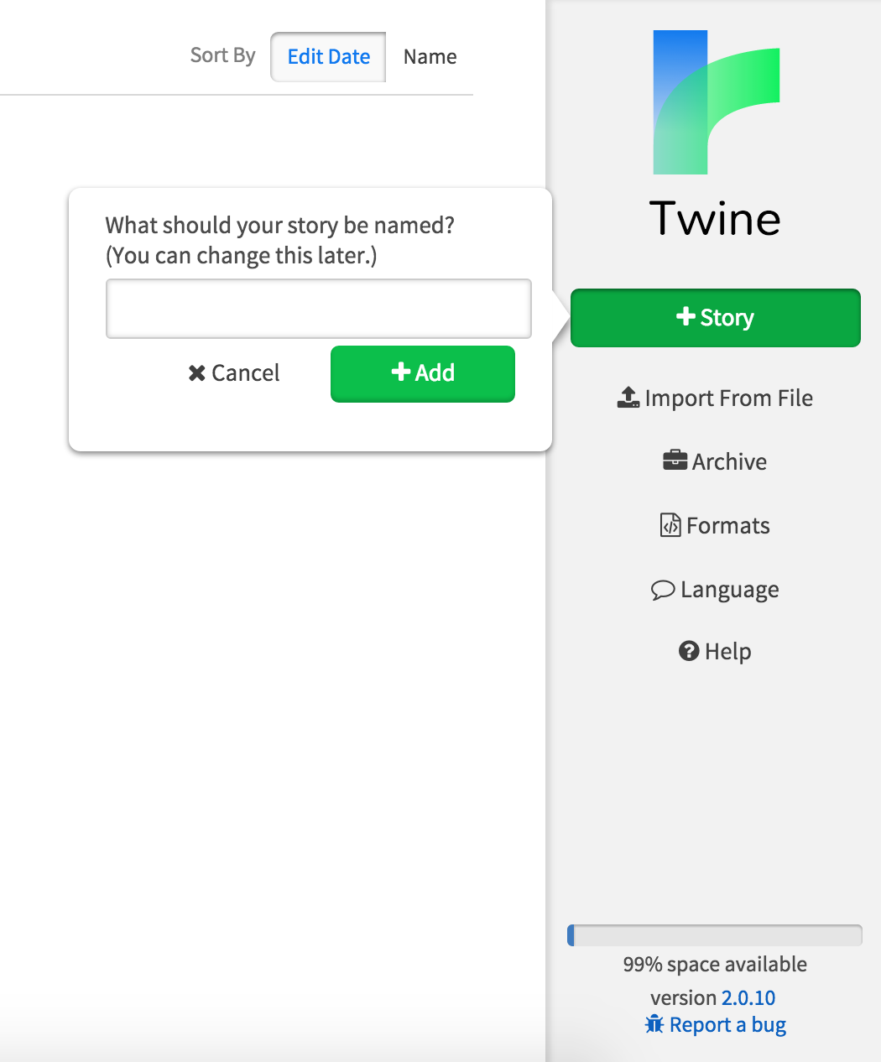

Twine was created in 2009. On its website Twine is described as “an open-source tool for telling interactive, nonlinear stories,” and it proudly proclaims that users do not need to know how to write code to create using Twine. It also makes it clear than stories created can be extended “with variables, conditional logic, images, CSS, and JavaScript when you're ready,” which means users can develop skills that provide personal and academic growth as they become more familiar with the code that will enhance their stories. Twine also allows for public sharing of the stories created because it can easily be published. The application and use of it is free, which allows users to create whatever they look and use it as they like.

Twine can be used to make visible the technology that students use to write. Most writing takes place in a digital space. This writing is essentially code, and so students write in code without explicitly thinking about it. Like the “magic” that is the iPad/iPhone, word processors also exist to students in a natural setting, and works, as they believe they should until they encounter an error. To create a story, or game, in Twine students must create the links between the stories so that readers will be directed to the next part. This process uses code, and images, or simple alphabetic text that reads similarly to a word processor. This forces the student to think in terms of the technology, coded language in this example that will create their story and/or game. If this is roughly how Twine works, and what students can do with it, what do they gain from it? How is Twine different than other applications or uses of technology in the composition classroom?

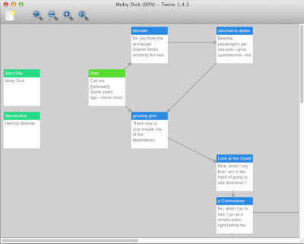 It is not only what Twine pushes a student to do to create their story, or game, but what they encounter when they create their Twine story, or game. To the left is an example of how students work in Twine to create their story, or game. The lines represent links. These links work as you would expect a hyperlink to work. The audience will read the text, as it’s presented to them, and click on an image, text, etc. that takes them to the next part of the story or game.

As students test their work they will immediately know if the coding was unsuccessful because they will encounter a glitch in their game/story as they review it. They will instantly become aware of the glitch, and have to work through it to correct it. The technology behind a website, or anything else that uses code is now exposed to them. The principle behind this is not simply that the glitches are made visible to the students, but that they must work to understand where the glitch came from, and how to fix it so that their game, or story, does what they want it to do.   
 Students are active in their learning and developing multiliteracies by playing with the technology to create something fun. The space where they create their story and write the code, with the links connecting each box is similar to how most networks are imagined. Lines connect the boxes and move back and forth between other boxes filled with code. In this form it looks like a storyboard, but when published the game, or story, takes the audience through it in either the order the author chooses, or if multiple links are used the audience members can choose their own path as they wander through the Twine.

Using Twine has its merits, but the affordances of the application will only go as far as the assignments push the students. Specific assignments that may be incredibly useful to applying theory and concepts often discussed in digital rhetoric are vital to the successful use of technology in the composition classroom. Twine can be used to have students map out their literacies. This practice allows students to critically think about where their literacies intersect, so that they can be linked to one another, and where they

**Conclusion (1 Page)**

**References**

Downing, K., Kwong, T., Chan, S. W., Lam, T. F., & Downing, W. K. (2009). Problem-

based learning and the development of metacognition. *Higher Education*, *57*(5),

609-621.

Ganz, M. N., & Ganz, B. C. (1990). Linking metacognition to classroom success. *The*

*high school Journal*, 180-185.

Hacker, D. J. (1998). Definitions and empirical foundations. *Metacognition in*

*educational theory and practice*, 1-23.

Hales, N. Katherine, (2012)How we think: Digital media and contemporary

technogenesis University of Chicago Press, Chicago

Kluwe, R. H. (1987). Executive decisions and regulation of problem solving behavior.

*Metacognition, motivation, and understanding*, 31-64.

New London Group. 1996. A pedagogy of multiliteracies: Designing social futures.

*Harvard Educational Review*, 66: 60–92.

Porter, James E. Recovering Delivery for Digital Rhetoric, Computers and Composition,

Volume 26, Issue 4, December 2009, Pages 207-224, ISSN 8755-4615,

Selber , S. A. ( 2004 ). *Multiliteracies for a digital age* . Carbondale : Southern Illinois

University Press

Yancey, Kathleen Blake, "Reflection in the Writing Classroom" (1998). *All USU Press*

*Publications.* Book 120.