**Writing Sample Jennifer Falcón**

**Summary of Dissertation**

This dissertation examines what types of multimodal assignments are included in first-year composition curriculum, how they are implemented, and which theories influence their learning outcomes and/or reasoning for their implementation into first-year composition curriculum. To meet the needs of developing digital multiliteracies and integrating more, or newer, technology in the classroom, it is understood that multimodal composition assignments are often part of first-year composition curriculum in an attempt to develop digital multiliteracies and implement technology to reflect current writing practices. As scholarship in digital rhetoric, procedural rhetoric and electracy grows, their scholarship and theories should be reflected in multimodal composing practices in first-year composition curriculum and classes in order to broaden the scope and understanding of what it means to use digital platforms to mix modes in communication and writing practices.

There exists a gap between a multiliteracies approach to first-year composition curriculum, which often includes a multimodal or multimedia assignment/assignments, and/or writing practices that incorporate elements of digital rhetoric, procedural rhetoric, and electracy. The gap is a result of privileging one approach or theory over the others in an attempt to incorporate multiliteracies, multimodal composition, or multimedia composition. Often times there is overlap among the different approaches as they each have similar goals. My dissertation concists of five chapters that explore the topic, review lieterature to better understand history of multimodal composition, digital rhetoric, procedural rhetoric, and electracy. Later chapters provide methodology used to conduct the research study, findings and recommendations.

Chapter 1 - Chapter 1 serves as an introduction to the topic of my research, and the specific focus of my dissertation. This will include any and all scholarship that will help establish the gap in research, and subsequent need to fill it based on findings in my dissertation.  
Chapter 2 - Chapter 2 provides the necessary review of literature of relevant scholarship on pedagogy, multimodal composition, electracy, procedural rhetoric, and digital rhetoric.. This will include a brief trace of the different definitions and understandings of digital rhetoric since the term was first discussed by Richard Lanham in 1992.

Chapter 3 - In chapter 3 I discuss in detail my methodology, which includes but is not limited to data collection and subject participants, and how grounded theory will be used to code and analyze data.

Chapter 4 - In this chapter I analyze the data collected from survey responses and interviews. Grounded theory is used to code data and identify patterns in the implementation and teaching of multimodal assignments in first-year composition curriculums.

Chapter 5 - In chapter 5 I provide recommendations for implementing and teaching multimodal composition assignments that reflect more of the theories and practices of digital rhetoric, procedural rhetoric, and electracy that are not part of current first-year composition curriculums.

Provided for you below are excerpts from four chapters of my dissertation.

**Sample of Chapter 1** With technological advancements that continue to alter and/or create new ways of communicating and writing comes the ability to not only study them, but bring them into the composition classroom. The continuous shift in communication and writing practices as a result of new or improved technology has a long history in the field of rhetoric and composition. Whereas once the typewriter, and word processors changed how we wrote, we now have computers, tablets, smartphones and their software that change how we make meaning and communicate it to others. As more communication devices and software become available, the gap between the kinds of writing people do everyday and kind of writing students do inside the classroom continues to grow. As a result the first-year composition classroom becomes a space where instructors attempt to build on the writing skills students utilize outside of the classroom in addition to the writing practices that aim to help students transfer their skills to other classes and their professional writing. In first-year composition, where students continue to develop their literacies through writing and meaning-making practices, scholars and instructors approach look to multimodal composition as a bridge for developing and building digital multiliteracies. Developing these literacies serves the student both inside and outside the classroom.

The concept of multimodality refers to the notion that multiple modes, where a mode is defined as “a unit of expression and representation” (Roswell, 2013, p. 3). In The New London Group’s “A Pedagogy of Multiliteracies,” the five modes of communication are visual, linguistic, aural, spatial, and gestural (p. 83 ) and each separate mode is capable of communicating a message on its own. However, when combined, they can communicate a more complex or nuanced message that can appeal to an audience more effectively. Some common examples of multimodal compositions are a video that makes use of sound, and text, in addition to the moving images to deliver a message, or an infographic that combines text and an image to relay information. As an audience we are constantly exposed to multimodal compositions, so much so that we may not recognize them as an example of multimodality. The fact that multimodal compositions can go unnoticed points to how prevalent they are in communication and writing practices.

The NCTE Position Statement on Multimodal Literacies helps to establish the importance of embracing multimodal literacy practices. The statement points to how the “integration of modes of communication and expression can enhance or transform the meaning of the work beyond illustration or decoration” (Position Statement on Multimodal Literacies, 2005) which helps frame communicating using all available modes as an important aspect of meaning-making. By drawing attention to the fact that multimodal literacies are “the interplay of meaning-making systems (alphabetic, oral, visual, etc.) that teachers and students should strive to study and produce” the understanding is that this is already something that instructors teach students to evaluate and create in composition courses. Instructors and students work with and make meaning by mixing modes as both composer and audience member, therefore multimodal composition is not new, or another concept to teach. It is ingrained in what we teach.

In 2014, the Council of Writing Program Administrators released an updated version of WPA Outcomes Statement for First-Year Composition, which also addresses multimodality. The statement connects composition to technology by drawing attention to the notion that composition practices are “shaped by the technologies available to them, and digital technologies are changing writers’ relationships to their texts and audiences” (WPA Outcomes Statement For First-Year Composition 3.0). Again we see the idea that newer technology impacts writing practices, but that this is not a new phenomena because technology has always changed communication and writing practices. The NCTE and WPA statements point to the necessity of incorporating multimodality as part of an expanding and developing digital multiliteracies.

Multimodal composition then becomes an integral part of first-year composition curriculum as a means to develop digital multiliteracies and incorporate new or newer technology available to us for communicating, making meaning and writing. This approach to multimodal composition in first-year composition curriculum creates an opportunity to also implement scholarship that explores how software, platforms and devices impact communication and writing practices. Scholarship in digital rhetoric, procedural rhetoric, and electracy can propel multimodal composition beyond simply using the concept of multimodality as part of broadening the scope of literacy. With embracing multimodal literacies, and therefore multimodal composition, comes the responsibility to incorporate concepts and theories found in scholarship in related subfields of rhetoric. A first-year composition curriculum that makes use of digital platforms means it using the first-year composition classroom as a space to practices theories in subfields of rhetoric, such as digital rhetoric, procedural rhetoric and electracy, that can lead to a deeper understanding and/or broaden the scope of multimodality for instructors and students. As digital rhetoric, procedural rhetoric, and electracy grow through the work of scholars, I see what can only be described as a widening gap between theory and practice. The work done in these three subfields of rhetoric contribute to a better understanding on our parts of the relationship between technology and the person using it to communicate, write, and deliver messages to an audience.   
 A first-year composition curriculum with digital multimodal composition assignments make the first-year composition classroom a space to continue to include subfields of rhetoric, and their respective theories. Scholarly work in digital rhetoric, procedural rhetoric, and the concept of electracy is abundant, and not only limited to classroom practices. However, the abundance of theories has led to a limiting number of scholarly works in application, and there exist numerous appeals to scholars to critically address and think about the role of technology in the classroom, its social use and the implications of both in our daily lives and writing. There are various pedagogical practices and assignments that aim to incorporate elements of digital rhetoric and build digital literacies of students in composition classrooms, but do these assignments reflect current scholarship? Does first-year composition curriculum use multimodal or multimedia composition as a means to apply the majority of theoretical work in digital rhetoric, procedural rhetoric and electracy? By researching how WPAs implement multimodal composition in first-year composition curriculum, and how instructors approach introducing and assessing multimodal composition assignments in their classrooms this dissertation aims to better understand when, or if at all, theories in digital rhetoric, procedural rhetoric, electracy shape multimodal composition.

The intersection of literacy and technology represents a vast expanse of study where many scholars address, and critique areas of concern in rhetoric and composition, specifically how emerging devices and software may or may not impact writing and writing instruction. The increased usage of technology (software, device, and online platform) in the classroom and in our daily lives changed and continues to change how we communicate. The newfound mobility of technological devices, made possible with the availability of Wi-Fi, introduction of smartphones and tablets, in addition to improved desktop computers and laptops, directly impacted our writing practices. It is easy to view new or improved technology as a more recent concern in rhetoric and composition, but the implementation of more, or newer technology in the composition classroom has long been an important area of study in the field of rhetoric and composition.

In “The Rhetoric of Technology and the Electronic Writing Class,” Hawisher and Selfe (1991) express concern over the “new electronic classrooms” (p. 55) and its impact on how writing instructors teach writing. They warn of over reliance on technology, and integration of technology in the classroom. Their observations of the approaches of instructors teaching in these electronic classrooms leads to a call to “plan carefully and develop the necessary critical perspectives to help us avoid using computers to advance or promote mediocrity in writing instruction” (p. 62). Their warning of over reliance on the ways in which technology is integrated is not uncommon, nor is it only associated with the integration of technology in a classroom. The appeal of a new technology, and/or new approach to a preexisting theory is undeniable. The field must carefully consider the temptation to implement new technology and pedagogy based on specific technological developments without creating a critical eye as to what its impact may be.

The New London Group (1996) in “A Pedagogy of Multiliteracies: Designing Social Futures” provide an overview for “the changing social environment facing students and teachers” (p. 60). The social environment they recognize as changing is the result of the rise of globalized societies. They push for literacy pedagogy to include the “burgeoning variety of text forms associated with information and multimedia technologies” (p. 61). The effects and importance of both advancements in technology and The NLG’s changing view of literacy are apparent in Stuart Selber’s (2004) *Multiliteracies for a Digital Age,* and Kathleen Blake Yancey’s address “Made not only words: Composition in a new key” at the Conference on College Composition and Communication. Selber recognizes the need for changes in curriculum

while Yancey draws attention to move away teaching writing practices of alphabetic text only. The connection between teaching multiliteracies, digital multiliteracies, modes that represent communication practices, which became more commonly known as multimodal composition and multimedia composition as will be more thoroughly addressed in chapter 2 (Lit Review).

One way in which multiliteracies, digital multiliteracies, multimodal and multimedia composition come together as a teachable practice in first-year composition curriculum is through the inclusion of an assignment, or series of assignments that aim to develop students’ multiliteracies. These assignments vary from curriculum to curriculum but the goals remain similar. Students use software, a specific platform, device, or website to compose by mixing modes, or by using something other than alphabetic text only. The composition and delivery of a message depends on utilizing the available technological means. An example of this is the E-Portfolio, which Clarke (2009) writes about in “The Digital Imperative: Making the Case for a 21st-Century Pedagogy” presents digital rhetoric as another literacy students must develop. She points to web 2.0 technologies as a means to access and allow for exploring new ways to encourage authorial control of writing (p. 28). Assignments such as the E-Portfolio are highlighted as a means for “discussions of ownership of digital material” (p. 29). Clarke also describes the composition classroom as an “emerging space for digital rhetoric” and views this as one way to develop students’ literacy in digital rhetoric. Building on Clarke’s idea that the composition classroom is a space to incorporate concepts of digital rhetoric, allows for the opportunity for it to also be a space to include procedural rhetoric, and electracy.

As the field moves away from questioning whether it should teach students to compose by mixing modes, and not solely relying on alphabetic text to teach writing, the issue becomes how to incorporate a multimodal or multimedia assignment. The inclusion of multimodal composition assignments in a first-year composition bring about concerns as to what types of multimodal composition assignments to include in first-year composition curriculum. WPAs and instructors must consider what type of multimodal composition will become part of the curriculum, which includes addressing how to introduce multimodality as a concept, how to assess the assignment, whether to place emphasis on the process of composing or the final product, in addition to introducing the assignment. This also coincides with attempting to achieve the goal of developing assignments that help to accomplish the learning outcomes of the program, university and/or field of rhetoric and composition.

With all that to consider it is clear that scholarly research on what to teach, how to teach it, and how to assess it are always needed, but can specific assignments be recreated? Are the experiences of one instructor’s classroom enough to answer the call put out by the NLG, Selber, and Yancey? What works in one classroom may not work in another, and if an instructor tries it and is unhappy with the results, does that mean they no longer attempt to incorporate multimodal composition in their curriculum? The large amount of scholarship related to multimodal assignments, and the experiences of instructors as they attempt to implement multimodal composition in their first-year composition courses is vital, but as first-year composition programs become more familiar and at ease with adding multimodal composition to their curriculums WPAs and first-year composition instructors should look beyond the basics of multimodality. Digital rhetoric, procedural rhetoric, and electracy provide a framework to approach the role of technology in the lives of students inside and outside the classroom. Each provides the student with an opportunity to develop multiliteracies, but also question their relationship with technology (digital rhetoric), explore their role as users of technology (procedural rhetoric), and the participatory nature of composition (electracy).

There are numerous theories and scholarship in these three areas that do not always reach the classroom. Without applying theories of digital rhetoric, procedural rhetoric, and electracy, or devoting more scholarship to the application of these theories, there is a high likelihood that curriculum in composition will approach digital rhetoric, procedural rhetoric, and electracy as an area for students to become literate in working in digital spaces without exploring the relationship between the user and the technology. Students, as users of technology, need to understand how the technology can change them, but also how they can change it. Knowing how to use a platform, software, and device effectively also includes understanding its role beyond completing a task/assignment. To do this students as users of the technology must be able to think critically about the impact of the technology, how using it changes them, and how they change it, and what that means for their communication and writing practices.

This dissertation attempts to answer the following research questions:

***Research Questions***

1. How, if at all, do digital rhetoric, procedural rhetoric, and the concept of electracy influence composition curriculum and approaches to digital literacies in the field of rhetoric and composition?

2. What types of assignments and platforms allow for an attempt to combine theory and application in the composition classroom?

There is no single agreed upon definition of multimodal composition, because depending on one’s approach, multimodal composition can mean or refer to different aspects of meaning-making. If a WPA or instructor view multimodality as a means to implement digital technologies in a curriculum their multimodal assignments would mostly aim to make use of new or newer technology and digital platforms. If their view of multimodality reflects that it isn’t only digital, and therefore it can exist outside digital technologies and still be a useful composing practice then they may encourage students to embrace materiality when mixing modes.

Scholars such as Lutkewitte (2014) in *Multimodal Composition A Critical Sourcebook* defines multimodal composition as “communication using multiple modes that work purposely to create meaning,” which is a broad definition that does not marry itself to a digital technology. This may be a result of the arguments that oppose the ideas that multimodal composition is new, because as Jason Palmeri (2012) wrote in *Remixing Composition: A History of Multimodal Writing Pedagogy* “past compositionists responded to the new media of their day” (p. 5) by creating multimedia textbooks in 1970s that were “designed to appeal to the multimodal interests of students who had grown up watching television” (p. 5). The idea that composition instructors react to the technology and media that influences communication habits and experiences of our students may not be new as Palmeri suggests. For this reason some in the field prefer to use multimedia composition, or new media composition, as it is specific to more current technology and media used to communicate and write. It should also be noted that before multimodal composition was a widely used term in the field of rhetoric and composition, multimedia composition was a commonly used term to describe writing practices using newly available technology. Jim Heid (1991) defined multimedia as “the integration of two or more communications media,” and again we see this type of composition as using more than one type of media or mode to communicate as central focus of the definition. This aspect of the definitions of multimodal composition, multimedial composition, and new media composition point to the process of mixing modes and/or media as the central focus of this type of communication and writing.

The field might have long been multimodal or taken into account visual or audio modes used in communication, but the technological developments made in the 1990s and 2000s allowed for more communication mixing modes than ever before. For this dissertation I chose to use the term multimodal composition, and not multimedia or new media, because multimodal composition is the most often used term in the scholarship. It is commonly used to describe the composition process by which modes are mixed, arranged, and delivered to communicate and write. To effectively research how multimodal composition is implemented in a first-year composition curriculum I felt it was important not to tie multimodal composition to digital practices. If a first-year composition curriculum or instructor concerns itself more with mixing modes and not using multimodal composition as a means to develop students’ digital multiliteracies, I felt it was necessary to use a term that does not exclude those practices and assignments. The focus of this dissertation is how these assignments are implemented and taught and if theories and practices in digital rhetoric, procedural rhetoric, and electracy are part of programmatic discussions and/or instruction or if the inclusion of multimodal composition assignments stems from the necessity of building digital multiliteracies.

The definitions of multimodal composition and multimedia composition above can also fall under the umbrella of digital composition. In *Theorizing Digital Rhetoric* (2018) Aaron Hess and Amber Davisson define digital rhetoric as “the study of meaning-making, persuasion, or identification as expressed through language, bodies, machines, and texts that are created, circulated, or experiences through or regarding digital technologies” (p. 6). The importance of this definition is the inclusion of how information is created, circulated or delivered, and the experiences of those using digital technology. This definition places the experience of using digital technology as equal importance as the creation and delivery of information. Digital composition, which can also fall under the umbrella of digital rhetoric, refers to specific practices available to today’s writers through a variety of digital platforms including but not limited to social media networking sites, video and sound editing software, word processor software, and mobile devices (<http://guides.library.stonybrook.edu/digital-storytelling/home>). In using the available technology to compose digitally it becomes important to also understand not only how to use the technology effectively to communicate and write, but also what it means to use specific technology.

Multimodal composition can fall under digital composition when the modes mixed are done so in digital environments based on the definition provided by Hess and Davidson because to mix modes digitally is to make use of available technologies to deliver a message to an audience. The definition of digital composition above also positions digital composition as part of digital rhetoric. For this reason I view multimodal composition as a practice of digital rhetoric, which is why theories and concepts of digital rhetoric should be more present in multimodal practices. However, like multimodal composition there are numerous definitions of digital rhetoric that have changed over time as communication and writing practices did based on technological advancements and developments.

**Sample of Chapter 2**

To avoid becoming complacent with the concepts of multimodal composition, in *On Multimodality* (2014) Jonathan Alexander and Jacqueline Rhodes urge the field to explore “other possibilities for expression, for representation, for communicating, for making knowledge” (p. 7), Rather than placing too much emphasis on one mode, such as video, Alexander and Rhodes suggest that our focus should be on moving towards different types of multimodal composition practices preparing us to move beyond multimodal. Alexander and Rhodes push for the field to “pay attention to specific rhetorical and production capabilities of new and multimedia” or else we risk not fully understanding the benefits and challenges of using multimodal to understand “literacy and communicative possibilities of the 21st century” (p. 5). Here again we see multimodal composition linked to literacy as demanded by advancements in technology that change our communication and meaning making practices. This raises the level of responsibility instructors have in meeting the specific needs of both current and future students.

Alexander and Rhodes (2014) state that the need to successfully build students’ multiliteracies through multimodal composition practices requires/relies on providing students with:

robust vocabulary of textual, visual, and multimodal meaning-making—a vocabulary that should also include the nontraditional, the alternative, the knowledges of the body, and the avant-garde as part of its critical lexicon (p. 71).

Their observation falls in line with their warnings against fluctuating between treating multimodal composition as a process by which the field either continues to teach the traditional essay or to reconfigure it by only seeing multimodal composition “through the lens of the essay” (p. 45). This was a similar concern of Lutkewitte. If we are composing in different modes, then we need to treat them differently than the alphabetic text only version of composition that we are most familiar with. To view multimodal composition through the lens of the essay is to limit our rhetorical understanding of it. To avoid tying multimodal to practices that will prove to not be meaningful or beneficial to students results in multimodal composition practices that help broaden their scope of practices much in the way the NLG saw the need to do so with literacy pedagogy in 1996.

According to Jennifer Roswell (2013) in *Working with Multimodality* “we are constantly in the flow of multimodality” (p. 1), which manifests itself in the various ways in which we are able to communicate with each other. For Roswell the benefits of composing in multiple modes allow us to posses a “level of abstraction and universalization that crosses discipline-specific practices” (p. 2). But then, what does it mean to be multimodal? According to Roswell it means, in part, that we producers aware of “how modes work” and how they work together (p. 3). If we are familiar with different types of modes, then literacy pedagogy and/or multimodal pedagogy must reflect our previous knowledge working with or experience these modes. By treating multimodal composers as producers, scholars can look to producers of these texts in professional settings, such as video editor, etc. Producers at this level inform multimodal pedagogy (p. 148) by helping to draw attention to the fact that other modes outside of words/text only are equally important in communication (p. 147). Roswell, much like Alexander and Rhodes wants equal representation and attention given to all modes in an effort to ensure that pedagogical practices go beyond acknowledging the importance of working with multiple modes (p. 148), and actually give every mode “equal value” (p. 148). This approach is slightly different than others in that to give each mode its due value would require focusing on one mode before mixing them together to compose. The affordance of this is a deeper understanding how each individual mode operates and moves rhetorically before combining it with others. The fact that we, as Roswell states, are always multimodal may equate to our limited understanding at a deeper level of what that multimodality actually is, and without thinking about it rhetorically we may overlook the both the positive and negative attributes of each specific mode we use when composing. This approach places the composition classroom as a space to explore familiar and unfamiliar modes in an effort to reach a greater understanding of them so that communicative practices are strengthened through the practice of multimodal composition.

Similarly, Clarke (2009) views the composition classroom as a place where composition practices can develop and strengthen literacies of students. In “The digital imperative: Making the case for a 21st-century pedagogy” Clarke adds to the mulitliteracies conversation by acknowledging digital rhetoric as another literacy students must develop and enhance. She uses Lanham’s *The Electric Word* to support the shift towards images and words in writing and points to web 2.0 technologies as a means to access and allow for exploring new ways to encourage authorial control of writing (p. 28). Assignments such as the E-Portfolio are highlighted as a means for “discussions of ownership of digital material” (p. 29). Clarke goes so far as to describe the composition classroom as an “emerging space for digital rhetoric” and views this as one way to develop students’ literacy in digital rhetoric. If students are composing in digital spaces, then they should also be aware of theories and practices in the realm of digital rhetoric, which falls in line directly with the idea that a comprehensive education of multiliteracies must reflect the growth of knowledge in digital rhetoric. It should be noted that within an E-portfolio there are elements of composing by mixing modes, which enhances its appeal as an assignment and practice to be included in first-year composition curriculum because it takes a familiar concept and assignment and moves it into the 21st century.

It is no coincidence that following these strong statements in support of moving away from alphabetic text, and relying upon interfaces and digital spaces for communication that some in digital rhetoric focus more on the technology than the persuasive practices. Clarke’s argument that the composition classroom is a space to incorporate concepts of digital rhetoric also makes it a space to include procedural rhetoric, and electracy. It can be argued that there are assignments that implement elements of digital rhetoric, procedural rhetoric, and electracy, but can a multimodal assignment provide students the opportunity to practice composing in different modes, developing multiliteracies, using new/different software, questioning their relationship to technology, and practicing composing in non-alphabetic text? This is as an important question to ask as any in relation to first-year composition curriculum, because first-year composition curriculum must value new writing practices associated with specific technologies, while still valuing the writing practices of the past. It can be understood that writing and composing has always been multimodal, but when mixing modes in new media, the focus tends to be on newer communication and composition practices. The result of this can be the exclusion of other types of multimodal composition practices, specifically those that do not require use of digital environments. The importance here lies in the fact that it is possible to teach students to make meaning mixing modes that are not digital.

Jody Shipka explores this in *Toward a composition made whole (2011)* notes that “one impetus for curricular change has to do with bridging the gap between the numerous and varied communicative practices in which students routinely engage,” which captures the need of the field to not only stay current, but also relevant. However, this reasoning can at times lead to privileging new media and new technologies as a means to achieve pedagogical goals, which can lead to excluding multimodal composition practices that are not digital. The eagerness to incorporate elements of current communication and composition practices in an effort to find a balance between the communication and composing practices of our students inside and outside the classroom can lead the field to embrace certain practices too quickly. Some may argue that the field of rhetoric and composition does not move to embrace these practices as quickly as they should, but there are valid reasons to being critical. As we hope our students will question and fully understand their relationship to technology and any communication and writing practices as a result of a specific technology, then we too must carefully consider how certain technologies and practices associated with them enhance our communicative practices. As Shipka warns, we should not only concern ourselves with the new, because it is possible that the practices we embrace, such as multimodal composition, might be one we’ve long been participating in and teaching. While it is important to look to our past, the current speed at which technology develops, and influences our communication, writing, and how we make meaning it is impossible not to look at the present with a keen eye to the future. To do this we must look back, while looking forward, which means that while we are implementing multimodal, or multimedia assignments in first-year composition curriculum we must also look for ways to incorporate digital rhetoric, procedural rhetoric, and electracy. The next section will dive deeper into additional theories that are both beneficial when teaching multimodal composition and reflect more current scholarship.

**Digital Rhetoric, Procedural Rhetoric and Electracy**

Digital rhetoric, with its various definitions and deeper understandings of the role of technology both in and out of the classroom, often preoccupies itself with theory that is critical and challenging to the ever-changing technological scope of our daily lives. Digital literacies as a result of advancements in technology, and continual integration in the classroom, concerns itself with developing literacies that are deemed necessary because of the ways in which our daily lives involve interacting with an interface that we must navigate in some meaningful way. The composition classroom, as a result, is often the space that allows for students and instructors to apply specific definitions and approaches to digital rhetoric, procedural rhetoric, and electracy to specific assignments.

In an attempt to better understand a potential framework for this study digital rhetoric, procedural rhetoric and electracy the following pages review definitions, similar movements, and areas of concern within digital rhetoric, procedural rhetoric, electracy, digital literacies, and composition pedagogy from 1991 to 2015 in order to explore connections between scholarship in these areas and concepts of multimodality and digital multiliteracies.

Whereas digital rhetoric theorizes the changing technological scope of our daily lives in communication practices and rhetorical awareness, procedural rhetoric concerns itself with the computational practices of using a computer, or software. Procedural rhetoric is as equally as persuasive as verbal and visual forms of communication. Electracy moves onward by addressing the participatory nature of composition as a result of video culture. Scholarship in digital rhetoric, procedural rhetoric, and electracy provide a framework for new or different concepts to address and incorporate into first-year composition curriculum, because they push concepts of multimodality and digital literacies to continually be developed.

Elizabeth Losh approaches digital rhetoric differently. As a result of developments in technology and an increased reliance and uses of technology in our daily lives, we begin to see definitions of digital rhetoric that attempt to address the shift and implications of digital rhetoric. In Losh’s 2009 book *Virtualpolitik : An electronic history of government media-making in a time of war, scandal, disaster, miscommunication, and mistakes* she provides a comprehensive four-part definition of digital rhetoric:

1. The conventions of new digital genres that are used for everyday discourse, as well as for special occasions, in average people’s lives.

2. Public rhetoric, often in the form of political messages from government institutions, which is represented or recorded through digital technology and disseminated via electronic distributed networks.

3. The emerging scholarly discipline concerned with the rhetorical interpretation of computer-generated media as objects of study.

4. Mathematical theories of communication from the field of information science, many of which attempt to quantify the amount of uncertainty in a given linguistic exchange or the likely paths through which messages travel. (p. 47 - 48)

This definition encompasses several aspects of scholarship within digital rhetoric. It touches on digital genres as a means of discourse, public rhetoric/political messages distributed through networks, the computer generated media becoming objects of study in their own right, and the use of mathematical theories of communication within information science to gauge linguistic exchanges. The importance of this comprehensive definition is that it details the difference in approach and understanding of what digital rhetoric is, what it can do, and ultimately how it is interdisciplinary.

Carolyn Handa’s 2013 book *The Multimediated Rhetoric of the Internet: Digital Fusion* approaches digital rhetoric as practicing rhetoric in a digital space that incorporates visual and textual elements. Specifically Handa defines defines digital rhetoric as:

“simply (or maybe not so simply) traditional rhetoric applied visually as well as textually. It is not another form of rhetoric. We do not switch from digital to traditional rhetoric. All of the components we are accustomed to discussing in traditional rhetoric, especially having to do with style and arrangement for the purposes of conducting logical, discursive, persuasive arguments, are elements that can occur visually” (p. 18). This definition views digital rhetoric as traditional rhetorical practices in digital spaces. Handa’s inclusion of the visual elements attempts to account for these types elements one can use in a digital space. This is one example of the overlap between visual and digital rhetoric. Handa’s view of digital rhetoric as rhetoric occurring in a different space tends to keep the field of rhetoric in line with Aristotle’s definition. While definitions need not necessarily break away from rhetoric’s past there does exist an area to address new concerns as a result of advances in technology and our uses of such technology.

While scholars attempt to define digital rhetoric, Ian Bogost argues for the creation of a different branch of rhetoric. In his 2007 book *Persuasive games: The expressive power of videogames* Bogost argues that a “theory of procedural rhetoric is needed to make commensurate judgments about the software systems we encounter every day,” and to also to “allow a more sophisticated procedural authorship with both persuasion and expression as its goal” (p. 29). He defines procedural rhetoric as “the art of persuasion through rule-based representations and interactions, rather than the spoken word, writing, images, or moving pictures” (p. 3). This definition is closely linked to the procedural computational practices. Bogost views these practices equally as persuasive as verbal and visual forms of communication. However, rather than the persuasion done in alphabetic text or multiple modes with a knowledge of language and images it is achieved as a result of the procedural nature of computer code. The code may appear to us in forms we know, but it is essentially the result of code. Therefore, to compose media within a computer is “the art of using processes persuasively” (p. 3). His work in procedural rhetoric pushes scholars to move beyond the view that the technologies we use are simply tools available to us. Bogost view of procedural rhetoric as the “practice of using processes persuasively,” due to the nature of the digital spaces we compose in, and inhabit, make it impossible to separate any understanding of digital rhetoric from the processes we engage in to accomplish communication. Bogost specifically applies procedural rhetoric to video games, but the concept of persuasion through software, and procedural processes ought be included under the umbrella of digital rhetoric, and as a potential theory to inform pedagogical practices in composition.

As Bogost argues for procedural rhetoric Sarah Arroyo attempts to shift the focus towards electracy. In Arroyo’s (2013) book *Participatory Composition: Video Culture, Writing, and Electracy* uses Gregory Ulmer’s concept of electracy as shediscusses participatory composition, and the connectedness of students that alters composition classes. Ulmer (2003) in *Internet Invention From Literacy to Electracy* views electracy as “to digital media what literacy is to print” (p. xii). Ulmer views the lack of consensus about teaching new media and an understanding that “new forms require new institutional practices” as the basis for the necessity of electracy. Ulmer believes an education based on electracy is needed to better understand new media practices to participate in a “virtual civic sphere” (p. xiii). Electracy is the literacy needed to better understand the electric media, multimedia, and digital media. It is needed to understand new media practices because theories only related to print literacy can’t simply be applied to the new electric media.

Arroyo uses Ulmer’s electracy to explore the connectedness of current online culture that includes what Arroyo labels “video culture” (p. 1), but the concept of electracy is not limited to it, or other forms of communication. Rather, Arroyo uses it as a theoretical framework because for her the concept of electracy goes beyond digital literacy. Electracy includes “civic engagement, community building, and participation” (p. 1). The idea that a specific type of literacy is now needed to enter the civic sector speaks to the increased usage of electric and digital communicative practices. The importance of print and print literacy has not diminished, but that does not mean we can ignore literacies related to more recent practices.

In Arroyo’s work we see a continued desire to create scholarship that reflects current writing practices. If electracy is different than print literacy, then the time for a theory to turn into a practice commonly associated with pedagogy pertaining to literacy and composition is not needed with electracy, because the “notion changes from a theory into a practice to a practicing theory as it is emerging” (p. 104). The approach to how we teach in electracy is different than print literacy, because as Arroyo argues electracy offers us a chance to work with “established forms as well as inventing new ones as they become timely and necessary” (p. 111). This makes electracy important because it attempts to include composition practices as they happen and are needed in real time. This includes, but is not limited to writing outside of the classroom on multiple platforms. Where Shipka notes the desire to bridge the gap between the writing practices of students inside and outside the classroom, Arroyo sees electracy as the bridge we continually try to build with theories and approaches to incorporating writing practices outside of those that include alphabetic text only. If electracy offers us the chance to practice a theory as it is developed, then this approach should find itself as embedded in first-year curriculum as digital rhetoric, and procedural rhetoric.

**Sample of Chapter 4**

The purpose of this study was to examine the ways in which first-year composition programs implement multimodal composition assignments in first-year composition curriculum. Specifically, the primary focus of this study researches how, if at all, digital rhetoric, procedural rhetoric, and the concept of electracy influence the ways in which multimodal assignments are implemented in the curriculum of first-year composition classrooms. The secondary focus of this dissertation examines if, and how, multimodal composition is implemented in first-year composition curriculum to the benefit of multilingual writers. To examine how multimodal assignments are implemented in first-year composition classes I set out to research implementation from the perspective of first-year composition program director and first-year composition instructors.

To begin researching I conducted a survey and selected nine survey participants for follow up interviews. Survey responses from 55 participants indicate that a high percentage of first-year composition programs have a curriculum that includes at least one multimodal assignment. Below is a sample of some initial findings based on an analysis of survey responses and interviews.

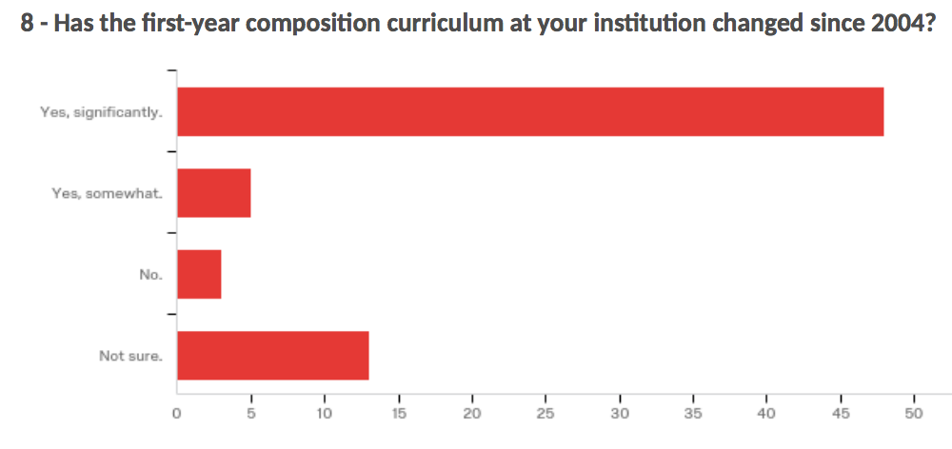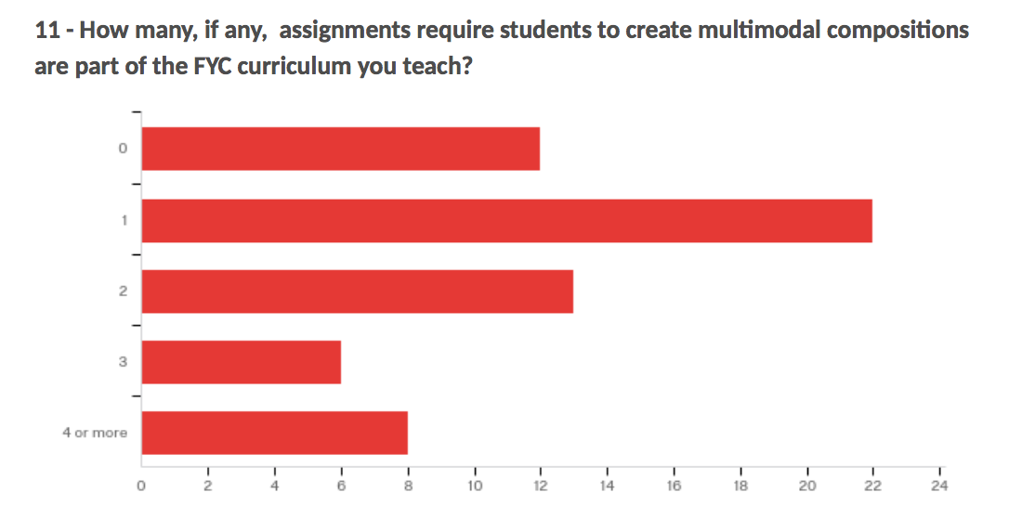

One of the primary goals of the survey was to provide evidence of multimodal composition in a high number of first-year composition curriculums. To be able to analyze the multitude of approaches and influencing factors a WPA and/or first-year composition instructor may use when teaching a multimodal assignment I set out to gather as much data about each specific program as possible. Survey responses provided context and background for each university and first-year composition program.The survey questions attempted to gain knowledge about the ratio of text only assignments to multimodal or multimedia assignments, what types of multimodal assignments are taught, if curriculums are standard and how that impacts a WPA or instructor’s approach to implementing and teaching multimodal composition assignments, and how instructor feedback is provided to the student. The above graphs demonstrate survey responses providing more specific information about each first-year composition program.

Changes in curriculum after 2004 often indicate a shift towards multimodality or an attempt made to build digital literacies of students. The number of multimodal assignments indicate if students have to continually compose by mixing modes or if they are required to do it once throughout the semester. The number of multimodal assignments may also point to a product or process based approach to multimodality. In the following sample WPAs and instructors select which type of multimodal assignment they teach. The survey specifically asked about digital multimodal assignments in an effort to examine the connection between technology, or newer technology and multimodal assignments. Data in Figure 1 suggests a large number of WPAs and instructors teach more than one multimodal assignment, with websites as the most popular example of a multimodal assignment.

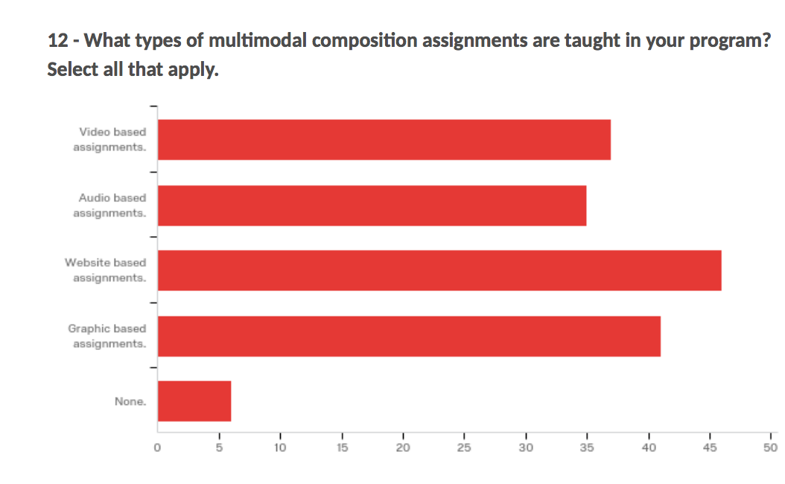

The data collected from survey responses helped to identify candidates for follow-up interviews. After conducting and coding nine interviews several patterns became apparent. The WPAs and first-year composition instructors approach to implementing and/or teaching multimodality are heavily influenced by their approach to rhetoric, often does not include more current concepts and practices in digital rhetoric, procedural rhetoric, and/or electracy, and can be heavily reliant on digital platforms rather than specific multimodal practices. Multimodality is often framed within concepts of rhetorical theory, genre theory, and analysis of audience, which are all important concepts for developing and delivering messages/written content to an audience. However, the pitfall of privileging these when teaching multimodal composition assignments is that multimodal scholarship is used in developing assignments second and/or primarily used to provide examples of multimodal assignments, if it is used at all.

One first-year composition instructor at a university in the Northeastern United States described the approach to multimodality at his university is to implement the use of e-portfolios. This is a university wide initiative where each student is required to build their e-portfolio throughout their academic career at the university. An interview conducted in 2017 with the first-year composition instructor at the Northeastern R1 university provided information about the learning outcomes of multimodal assignments. He stated that “the e-portfolio is for us” and serves as a “showcase for work that has it's own learning outcomes. Rather than something with learning outcomes of its own.” Multimodality at this university does not have its own learning outcomes. It is driven by the e-portfolio and the platform used to create and maintain the e-portfolios of undergraduate students. Therefore, the students learn more about how to use the platform and adapt or repurpose their traditional alphabetic text heavy assignments into a multimodal composition. Students can and do mix modes, but only within the constraints of the platform. With no clear learning outcomes it is difficult to determine if students are building digital literacies, which can also make determining the efficacy of multimodal assignments difficult. This specific approach does not utilize scholarship in digital rhetoric, or the participatory composition approach of Arroyo’s electracy to enhance the student’s awareness of complexities in multimodal composition. This platform driven implementation of multimodal composition does not promote critical awareness of technology in the composing process.