Developing Metacognitive Skills Through Digital Multimodal Self Reflective Assignments

Jennifer Falcon

UTEP

**Abstract**

The following paper researches the benefits of self-reflective digital multimodal compositions in rhetoric and writing studies. The purpose of this paper is to demonstrate the benefits of merging assignments that help to develop students’ metacognitive skills with low-stakes digital multimodal compositions. Currently specific tasks that push students to improve metacognitive skills in an effort to develop better study skills revolve around the production of alphabetic texts. Simultaneously there exists a push toward developing the digital multiliteracies of students by building upon their own digital metalangauge in the composition classroom.

Students reflecting on completed assignments in a composition class allows for instructors to gain insight on the overall effectiveness of these assignments. However, there remains the strong possibility that students will write what they believe their instructors want to read, and thus the reflection may not be helpful to the student, and the instructor. Students need to have more options made available to them when composing these reflections in order to make them more useful in developing their metacognitive and reflective skills, in addition to building multiple literacies.

The emerging need for students to begin to create multimodal pieces, and develop multiple literacies, creates space for the integration of Tumblr, a social network and microblogging site, in the classroom. Tumblr gives students practical, and relatively easy ways to create multimodal compositions, such as a piece of writing that makes use of memes, animated gifs, in addition to text to convey students’ understanding of an assignment.

*Keywords: metacognition, digital literacies, multiliteracies, self-reflection, multimodal, digital multimodal compositions,*

Studies in metacognition and the benefits of developing students’ metacognitive skills are beneficial to rhetoric and writing studies. They assist in identifying strategies, and pedagogical choices that not only help students improve their metacognitive skills, but assist instructors in deploying similar metacognitive approaches to their teaching practices. However, understanding the importance of developing the metacognitive skills to improve understanding of concepts, and develop better study habits of students is only one part of the many complex issues writing instructors face in the classroom. In the writing classroom there are many other skills that need to be developed, such as metalanguage, and developing digital multiliteracies. Therefore, to incorporate strategies that develop those skills in the writing classroom instructors must multitask. In addition to the push to embrace the self-reflective nature of metacognition in reflection assignments, writing instructors face the pressure of adding assignments that also develop and build upon the digital literacies of students.

Simply put, there is little time in a semester to achieve many of these goals. Currently, the direction of research is split. Metacognition is used in developing meaningful reflection assignments, but these assignments are mostly composed as alphabetic texts. This paper aims to demonstrate the usefulness of combining reflective assignments with multimodal compositions to encourage students to use and further develop their digital metalanguage by researching the following questions:

* + What is the importance of metacognitive studies in RWS?
  + How can instructors develop metacognitive skills of students and digital
  + literacies?
  + What is the impact of students composing self-reflection assignments using multiple modes?

The first section of this paper sets up metacognition as the theoretical framework for the practice of self-reflective multimodal composition assignments deployed in the writing classroom. The next section explores the practices and patterns found in the work of students composing these self-reflective multimodal assignments. The goal of this paper is to demonstrate the ways in which metacognitive skills can assist in the development of digital literacies, and student self-reflection in an effort to establish better study habits through the use of digital multimodal compositions.

**Metacognition: A Brief Overview and Implications for Multimodal Reflections**

Metacognition can be defined by the work of D.J. Hacker. Hacker (1998) aims to work through the many definitions of metacognition. His work aims to “cut through the fuzziness surrounding the concept by describing the characteristics of metacognition that have remained relatively constant across disciplines” (p.1). Hacker focuses on Flavell’s work to review the ways in which metacognition operates and has been researched. The basic notion that Hacker presents to the reader is that “metacognitive thoughts do not spring form a person’s immediate external reality,” and that “their source is tied to the person’s own internal mental representation,” so then their source is “tied to the person’s own internal mental representations of that reality” (p.2). Therefore, when designing an assignment aimed at developing metacognitive skills instructors must use strategies, and techniques that promote, or appeal to a student’s internal representation of themselves. An exercise whose goal is to make use of a student’s metacognitive skills must incorporate elements that appeal to the internal representation. This may include using forms of media, or communication that students are familiar with in order to engage with them on this level before encouraging students to foster this type of metacognitive development. It is important for students to think about their thoughts, what they know, and what is their current problem. This type of metacognition, according to Flavell (1979), is based on “knowledge and cognition about cognitive phenomena” (p. 2). Hacker through Flavell (1971) explains that this type of metacognition is “an awareness of oneself as an actor in his environment, that is, a heightened sense of the ego as an active, deliberate storer and retriever of information” (275). The clearing up of metacognition as more than thinking about thinking is useful when relating that information to pedagogical practices. Hacker, after clearly defining and explaining the purposes of the definitions he uses details a research study that follows the metacognitive practices of a high school student. The outcome of this study demonstrates the ways in which one uses what they previously know, what they want to know, and how the student made connections between the two to solve a problem (Hacker). It is important to note that these metacognitive practices are conscious practices, and that this general understanding and definition is aimed at providing an “overall view of the kinds of processes that have been associated with it” (p.6). This basic understanding of the types of appeals an assignment making use of metacognitive practices is imperative to developing an assignment that will be successful in developing these types of skills in students.

Building on these concepts is Kluwe who refines metacognition by drawing attention to two characteristics. According to Kluwe, (1987), “the thinker knows something about his or her and others’ thought processes, and the thinker can pay attention to change his or her thinking” (p.610). The importance of this is that students that are aware of their own thinking, and others, can use such knowledge to improve their thought process, which means that the social aspect of learning is equally as important as the internal. Downing et al (2008) use Brown (1987) to support this by stating that “metacognition requires the thinker to use and describe the process of mental activity” (p. 610), and use Hacker’s work (1998) to divide metacognition into three categories. The first deals with metacognitive knowledge as what one knows, metacognitive skill as what one is currently doing, and metacognitive experience which is one’s current cognitive state. Downing et al. use metacognition as a framework for studying problem-based learning. Their aim is to understand ways in which students approach problems that need to be solved. Therefore they suggest that “in order to effectively solve problems, students often need to understand how their mind functions.” They need to be able to “perceive how they perform important tasks” (610).

In composition classes the self-reflection assignment requires metacognitive skills. Some of the goals of the reflection assignment are to encourage students to assess what they learned by way of critical thinking, address progress, and be critical of their literacies. However, before students can assess what they learned, they must think about their process. Simply put, they are asked to assess what they knew during the process of completing a composition, what they needed to learn to complete the assignment, and the ways in which they did to achieve that knowledge. These demonstrations of knowledge must incorporate the three categories Hacker created. Metacognition is implied within the self-reflection assignment, but composition instructors incorporate other elements and approaches.

To develop metacognitive skills, Ganz and Ganz (1990) state “success should not be defined solely from the standpoint of student mastery of the subject matter, but rather from the perspective of helping students” (180). They encourage an environment, teacher, and curriculum that “develop a major self-control process, metacognitive skills processing” (180) to aid the student. The fact that instructors help shape metacognition demonstrates the importance of using it as a framework. Learning should be efficient, and accompanied with a teacher that plans for such development. Their work specifically speaks to assignments, and pedagogies of teachers that will be able to alter the changes in study habit. The goal is to push students toward not merely thinking about thinking, but thinking about their own learning. Therefore, teaching about this process “should not be random,” (181) because the students that develop these skills, and understand their own learning process, but the process of others through comparison, are more likely to “make the changes needed in their own study habits and learning strategies” (181). Ganz and Ganz view self-interrogation as an important technique to develop metacognition. They suggest that asking students to question themselves, assess their feelings, and hypothesize assist students in being able to develop, and ultimately use a self-correction strategy. This also allows for students to mix previous knowledge, or existing information, with new knowledge gained, or desired. Students that assess their feelings can also demonstrate their comprehension, and what they have learned, and/or are learning. These are not feelings based on value, or what they perceive as the importance of an assignment. Rather, these are questions that address the assignments, or goals, of the students in relation to completing an assignment, or task. Their examples are “Can I make some generalizations?” and “Can I draw some conclusions?” and “Is this similar to what I already know,” (182) which clearly demonstrate how students arrive at conclusions based on what they are thinking, and understanding. These are questions that are often incorporated in alphabetic text reflections. A common problem that instructors encounter with these types of assignments is the lack of honest assessment done by students. In my experience there are students that will mimic to me what they believe I want to read from them about their own process.

Ganza and Ganz also bring in Bransford (1979) to incorporate ideas of self-testing and rehearsal, which details the ways in which these practices assist in the transfer of information from the short-term memory to the long-term memory. These repeated practices of self-testing, and rehearsal can then be part of the information retrieval process during phases of metacognitive practices done by students. Through their research Ganz and Ganz ultimately come to the conclusion that independent and efficient learners are “the key to better education for the complex world of the future” (184). Metacognitive skills play a large role in assisting students as they develop self-regulation strategies. They view the individual as an important role player in their learning, but equally as important is their understanding of their learning processes through metacognition. Therefore, the role of the teacher as the individual that develops and creates tasks, and assignments that both teach and improve metacognitive skills must always be aware of what questions to ask students, and how their students think through these problems, because students that are able to describe their thinking processes have developed the metacognitive skills to do so.

The goals of developing metacognitive skills fall directly in line with Yancey’s work on the reflection assignment in composition. Yancey (1998) in her book *Reflections in the Writing Classroom*, views reflection in writing as a growth of consciousness, and a means of going “beyond the text to include a sense of the ongoing conversations that texts enter into” (p.5). Reflections have more value than simply pushing students to develop metacognitive skills, and assess their literacies critically. Yancey suggests that the student reflection also recovers what she calls “student talk,” which she defines as a part of the reflection process that asks students to participate with instructors as active participants in their learning (Yancey). She defines reflection as a “processes by which we know what we have accomplished and by which we articulate accomplishment, and the products of those processes” (p.6). Yancey’s view of reflection as a dialectical process that develops the way we, students and teachers, achieve goals for learning, strategies that help us reach those goals, and the ability to determine if we have met these goals. In addition, reflection includes the processes of projection, retrospection, and revision. Multiple perspectives are in play. Two of which are reflection-in-action, which is focused on a single composition, and constructive reflection, which is a product of successive composing. Reflections are often a companion to a completed assignment. Yancey urges instructors to either direct students to explicitly think the completed text as a task/problem worked through, and/or de-mystify the reading and evaluating of a text. Students compose reflections in their native language, and these language practices are a combination of their discourses that they bring into the classroom with them. This approach to student reflections as a composition made up of students’ native language allows for instructors to embrace this assignment as something that can move beyond alphabetic text. Simply put, for the digital native, this assignment should be inclusive of the many different modes students compose in.

The changes in the environment that surrounds students make theirs one very different from the environment their instructors learned in, which means that it is up to instructors to adapt to the practices of students, just as much as students need to adapt and develop new skills to complete assignments. The New London Group (1996) present an overview of the changes in the environment students and teachers face. They appeal to instructors to form new pedagogical practices based on the new multiliteracies. Their focus is one of design. To them global practices have changed, as a result the role of schools has also been altered, so they wish to “broaden understanding of literacy and literacy teaching and learning to include negotiating a multiplicity of discourses” (p.61). They urge instructors to rethink what they teach, and the new learning needs of students. Ultimately they see the changing environments as demanding that students develop new skills, and access to forms to “learn the new language of work” (67). A clear focus of their work is the notion that we are designers and understanding elements of design are crucial to helping students understands how to design in all aspects of their life. What students need is a developing a metalanguage based on design, and how this is accomplished is through understanding and utilizing the elements of design in different modes. The work of the New London Group in different modes, design, and multiple literacies is built upon by Selber in his book. His book is directed more at a rhetoric and composition audience.

Selber in his book Multiliteracies for a Digital Age (2004) investigates computer literacy in higher education. He directly discusses the obstacles literacy practices face due to technological myths, and the creating of both writing environments and computer literacy objectives without the consultation of writing instructors. He calls for educators and institutions to take a postcritical stance toward technology, because in doing so he believes a “computer literacy program that is comprehensive, innovative, and relevant” will come about (p. 7). The main framework Selber presents three types of digital literacy, functional, critical, and rhetorical, that students should develop. Part of this development is based on viewing technology, and/or software as more than a tool, and to reflect more on the technology they use. Critical literacy pushes students and teachers to ask why and how technology is used, and designed, to control, persuade or direct them to use it for only a specific purpose. Selber’s work is crucial in building on the idea that we all function in a world where multiple digital literacies are necessary.

In addition to developing multiliteracies J.E. Porter stresses that more importance must be placed on delivery, the cannon that tends to receive little attention in rhetoric. Porter (2009) in “Recovering Delivery for Digital Rhetoric” pushes us to put more importance on the ignored cannon of delivery. The reason for this, according to Porter, is that delivery is too often treated as superficial. Porter views the thinking surrounding delivery as functional. Delivery needs to be viewed more critically, and approached accordingly because it is important to understand how the “range of digital delivery choices influences the production, design, and reception of writing” (208). Understanding these ranges are essential to writing. Porter presents a theoretical framework that demonstrates the ways in which digital delivery is made up of five components. Each of these components operates in different situations that help you write, because the format of each can serve as a guide. Body/Identity, Distributin/Circulation, Access/Accessibility, and Economics are the five components that are elements of delivery. These elements must be addressed to reach a deeper critical thinking regarding delivery. These elements are also crucial in developing skills to become an effective digital writer; because knowing which element will serve you based on the purpose and audience you’re delivering them.

In addition to Porter’s work in delivery is N. Katherine Hayles’ book How We Think: Digital Media and Contemporary Technogenesis. Hayles explores the ways in which we think not through media, but alongside it. This means that we all participate in technologies that make use of digital delivery. Therefore, as scholars, we must engage with, and conceptualize the implementation of research projects that make use of digital media. Her book is aimed at a digital humanities audience, but has value in rhetoric and writing studies. She stresses that we must continue to work collaboratively, both with co-workers and students, to locate the ways in which much of the digital work with print traditions. Her work helps to conceptualize the role of digital media and its effect on mental processes. With all of these skills students need to develop it is vital that instructor develop and implement assignments into their curriculum that address as many of these areas as possible. This is no easy task. It is impossible to think of a curriculum that will address all of them, but it is important to try. One such assignment that I believe can help students develop these skills is a digital multimodal self-reflection. This assignment can take on many forms, and be used on several different social media, or blogging sites.

**The Digital Multimodal Self-Reflection Assignment**

To begin implementing this assignment in the composition classroom instructors, and students must have a clear understanding of the learning objectives associated with the multimodal reflections. Assignments that hope to build students’ metacognitive skills must contain goals that are made apparent to the student. Simply put, the student should know why they are doing this assignment, as opposed to thinking of it as another task to be completed for course credit. This open communication between instructor and student helps to build trust, and is imperative for the amount of public sharing students will do as they compose their multimodal reflections. It is well documented that students are active on social media networks, but instructors should not assume that the level of the activity of this generation of students on social media would equate to their active participation on a class blog on Tumblr. Each student makes their own Tumblr blog, and follow each other and the instructor. This can be done on other blog platforms, but Tumblr proves most efficient for this assignment. Tumblr is a multimedia blogging site that is the second largest microblogging site. Tumblr does not have the character restraints of Twitter, and posting multiple modes, or mixing media in a post is to do, but equally easy to explain to those not familiar with the platform. According to Yi Chang, Lei Tang, Yoshiyuki Inagaki and Yan Liu (2014) Tumblr is “reported to have 66.4 millions of users and 73.4 billions of posts by January 2014” (p. 1), which suggest that many students, if they are not active users of Tumblr, are at the very least familiar with it.

However, it also should not be assumed that students know how to use Tumblr, memes, gifs, etc. Simply because they are aware of these practices, or send them to friends via text, or other social media sites does not mean they have mastered them. I begin by introducing visual rhetoric to my students. I explain to them that they are active consumers of visual rhetoric, and that their experiences as consumers, and producers of media have trained them for this lecture. This isn’t pandering to students’ ego. It’s my attempt at including them in discussion. After a brief introduction to visual rhetoric, it’s time to move on to composing in multiple modes, and mixing them together. These lessons can be as simple as putting students in small groups and presenting examples of multimodal compositions. Brief introductions, and short assignments such as these are crucial to the students completing and understanding the multimodal reflection pieces they will write throughout the course. In the beginning it is important they understand the assignment at the functional level. It is a simple approach, but only with a solid foundation and clear understanding of the importance of metacognitive practices, visual rhetoric, and multimodality can students put them all together in their multimodal reflections.

The assignment is meant to be short. Students have a great deal of agency in how they decide to complete the assignment. This, however, does not mean that there are no parameters set by the instructor. Typically in my classes I will give students three to four questions to help guide their reflections. Students will answer all of the questions, or sometimes only the ones they find most important. This is their decision. I do require that they answer at least two. It’s necessary to explain to them that they only way to learn from their process is to put in effort. As is the case with any assignment some students are more engaged than others. Introducing the assignment, and developing questions is only one part of incorporating this version of the reflection assignment into a curriculum. It is important to interact with the students, reblog and reply to their reflections. Show them that their thoughts have value. Find areas to continue discussion, offer suggestions if students admit to struggling with aspects of the writing process, and clear up confusion about completed assignments. Instructors must be able to provide the same kind of feedback they would on an alphabetic text, or essay, on these multimodal reflections. To demonstrate how this can be done I will use examples from my students. These examples will serve two purposes. First, they will act as my research to support the inclusion of this version of the reflection assignment into composition curriculums. Second, they will help instructors eager to try these out in their classes with examples of patterns, potential results to look for in students’ work.

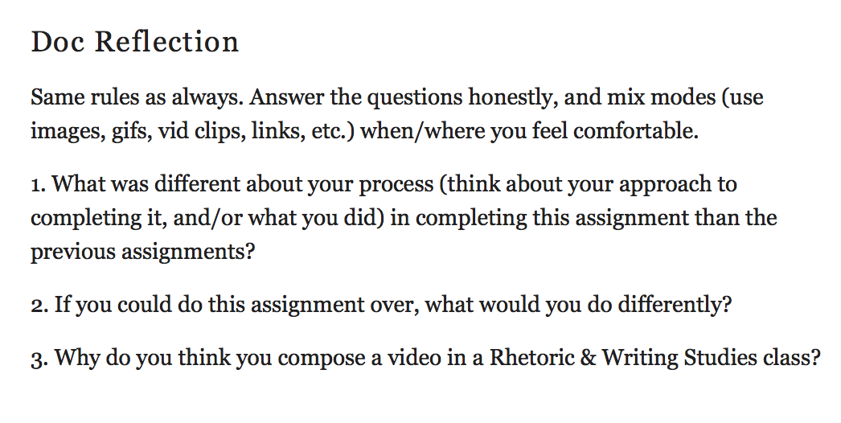Below is an example of reflection questions used in one of my classes.

Figure Reflection Questions Example

These questions are for a reflection composed by students at the end of the semester. At this point they are familiar with the process, and so my directions are informal. If a reflection is to be successful students must express themselves in modes they are comfortable with, and so if that means some students use text only I don’t penalize them, but it is made clear to them that I would prefer they compose in multiple modes. These questions address their process, and the assignment. The level of engagement, and understanding can be analyzed in one of two ways. If students focus on critiquing the assignment it can be deduced that they are not thinking back on their on thought process needed to successfully complete the assignment. If students critique themselves, their process, or identify areas they struggled with to complete their assignment, then they are likely engaging in metacognitive practices.

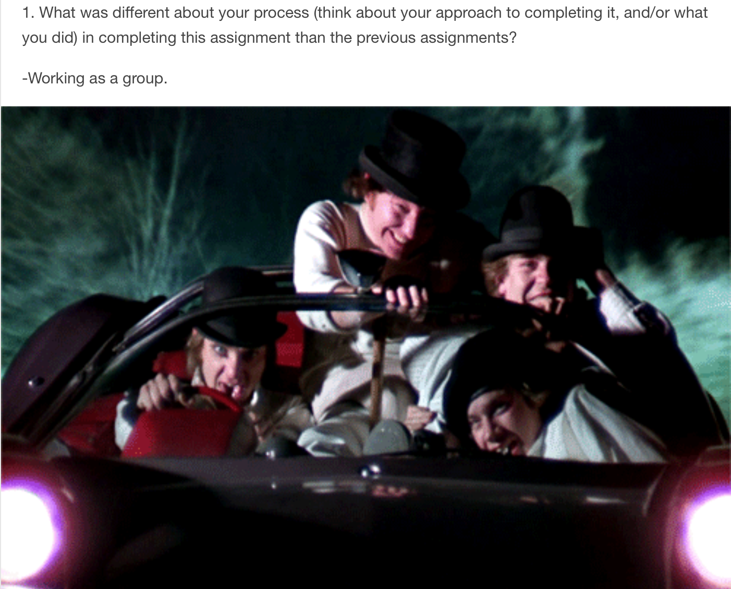One student, Brittany, used animated gifs to accompany text. She did not add the text over the gif. Her responses follow for the format of question, answer in alphabetic text, and then a gif. What is of interest here is that the gifs are all from the same movie, and the action in each line up accordingly with her written text. Her alphabetic text responses are short. She relies on the animated gif to express the experience of working on the assignment. An example of one of her responses is to the right. In response to this reflection it is important to guide the student toward adding text to the gif, and not keeping them separate. There are websites that are easy to use that will do most of this work for the student. This response is an attempt at producing a multimodal composition, but it can be improved upon. This mixed media response does reflect her experience in working in a group to complete an assignment. Brittany is thinking back on the process and work done on the assignment. So, despite this not executing multimodality perfectly, it does still hold value for the instructor, and student.

Figure Brittany's example

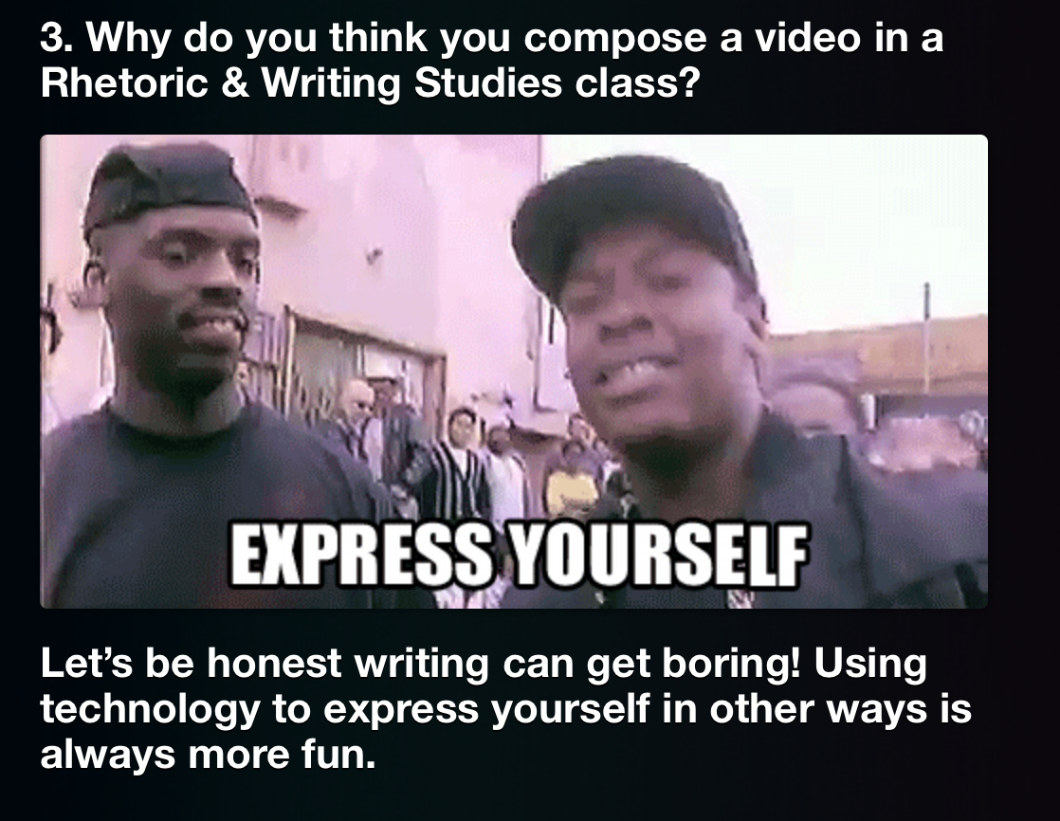Another student, Theresa, uses a meme to answer the question. She includes alphabetic text to explain the meme, but in keeping with the micro aspect of this multimodal assignment she composed one sentence to expand upon the sentiment behind the meme. The meme used successfully answers the question, and satisfies the multimodal requirement of the assignment.

Figure Theresa's example

The question requires the student to think critically about the purpose of the assignment. This is an example of a question that provides an opportunity for the student to relay their understanding of the learning objectives, in addition to giving the student agency to express their opinion. This particular student enjoyed the documentary assignment, because it was a different mode used than in previous assignments. The meme aligns itself with her alphabetic text response. Theresa understands how to use the meme to effectively answer the reflection question, and to convey her thoughts on the assignment. Theresa did not make the meme, and as I continue to use this assignment to develop metacognitive skills students will be asked to make a meme of their own.

It is important they do more than find a meme, or animated gif, that suits their needs. There are students that don’t post multimodal compositions. One such example is Jerry, who posts alphabetic texts only. He understands the reflection guidelines, but chooses not to include, or create, mixed media. His reflection responses are short. He conveys that he is thinking about his process, what he could have improved upon, and how some of those areas that need improvement will help his approach toward completing the next assignment more effectively. This demonstrates that questions posed to students can promote metacognitive practices.

These three examples demonstrate common responses, and techniques deployed by students when composing using multiple modes. Some will only focus on the meme, and let that do the work for them, which it should, but that does not mean that the student composed the meme, or gif, themselves. A disconnect exists between using a gif, and placing text within it. Some students will use the modes together to compose their reflection, but have them in separate sections working together as seen in the examples above. The process of making their own memes, or adding text to a pre-existing gif is simple. There are countless websites that do this for the student, so the issue of students needing to learn to use programs to do this is not something instructors need to worry about. The real concern is that they understand both the practice of composing in multiple modes, and can use their skills to effectively address their thought processes. These examples also show that some students will be resistant to mixing modes. It can be a result of their discomfort in doing so, lack of understanding of multimodality, or apprehensiveness to share thoughts on an assignment. These perceived hurdles to overcome support the need for this type of assignment in a composition classroom. For the student that doesn’t fully understand how to compose in this way, they can learn to develop these skills in a low-stakes assignment. The pressure of expectation to complete this task at a high level does not exist.

Often in curriculum that includes a multimodal project students are asked to complete a big project. There are smaller ones along the way that build students up to this larger, or longer, project. This is certainly a pedagogical strategy that serves a purpose, but the focus can veer from the practice, and developing the multiliteracies of the student. The large project pulls focus from the practice. The pressure is to compose something that meets multiple requirements, but on a larger scale than the micromodal reflections I encourage. Unfortunately it is not uncommon that we make assumptions about the skill level and comfort level of students because of the numbers of social media users. This assignment focuses only on the process, because it is a low-stakes assignment. It is not an assignment that is worth a lot of points, but students typically take to it because they can use different forms to compose a message. It is more creative than only using alphabetic text. Theresa’s example from above demonstrates her happiness at being given the opportunity express her thoughts not only in alphabetic text. That was in response to the documentary assignment I teach, but she was able to convey her thoughts on why that assignment is included in a composition class. What these examples hopefully demonstrate is that when used these low-stakes multimodal reflections can be of great benefit to the instructor and student. Theresa demonstrated throughout the semester in her reflections that she understood how to use multimodal composing effectively. It was no surprise then that her documentary made good specific visual rhetorical appeals.

The process behind students completing these assignments is dependent upon their comfort level publishing their thoughts, concerns, and understanding of an assignment. The multimodal reflection is intended to be a short low-stakes assignment. The public nature of their blogs adds pressure to this otherwise low-stakes assignment. However, an instructor can curb some of that nervousness by providing feedback for each blog post by reblogging students’ posts. Adding gifs, alphabetic text comments, or memes that support the students’ work is beneficial to creating an online community of practice. The feedback need not only be positive, but if a student makes an error, or conveys they don’t grasp a specific aspect of an assignment, or learning objective, then this multimodal reflection gives instructors an opportunity to address the student, and the class because of the public nature of the blogs.

The value of these types of assignments is high. The practice itself is not particularly difficult for students, because of their immersion, or exposure, to these types of multimodal compositions. The difficulty from an instructor point of view is engaging the students, and scaffolding for this type of assignment, in addition to the larger assignments often a part of the composition curriculum. The fact that the assignment is low-stakes, and repeated throughout the semester also makes it less intimidating to instructors unfamiliar with teaching multimodal assignments, and like any other assignment taught it will take time to develop and teach effectively. As I write this, I have only used this assignment in my class for two semesters. Initially the reflection assignment my students wrote on Tumblr was not a multimodal composition. They could include images, memes, etc., but it was not encouraged or required.

Recently, I switched to requiring them to do create multimodal compositions. There are several reasons for this change. First, the reflection posts I received from students earlier didn’t convey much about the students’ process, or honest feelings about the assignment and their understanding of the larger completed assignments. The current multimodal reflections I receive from students through the use of humor tend to be more critical of assignments, and students’ level of understanding. For example, if a student does not convey that they understand why they write a specific paper, or genre of paper, then I know that I have not taught it properly, or that I have taught it well, but need to spend more time with that student to review the objectives, so that when the students have an opportunity to revise their work they will do so as a more informed student. They will have gained new knowledge about a previous assignment that they can transfer to the next assignment, or apply when given the opportunity to make revisions. Second, the multimodal reflection is a short reflection piece. This makes it low-stakes for the student, but easier for the instructor to quickly read, assess and provide feedback.

Moving forward I understand that the questions asked of students must be clear, and promote metacognitive practices. The current questions I use are basic, and need to be developed more to push the development of students’ metacognitive skills. There must also be a space provided for students to explain the rhetorical choices they made in their reflections. However, as the assignment continues to be developed, I still find value in incorporating it in the composition classroom. The effectiveness will also need to be assessed over a longer period of time through more thorough research than I have provided in this paper. However, this assignment can be beneficial to both the student and instructor because of the multiple skills it can help students develop. There is more to do in a composition classroom than instructors have time for, therefore developing an assignment that assists in the growth of multiple skillsets at once, and is repeated throughout the semester should warrant more attention, and application in the classroom.

**References**

Downing, K., Kwong, T., Chan, S. W., Lam, T. F., & Downing, W. K. (2009). Problem-

based learning and the development of metacognition. *Higher Education*, *57*(5),

609-621.

Ganz, M. N., & Ganz, B. C. (1990). Linking metacognition to classroom success. *The*

*high school Journal*, 180-185.

Hacker, D. J. (1998). Definitions and empirical foundations. *Metacognition in*

*educational theory and practice*, 1-23.

Hales, N. Katherine, (2012)How we think: Digital media and contemporary

technogenesis University of Chicago Press, Chicago

Kluwe, R. H. (1987). Executive decisions and regulation of problem solving behavior.

*Metacognition, motivation, and understanding*, 31-64.

New London Group. 1996. A pedagogy of multiliteracies: Designing social futures.

*Harvard Educational Review*, 66: 60–92.

Porter, James E. Recovering Delivery for Digital Rhetoric, Computers and Composition,

Volume 26, Issue 4, December 2009, Pages 207-224, ISSN 8755-4615,

Selber , S. A. ( 2004 ). *Multiliteracies for a digital age* . Carbondale : Southern Illinois

University Press

Yancey, Kathleen Blake, "Reflection in the Writing Classroom" (1998). *All USU Press*

*Publications.* Book 120.