2.3 Class Notes

self-policing, self regulating

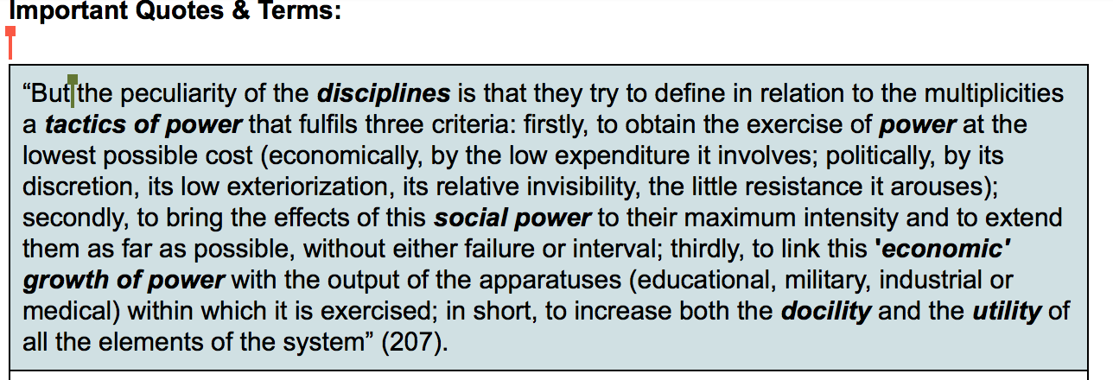

economic terms 🡪 Marxist? Internal organization of a “discipline,” not necessarily related to capital  
consent without consenting 🡪 slight of hand

Gramsci 🡪 3 steps: implementation of norms, conserving interest of power, ushering consensus   
other translations 🡪 docility: obedience utility, usefulness

Disciplines are not people,  
power is just a position

How does power fit in here?

Epist vs. techne

Movement, or conditions that make knowledge possible, knowing positions  
play on double meanings  
be aware of the translation aspect,

Discourse vs. non discursive practices

How you conceptualize language. Language is not transparent. Language constitutes reality. It produces reality.

p. 55 “Discourse does not simply translate reality into language…”

discipline and punish as a whole

the political site of the body

connection between the building and the metaphor

retract and

permanent record

regime in Foucault 🡪 p. 43

subject position in testing

the focus in a regime is on people who are on the margins 🡪 women will be talked about more than men because they are the other, so they are described certain characteristics as those who fail

the regime is meant to maintain  
no group of people that does this to other people, it’s a thing/object. It’s not a who, but a what holds others back/in place to maintain the status quo (agreed upon practices)

What would Foucault, Friere, Gramsci say about Facebook?

Power is productive

Why is Foucault important to RWS?

Subjects sometime can maneuver within that circulation of power.